* **AndroidManifest.xml**

*<?***xml version="1.0" encoding="utf-8"***?>*<**manifest xmlns:android="http://schemas.android.com/apk/res/android"  
 xmlns:tools="http://schemas.android.com/tools"  
 package="com.project.amit.onlinefurniturestore"**>  
  
 <**uses-permission android:name="android.permission.INTERNET"** />  
  
 <**application  
 android:allowBackup="true"  
 android:dataExtractionRules="@xml/data_extraction_rules"  
 android:fullBackupContent="@xml/backup_rules"  
 android:icon="@drawable/logo"  
 android:label="@string/app_name"  
 android:roundIcon="@drawable/logo"  
 android:supportsRtl="true"  
 android:theme="@style/Theme.OnlineFurnitureStore"  
 tools:targetApi="31"**>  
  
 <**activity  
 android:name=".activites.RegistrationActivity"  
 android:exported="true"**>  
 <**intent-filter**>  
 <**action android:name="android.intent.action.MAIN"** />  
  
 <**category android:name="android.intent.category.LAUNCHER"** />  
 </**intent-filter**>  
 </**activity**>  
 <**activity android:name=".activites.MainActivity"** />  
 <**activity android:name=".activites.ShowAllActivity"** />  
 <**activity android:name=".activites.LoginActivity"** />  
 <**activity android:name=".activites.DetailedActivity"** />  
 <**activity android:name=".activites.OnBoardingActivity"** />  
 <**activity android:name=".activites.GooglePay"** />  
 <**activity android:name=".activites.VerifyOTP"** />  
 <**activity android:name=".activites.AddressActivity"** />  
 <**activity android:name=".activites.AddAddressActivity"** />  
 <**activity android:name=".activites.PaymentActivity"** />  
 <**activity android:name=".activites.PlaceOrderActivity"**/>  
  
 <**meta-data  
 android:name="preloaded_fonts"  
 android:resource="@array/preloaded_fonts"** />  
 </**application**>  
  
</**manifest**>

* Java File
* Activites

AddAddressActivity

**package** com.project.amit.onlinefurniturestore.activites;  
  
**import** androidx.annotation.NonNull;  
**import** androidx.appcompat.app.AppCompatActivity;  
**import** androidx.appcompat.widget.Toolbar;  
  
**import** android.content.Intent;  
**import** android.os.Bundle;  
**import** android.view.View;  
**import** android.widget.Button;  
**import** android.widget.EditText;  
**import** android.widget.Toast;  
  
**import** com.google.android.gms.tasks.OnCompleteListener;  
**import** com.google.android.gms.tasks.Task;  
**import** com.google.firebase.auth.FirebaseAuth;  
**import** com.google.firebase.firestore.DocumentReference;  
**import** com.google.firebase.firestore.FirebaseFirestore;  
**import** com.project.amit.onlinefurniturestore.R;  
  
**import** java.util.HashMap;  
**import** java.util.Map;  
  
**public class** AddAddressActivity **extends** AppCompatActivity {  
  
 EditText **name**,**address**,**city**,**pincode**,**phoneNumber**;  
 Button **addAddressBtn**;  
 Toolbar **toolbar**;  
  
 FirebaseFirestore **firestore**;  
 FirebaseAuth **auth**;  
  
 @Override  
 **protected void** onCreate(Bundle savedInstanceState) {  
 **super**.onCreate(savedInstanceState);  
 setContentView(R.layout.***activity_add_address***);  
  
 **toolbar** = findViewById(R.id.***add_address_toolbar***);  
 setSupportActionBar(**toolbar**);  
 getSupportActionBar().setDisplayHomeAsUpEnabled(**true**);  
  
 **auth** = FirebaseAuth.*getInstance*();  
 **firestore** = FirebaseFirestore.*getInstance*();  
  
 **name** = findViewById(R.id.***add_name***);  
 **address** = findViewById(R.id.***add_address_lane***);  
 **city** = findViewById(R.id.***add_city***);  
 **pincode** = findViewById(R.id.***add_pin_code***);  
 **phoneNumber** = findViewById(R.id.***add_phone***);  
 **addAddressBtn** = findViewById(R.id.***ad_add_address***);  
  
 **addAddressBtn**.setOnClickListener(**new** View.OnClickListener() {  
 @Override  
 **public void** onClick(View view) {  
  
 String userName = **name**.getText().toString();  
 String userAddress = **address**.getText().toString();  
 String userCity = **city**.getText().toString();  
 String userPincode = **pincode**.getText().toString();  
 String userNumber = **phoneNumber**.getText().toString();  
  
 String final_address = **""**;  
  
 **if** (!userName.isEmpty()){  
 final_address+=userName;  
 }  
  
 **if** (!userAddress.isEmpty()){  
 final_address+=userAddress;  
 }  
  
 **if** (!userCity.isEmpty()){  
 final_address+=userCity;  
 }  
  
 **if** (!userPincode.isEmpty()){  
 final_address+=userPincode;  
 }  
  
 **if** (!userNumber.isEmpty()){  
 final_address+=userNumber;  
 }  
  
 **if** (!userName.isEmpty() && !userAddress.isEmpty() && !userCity.isEmpty() && !userPincode.isEmpty() && !userNumber.isEmpty()){  
  
 Map<String,String> map = **new** HashMap<>();  
 map.put(**"userAddress"**,final_address);  
  
 **firestore**.collection(**"CurrentUser"**).document(**auth**.getCurrentUser().getUid())  
 .collection(**"Address"**).add(map).addOnCompleteListener(**new** OnCompleteListener<DocumentReference>() {  
 @Override  
 **public void** onComplete(@NonNull Task<DocumentReference> task) {  
  
 **if** (task.isSuccessful()){  
 Toast.*makeText*(AddAddressActivity.**this**, **"Address Added"**, Toast.***LENGTH_SHORT***).show();  
 startActivity(**new** Intent(AddAddressActivity.**this**,DetailedActivity.**class**));  
 finish();  
 }  
 }  
 });  
 }**else** {  
 Toast.*makeText*(AddAddressActivity.**this**, **"Kindly Fill All Field"**, Toast.***LENGTH_SHORT***).show();  
 }  
 }  
 });  
  
  
 }  
}

* AddressActivity

**package** com.project.amit.onlinefurniturestore.activites;  
  
**import** androidx.annotation.NonNull;  
**import** androidx.appcompat.app.AppCompatActivity;  
**import** androidx.appcompat.widget.Toolbar;  
**import** androidx.recyclerview.widget.LinearLayoutManager;  
**import** androidx.recyclerview.widget.RecyclerView;  
  
**import** android.content.Intent;  
**import** android.os.Bundle;  
**import** android.view.View;  
**import** android.widget.Button;  
**import** android.widget.RadioButton;  
  
**import** com.google.android.gms.tasks.OnCompleteListener;  
**import** com.google.android.gms.tasks.Task;  
**import** com.google.firebase.auth.FirebaseAuth;  
**import** com.google.firebase.firestore.DocumentSnapshot;  
**import** com.google.firebase.firestore.FirebaseFirestore;  
**import** com.google.firebase.firestore.QuerySnapshot;  
**import** com.project.amit.onlinefurniturestore.R;  
**import** com.project.amit.onlinefurniturestore.adapter.AddressAdapter;  
**import** com.project.amit.onlinefurniturestore.models.AddressModel;  
**import** com.project.amit.onlinefurniturestore.models.AllProductsModel;  
**import** com.project.amit.onlinefurniturestore.models.MyCartViewModel;  
**import** com.project.amit.onlinefurniturestore.models.NewProductsModel;  
**import** com.project.amit.onlinefurniturestore.models.ShowAllModel;  
**import** com.squareup.okhttp.Address;  
  
**import** java.util.ArrayList;  
**import** java.util.List;  
  
**public class** AddressActivity **extends** AppCompatActivity **implements** AddressAdapter.SelectedAddress{  
  
 Button **addAddress**;  
 RecyclerView **recyclerView**;  
 **private** List<AddressModel> **addressModelList**;  
 **private** AddressAdapter **addressAdapter**;  
 FirebaseFirestore **firestore**;  
 FirebaseAuth **auth**;  
 Button **paymentBtn**;  
 Toolbar **toolbar**;  
 String **mAddress** = **""**;  
  
 @Override  
 **protected void** onCreate(Bundle savedInstanceState) {  
 **super**.onCreate(savedInstanceState);  
 setContentView(R.layout.***activity_address***);  
  
 **toolbar** = findViewById(R.id.***address_toolbar***);  
 setSupportActionBar(**toolbar**);  
 getSupportActionBar().setDisplayHomeAsUpEnabled(**true**);  
  
 *//get data from detailed activity* Object obj = getIntent().getSerializableExtra(**"item"**);  
  
 **firestore** = FirebaseFirestore.*getInstance*();  
 **auth** = FirebaseAuth.*getInstance*();  
  
 **recyclerView** = findViewById(R.id.***address_recycler***);  
 **paymentBtn** = findViewById(R.id.***payment_btn***);  
 **addAddress** = findViewById(R.id.***add_address_btn***);  
  
 **recyclerView**.setLayoutManager(**new** LinearLayoutManager(getApplicationContext()));  
 **addressModelList** = **new** ArrayList<>();  
 **addressAdapter**=**new** AddressAdapter(getApplicationContext(),**addressModelList**,**this**);  
 **recyclerView**.setAdapter(**addressAdapter**);  
  
 **firestore**.collection(**"CurrentUser"**).document(**auth**.getCurrentUser().getUid())  
 .collection(**"Address"**).get().addOnCompleteListener(**new** OnCompleteListener<QuerySnapshot>() {  
 @Override  
 **public void** onComplete(@NonNull Task<QuerySnapshot> task) {  
 **if** (task.isSuccessful()) {  
 **for** (DocumentSnapshot doc : task.getResult().getDocuments()) {  
  
 AddressModel addressModel = doc.toObject(AddressModel.**class**);  
 **addressModelList**.add(addressModel);  
 **addressAdapter**.notifyDataSetChanged();  
 }  
 }  
 }  
 });  
  
 **paymentBtn**.setOnClickListener(**new** View.OnClickListener() {  
 @Override  
 **public void** onClick(View view) {  
  
 **double** amount = 0.0;  
 **if**(obj **instanceof** NewProductsModel){  
 NewProductsModel newProductsModel = (NewProductsModel) obj;  
 amount = newProductsModel.getPrice();  
 }  
  
 **if**(obj **instanceof** AllProductsModel){  
 AllProductsModel allProductsModel = (AllProductsModel) obj;  
 amount = allProductsModel.getPrice();  
 }  
  
 **if**(obj **instanceof** ShowAllModel){  
 ShowAllModel showAllModel = (ShowAllModel) obj;  
 amount = showAllModel.getPrice();  
 }  
  
 Intent intent = **new** Intent(AddressActivity.**this**,PaymentActivity.**class**);  
 intent.putExtra(**"amount"**,amount);  
 startActivity(intent);  
  
 }  
 });  
  
 **addAddress**.setOnClickListener(**new** View.OnClickListener() {  
 @Override  
 **public void** onClick(View view) {  
 startActivity(**new** Intent(AddressActivity.**this**,AddAddressActivity.**class**));  
  
 }  
 });  
 }  
  
 @Override  
 **public void** setAddress(String address) {  
 **mAddress** = address;  
  
 }  
}

* DetailedActivity

**package** com.project.amit.onlinefurniturestore.activites;  
  
**import** androidx.annotation.NonNull;  
**import** androidx.appcompat.app.AppCompatActivity;  
**import** androidx.appcompat.widget.Toolbar;  
  
**import** android.content.Intent;  
**import** android.os.Bundle;  
**import** android.view.View;  
**import** android.widget.Button;  
**import** android.widget.ImageView;  
**import** android.widget.TextView;  
**import** android.widget.Toast;  
  
**import** com.bumptech.glide.Glide;  
**import** com.google.android.gms.tasks.OnCompleteListener;  
**import** com.google.android.gms.tasks.Task;  
**import** com.google.firebase.auth.FirebaseAuth;  
**import** com.google.firebase.firestore.DocumentReference;  
**import** com.google.firebase.firestore.FirebaseFirestore;  
**import** com.project.amit.onlinefurniturestore.R;  
**import** com.project.amit.onlinefurniturestore.models.ShowAllModel;  
**import** com.project.amit.onlinefurniturestore.models.AllProductsModel;  
**import** com.project.amit.onlinefurniturestore.models.NewProductsModel;  
  
**import** java.text.SimpleDateFormat;  
**import** java.util.Calendar;  
**import** java.util.HashMap;  
  
**public class** DetailedActivity **extends** AppCompatActivity {  
  
  
  
 ImageView **detailedImg**;  
 TextView **description**,**name**,**price**,**rating**,**quantity**;  
 Button **addToCart**,**buyNow**;  
 ImageView **addItems**,**removeItems**;  
  
 Toolbar **toolbar**;  
 **int totalQuantity** = 1;  
 **int totalPrice** = 0;  
  
 *//New Products* NewProductsModel **newProductsModel** = **null**;  
  
  
 *//All Product* AllProductsModel **allProductsModel** = **null**;  
  
 *//ShowAll Item* ShowAllModel **showAllModel** = **null**;  
  
 FirebaseAuth **auth**; *// use for addtocart* **private** FirebaseFirestore **firestore**;  
  
 @Override  
 **protected void** onCreate(Bundle savedInstanceState) {  
 **super**.onCreate(savedInstanceState);  
 setContentView(R.layout.***activity_detailed***);  
  
 **toolbar** = findViewById(R.id.***detailed_toolbar***);  
 setSupportActionBar(**toolbar**);  
 getSupportActionBar().setDisplayHomeAsUpEnabled(**true**);  
  
 **firestore** = FirebaseFirestore.*getInstance*();  
 **auth** = FirebaseAuth.*getInstance*();  
  
 **final** Object obj = getIntent().getSerializableExtra(**"detailed"**);  
  
 **if** (obj **instanceof** NewProductsModel){  
 **newProductsModel** = (NewProductsModel) obj;  
 }**else if** (obj **instanceof** AllProductsModel){  
 **allProductsModel** = (AllProductsModel) obj;  
 }**else if** (obj **instanceof** AllProductsModel){  
 **allProductsModel** = (AllProductsModel) obj;  
 }  
  
 **detailedImg** = findViewById(R.id.***detailed_img***);  
 **description** = findViewById(R.id.***detailed_desc***);  
 **name** = findViewById(R.id.***detailed_name***);  
 **price** = findViewById(R.id.***detailed_price***);  
 **rating** = findViewById(R.id.***detailed_rating***);  
 **quantity** = findViewById(R.id.***quantity***);  
  
 **addToCart** = findViewById(R.id.***add_to_cart***);  
 **buyNow** = findViewById(R.id.***buy_now***);  
  
 **addItems** = findViewById(R.id.***add_item***);  
 **removeItems** = findViewById(R.id.***remove_item***);  
  
 *//New Products* **if** (**newProductsModel** != **null**){  
 Glide.*with*(getApplicationContext()).load(**newProductsModel**.getImg_url()).into(**detailedImg**);  
 **description**.setText(**newProductsModel**.getDescription());  
 **name**.setText(**newProductsModel**.getName());  
 **price**.setText(String.*valueOf*(**newProductsModel**.getPrice()));  
 **rating**.setText(**newProductsModel**.getRating());  
 **name**.setText(**newProductsModel**.getName());  
  
 **totalPrice** = **newProductsModel**.getPrice() * **totalQuantity**;  
 }  
  
  
 *//All Product* **if** (**allProductsModel** != **null**){  
 Glide.*with*(getApplicationContext()).load(**allProductsModel**.getImg_url()).into(**detailedImg**);  
 **description**.setText(**allProductsModel**.getDescription());  
 **name**.setText(**allProductsModel**.getName());  
 **price**.setText(String.*valueOf*(**allProductsModel**.getPrice()));  
 **rating**.setText(**allProductsModel**.getRating());  
 **name**.setText(**allProductsModel**.getName());  
  
 **totalPrice** = **allProductsModel**.getPrice() * **totalQuantity**;  
 }  
  
 *//ShowAll Product* **if** (**showAllModel** != **null**) {  
 Glide.*with*(getApplicationContext()).load(**showAllModel**.getImg_url()).into(**detailedImg**);  
 **description**.setText(**showAllModel**.getDescription());  
 **name**.setText(**showAllModel**.getName());  
 **price**.setText(String.*valueOf*(**showAllModel**.getPrice()));  
 **rating**.setText(**showAllModel**.getRating());  
 **name**.setText(**showAllModel**.getName());  
  
 **totalPrice** = **showAllModel**.getPrice() * **totalQuantity**;  
 }  
  
 *//Buy Now* **buyNow**.setOnClickListener(**new** View.OnClickListener() {  
 @Override  
 **public void** onClick(View view) {  
 Intent intent = **new** Intent(DetailedActivity.**this**,AddressActivity.**class**);  
  
 **if** (**newProductsModel** != **null**) {  
 intent.putExtra(**"item"**,**newProductsModel**);  
 }  
 **if** (**allProductsModel** != **null**) {  
 intent.putExtra(**"item"**,**allProductsModel**);  
 }  
 **if** (**showAllModel** != **null**){  
 intent.putExtra(**"item"**,**showAllModel**);  
 }  
 startActivity(intent);  
 }  
 });  
 *//Add to cart* **addToCart**.setOnClickListener(**new** View.OnClickListener() {  
 @Override  
 **public void** onClick(View view) {  
 addtoCart();  
  
 }  
 });  
  
 **addItems**.setOnClickListener(**new** View.OnClickListener() {  
 @Override  
 **public void** onClick(View view) {  
 **if**(**totalQuantity** < 10){  
 **totalQuantity**++;  
 **quantity**.setText(String.*valueOf*(**totalQuantity**));  
  
 **if** (**newProductsModel** !=**null**){  
 **totalPrice** = **newProductsModel**.getPrice() * **totalQuantity**;  
 }**if** (**allProductsModel** !=**null**){  
 **totalPrice** = **allProductsModel**.getPrice() * **totalQuantity**;  
 }**if** (**showAllModel** !=**null**){  
 **totalPrice** = **showAllModel**.getPrice() * **totalQuantity**;  
 }  
 }  
  
 }  
 });  
  
 **removeItems**.setOnClickListener(**new** View.OnClickListener() {  
 @Override  
 **public void** onClick(View view) {  
 **if**(**totalQuantity** > 1){  
 **totalQuantity**--;  
 **quantity**.setText(String.*valueOf*(**totalQuantity**));  
 }  
  
 }  
 });  
 }  
  
 *// Add to cart* **private void** addtoCart(){  
  
 String saveCurrentTime,saveCurrentDate;  
  
 Calendar calForDate = Calendar.*getInstance*();  
  
 SimpleDateFormat currentDate = **new** SimpleDateFormat(**" dd-MM-yyyy"**);  
 saveCurrentDate = currentDate.format(calForDate.getTime());  
  
 SimpleDateFormat currentTime = **new** SimpleDateFormat(**"HH:mm:ss a"**);  
 saveCurrentTime = currentTime.format(calForDate.getTime());  
  
 **final** HashMap<String,Object> cartMap = **new** HashMap<>();  
  
 cartMap.put(**"productName"**,**name**.getText().toString());  
 cartMap.put(**"productPrice"**,**price**.getText().toString());  
 cartMap.put(**"currentTime"**,saveCurrentTime);  
 cartMap.put(**"currentDate"**,saveCurrentDate);  
 cartMap.put(**"totalQuantity"**,**quantity**.getText().toString());  
 cartMap.put(**"totalPrice"**,**totalPrice**);  
  
  
 **firestore**.collection(**"AddToCart"**).document(**auth**.getCurrentUser().getUid())  
 .collection(**"User"**).add(cartMap).addOnCompleteListener(**new** OnCompleteListener<DocumentReference>() {  
 @Override  
 **public void** onComplete(@NonNull Task<DocumentReference> task) {  
 Toast.*makeText*(DetailedActivity.**this**, **"Added To Cart"**, Toast.***LENGTH_SHORT***).show();  
 finish();  
 }  
 });  
  
 }  
 }

* GooglePay

**package** com.project.amit.onlinefurniturestore.activites;  
  
**import** android.content.Context;  
**import** android.content.Intent;  
**import** android.net.ConnectivityManager;  
**import** android.net.NetworkInfo;  
**import** android.net.Uri;  
**import** android.os.Build;  
  
**import** android.os.Bundle;  
**import** android.text.TextUtils;  
**import** android.util.Log;  
**import** android.view.View;  
**import** android.widget.Button;  
**import** android.widget.EditText;  
**import** android.widget.Toast;  
  
**import** androidx.appcompat.app.AppCompatActivity;  
  
**import** com.project.amit.onlinefurniturestore.R;  
  
**import** java.time.Duration;  
**import** java.util.ArrayList;  
  
**public class** GooglePay **extends** AppCompatActivity {  
  
 EditText **amount**, **note**, **name**, **upivirtualid**;  
 Button **send**;  
 String **TAG** =**"main"**;  
 **final int UPI_PAYMENT** = 0;  
  
 @Override  
 **protected void** onCreate(Bundle savedInstanceState) {  
 **super**.onCreate(savedInstanceState);  
 setContentView(R.layout.***google_pay***);  
  
 **send** = (Button) findViewById(R.id.***send***);  
 **amount** = (EditText)findViewById(R.id.***amount_et***);  
 **note** = (EditText)findViewById(R.id.***note***);  
 **name** = (EditText) findViewById(R.id.***name***);  
 **upivirtualid** =(EditText) findViewById(R.id.***upi_id***);  
  
 **send**.setOnClickListener(**new** View.OnClickListener() {  
 @Override  
 **public void** onClick(View view) {  
 *//Getting the values from the EditTexts* **if** (TextUtils.*isEmpty*(**name**.getText().toString().trim())){  
 Toast.*makeText*(GooglePay.**this**,**" Name is invalid"**, Toast.***LENGTH_SHORT***).show();  
  
 }**else if** (TextUtils.*isEmpty*(**upivirtualid**.getText().toString().trim())){  
 Toast.*makeText*(GooglePay.**this**,**" UPI ID is invalid"**, Toast.***LENGTH_SHORT***).show();  
  
 }**else if** (TextUtils.*isEmpty*(**note**.getText().toString().trim())){  
 Toast.*makeText*(GooglePay.**this**,**" Note is invalid"**, Toast.***LENGTH_SHORT***).show();  
  
 }**else if** (TextUtils.*isEmpty*(**amount**.getText().toString().trim())){  
 Toast.*makeText*(GooglePay.**this**,**" Amount is invalid"**, Toast.***LENGTH_SHORT***).show();  
 }**else**{  
  
 payUsingUpi(**name**.getText().toString(), **upivirtualid**.getText().toString(),  
 **note**.getText().toString(), **amount**.getText().toString());  
  
 }  
  
  
 }  
 });  
 }  
  
  
 **void** payUsingUpi( String name,String upiId, String note, String amount) {  
 Log.*e*(**"main "**, **"name "**+name +**"--up--"**+upiId+**"--"**+ note+**"--"**+amount);  
 Uri uri = Uri.*parse*(**"upi://pay"**).buildUpon()  
 .appendQueryParameter(**"pa"**, upiId)  
 .appendQueryParameter(**"pn"**, name)  
 *//.appendQueryParameter("mc", "")  
 //.appendQueryParameter("tid", "02125412")  
 //.appendQueryParameter("tr", "25584584")* .appendQueryParameter(**"tn"**, note)  
 .appendQueryParameter(**"am"**, amount)  
 .appendQueryParameter(**"cu"**, **"INR"**)  
 *//.appendQueryParameter("refUrl", "blueapp")* .build();  
  
  
 Intent upiPayIntent = **new** Intent(Intent.***ACTION_VIEW***);  
 upiPayIntent.setData(uri);  
  
 *// will always show a dialog to user to choose an app* Intent chooser = Intent.*createChooser*(upiPayIntent, **"Pay with"**);  
  
 *// check if intent resolves* **if**(**null** != chooser.resolveActivity(getPackageManager())) {  
 startActivityForResult(chooser, **UPI_PAYMENT**);  
 } **else** {  
 Toast.*makeText*(GooglePay.**this**,**"No UPI app found, please install one to continue"**,Toast.***LENGTH_SHORT***).show();  
 }  
  
 }  
  
 @Override  
 **protected void** onActivityResult(**int** requestCode, **int** resultCode, Intent data) {  
 **super**.onActivityResult(requestCode, resultCode, data);  
 Log.*e*(**"main "**, **"response "**+resultCode );  
 */*  
 E/main: response -1  
 E/UPI: onActivityResult: txnId=AXI4a3428ee58654a938811812c72c0df45&responseCode=00&Status=SUCCESS&txnRef=922118921612  
 E/UPIPAY: upiPaymentDataOperation: txnId=AXI4a3428ee58654a938811812c72c0df45&responseCode=00&Status=SUCCESS&txnRef=922118921612  
 E/UPI: payment successfull: 922118921612  
 */* **switch** (requestCode) {  
 **case UPI_PAYMENT**:  
 **if** ((***RESULT_OK*** == resultCode) || (resultCode == 11)) {  
 **if** (data != **null**) {  
 String trxt = data.getStringExtra(**"response"**);  
 Log.*e*(**"UPI"**, **"onActivityResult: "** + trxt);  
 ArrayList<String> dataList = **new** ArrayList<>();  
 dataList.add(trxt);  
 upiPaymentDataOperation(dataList);  
 } **else** {  
 Log.*e*(**"UPI"**, **"onActivityResult: "** + **"Return data is null"**);  
 ArrayList<String> dataList = **new** ArrayList<>();  
 dataList.add(**"nothing"**);  
 upiPaymentDataOperation(dataList);  
 }  
 } **else** {  
 *//when user simply back without payment* Log.*e*(**"UPI"**, **"onActivityResult: "** + **"Return data is null"**);  
 ArrayList<String> dataList = **new** ArrayList<>();  
 dataList.add(**"nothing"**);  
 upiPaymentDataOperation(dataList);  
 }  
 **break**;  
 }  
 }  
  
 **private void** upiPaymentDataOperation(ArrayList<String> data) {  
 **if** (*isConnectionAvailable*(GooglePay.**this**)) {  
 String str = data.get(0);  
 Log.*e*(**"UPIPAY"**, **"upiPaymentDataOperation: "**+str);  
 String paymentCancel = **""**;  
 **if**(str == **null**) str = **"discard"**;  
 String status = **""**;  
 String approvalRefNo = **""**;  
 String response[] = str.split(**"&"**);  
 **for** (**int** i = 0; i < response.**length**; i++) {  
 String equalStr[] = response[i].split(**"="**);  
 **if**(equalStr.**length** >= 2) {  
 **if** (equalStr[0].toLowerCase().equals(**"Status"**.toLowerCase())) {  
 status = equalStr[1].toLowerCase();  
 }  
 **else if** (equalStr[0].toLowerCase().equals(**"ApprovalRefNo"**.toLowerCase()) || equalStr[0].toLowerCase().equals(**"txnRef"**.toLowerCase())) {  
 approvalRefNo = equalStr[1];  
 }  
 }  
 **else** {  
 paymentCancel = **"Payment cancelled by user."**;  
 }  
 }  
  
 **if** (status.equals(**"success"**)) {  
 *//Code to handle successful transaction here.* Toast.*makeText*(GooglePay.**this**, **"Transaction successful."**, Toast.***LENGTH_SHORT***).show();  
 Log.*e*(**"UPI"**, **"payment successfull: "**+approvalRefNo);  
 }  
 **else if**(**"Payment cancelled by user."**.equals(paymentCancel)) {  
 Toast.*makeText*(GooglePay.**this**, **"Payment cancelled by user."**, Toast.LENGTH_SHORT).show();  
 Log.e(**"UPI"**, **"Cancelled by user: "**+approvalRefNo);  
  
 }  
 **else** {  
 Toast.makeText(GooglePay.**this**, **"Transaction failed.Please try again"**, Toast.LENGTH_SHORT).show();  
 Log.e(**"UPI"**, **"failed payment: "**+approvalRefNo);  
  
 }  
 } **else** {  
 Log.e(**"UPI"**, **"Internet issue: "**);  
  
 Toast.makeText(GooglePay.**this**, **"Internet connection is not available. Please check and try again"**, Toast.LENGTH_SHORT).show();  
 }  
 }  
  
 **public static boolean** isConnectionAvailable(Context context) {  
 ConnectivityManager connectivityManager = (ConnectivityManager) context.getSystemService(Context.CONNECTIVITY_SERVICE);  
 **if** (connectivityManager != **null**) {  
 NetworkInfo netInfo = connectivityManager.getActiveNetworkInfo();  
 **if** (netInfo != **null** && netInfo.isConnected()  
 && netInfo.isConnectedOrConnecting()  
 && netInfo.isAvailable()) {  
 **return true**;  
 }  
 }  
 **return false**;  
 }  
  
}

* LoginActivity

**package** com.project.amit.onlinefurniturestore.activites;  
  
**import** androidx.annotation.NonNull;  
**import** androidx.appcompat.app.AlertDialog;  
**import** androidx.appcompat.app.AppCompatActivity;  
  
**import** android.content.DialogInterface;  
**import** android.content.Intent;  
**import** android.os.Bundle;  
**import** android.text.TextUtils;  
**import** android.view.View;  
**import** android.widget.Button;  
**import** android.widget.EditText;  
**import** android.widget.ProgressBar;  
**import** android.widget.TextView;  
**import** android.widget.Toast;  
  
**import** com.google.android.gms.tasks.OnCompleteListener;  
**import** com.google.android.gms.tasks.OnFailureListener;  
**import** com.google.android.gms.tasks.OnSuccessListener;  
**import** com.google.android.gms.tasks.Task;  
**import** com.google.firebase.auth.AuthResult;  
**import** com.google.firebase.auth.FirebaseAuth;  
**import** com.project.amit.onlinefurniturestore.R;  
  
**public class** LoginActivity **extends** AppCompatActivity {  
  
 EditText **mEmail**,**cPassword**;  
 Button **mLoginBtn**;  
 TextView **mCreateBtn**,**forgotTextLink**;  
 ProgressBar **progressBar**;  
 FirebaseAuth **fAuth**;  
  
 @Override  
 **protected void** onCreate(Bundle savedInstanceState) {  
 **super**.onCreate(savedInstanceState);  
 setContentView(R.layout.***activity_login***);  
  
 **mEmail** = findViewById(R.id.***email***);  
 **cPassword** = findViewById(R.id.***password***);  
 **progressBar** = findViewById(R.id.***progressBar***);  
 **fAuth** = FirebaseAuth.*getInstance*();  
 **mLoginBtn** = findViewById(R.id.***loginBtn***);  
 **mCreateBtn** = findViewById(R.id.***createText2***);  
 **forgotTextLink** = findViewById(R.id.***forgetPassword***);  
  
 **mLoginBtn**.setOnClickListener(**new** View.OnClickListener() {  
 @Override  
 **public void** onClick(View view) {  
  
 loginUser();  
 }  
 });  
  
 **mCreateBtn**.setOnClickListener(**new** View.OnClickListener() {  
 @Override  
 **public void** onClick(View view) {  
 startActivity(**new** Intent(getApplicationContext(), RegistrationActivity.**class**));  
 }  
 });  
  
 **forgotTextLink**.setOnClickListener(**new** View.OnClickListener() {  
 @Override  
 **public void** onClick(View view) {  
 EditText resetMail = **new** EditText(view.getContext());  
 AlertDialog.Builder passwordResetDialog = **new** AlertDialog.Builder(view.getContext());  
 passwordResetDialog.setTitle(**"Reset Password ? "**);  
 passwordResetDialog.setMessage(**"Enter Your Email To Received Reset Link. "**);  
 passwordResetDialog.setView(resetMail);  
  
 passwordResetDialog.setPositiveButton(**"Yes"**, **new** DialogInterface.OnClickListener() {  
 @Override  
 **public void** onClick(DialogInterface dialogInterface, **int** i) {  
  
 *// extract the email and send reset link* String mail = resetMail.getText().toString();  
 **fAuth**.sendPasswordResetEmail(mail).addOnSuccessListener(**new** OnSuccessListener<Void>() {  
 @Override  
 **public void** onSuccess(Void unused) {  
 Toast.*makeText*(LoginActivity.**this**, **"Reset Link Sent To Your Email."**, Toast.***LENGTH_SHORT***).show();  
 }  
 }).addOnFailureListener(**new** OnFailureListener() {  
 @Override  
 **public void** onFailure(@NonNull Exception e) {  
  
 Toast.*makeText*(LoginActivity.**this**, **"Error ! Reset Link is Not Sent"** +e.getMessage(), Toast.***LENGTH_SHORT***).show();  
 }  
 });  
 }  
 });  
  
 passwordResetDialog.setNegativeButton(**"No"**, **new** DialogInterface.OnClickListener() {  
 @Override  
 **public void** onClick(DialogInterface dialogInterface, **int** i) {  
 *// Close the dialog* }  
 });  
  
 passwordResetDialog.create().show();  
 }  
 });  
  
 }  
 **private void** loginUser(){  
 String email= **mEmail**.getText().toString().trim();  
 String cpass = **cPassword**.getText().toString().trim();  
  
 **if** (TextUtils.*isEmpty*(email)){  
 **mEmail**.setError(**"Email is Empty."**);  
 **return**;  
 }  
  
 **if** (TextUtils.*isEmpty*(cpass)){  
 **cPassword**.setError(**"Password is Required"**);  
 **return**;  
 }  
  
 **if** (cpass.length() < 6){  
 **cPassword**.setError(**"Password Must be <= 6 Characters"**);  
 **return**;  
 }  
  
 **progressBar**.setVisibility(View.***VISIBLE***);  
  
 *//Login User* **fAuth**.signInWithEmailAndPassword(email,cpass).addOnCompleteListener(**new** OnCompleteListener<AuthResult>() {  
 @Override  
 **public void** onComplete(@NonNull Task<AuthResult> task) {  
  
 **if** (task.isSuccessful()){  
 Toast.*makeText*(LoginActivity.**this**, **"Login is Successfully"**, Toast.***LENGTH_SHORT***).show();  
 startActivity(**new** Intent(getApplicationContext(), MainActivity.**class**));  
 }**else**{  
 Toast.*makeText*(LoginActivity.**this**, **"Error ! "** + task.getException().getMessage(), Toast.***LENGTH_SHORT***).show();  
 **progressBar**.setVisibility(View.***GONE***);  
 }  
 }  
 });  
  
 }  
}

* MainActivity

**package** com.project.amit.onlinefurniturestore.activites;  
  
**import static** java.security.AccessController.*getContext*;  
  
**import** android.content.Intent;  
**import** android.os.Bundle;  
**import** android.view.Menu;  
**import** android.view.MenuItem;  
**import** android.view.View;  
**import** android.widget.TextView;  
  
**import** androidx.annotation.NonNull;  
**import** androidx.annotation.Nullable;  
**import** androidx.appcompat.app.AppCompatActivity;  
**import** androidx.appcompat.widget.Toolbar;  
**import** androidx.drawerlayout.widget.DrawerLayout;  
**import** androidx.navigation.NavController;  
**import** androidx.navigation.Navigation;  
**import** androidx.navigation.ui.AppBarConfiguration;  
**import** androidx.navigation.ui.NavigationUI;  
  
**import** com.bumptech.glide.Glide;  
**import** com.google.android.material.navigation.NavigationView;  
**import** com.google.firebase.auth.FirebaseAuth;  
**import** com.google.firebase.database.DataSnapshot;  
**import** com.google.firebase.database.DatabaseError;  
**import** com.google.firebase.database.FirebaseDatabase;  
**import** com.google.firebase.database.ValueEventListener;  
**import** com.project.amit.onlinefurniturestore.R;  
**import** com.project.amit.onlinefurniturestore.models.UserModel;  
**import** com.project.amit.onlinefurniturestore.ui.MyCartFragment;  
  
**import** de.hdodenhof.circleimageview.CircleImageView;  
  
**public class** MainActivity **extends** AppCompatActivity {  
  
  
 **private** AppBarConfiguration **mAppBarConfiguration**;  
 **private** MainActivity **binding**;  
  
 FirebaseAuth **auth**;  
 FirebaseDatabase **database**;  
  
 Toolbar **toolbar**;  
 @Override  
 **protected void** onCreate(@Nullable Bundle savedInstanceState) {  
 **super**.onCreate(savedInstanceState);  
 setContentView(R.layout.***activity_main***);  
  
 **auth** = FirebaseAuth.*getInstance*();  
 **database** = FirebaseDatabase.*getInstance*();  
  
 **toolbar** = findViewById(R.id.***toolbar***);  
 setSupportActionBar(**toolbar**);  
 getSupportActionBar().setDisplayHomeAsUpEnabled(**true**);  
 getSupportActionBar().setHomeAsUpIndicator(R.drawable.***ic_baseline_menu_24***);  
  
  
 DrawerLayout drawer = findViewById(R.id.***drawer_layout***);  
 NavigationView navigationView = findViewById(R.id.***nav_view***);  
 *// Passing each menu ID as a set of Ids because each  
 // menu should be considered as top level destinations.* **mAppBarConfiguration** = **new** AppBarConfiguration.Builder(  
 R.id.***nav_myprofile***,R.id.***nav_myorder***,R.id.***nav_home***,R.id.***nav_cart***,  
 R.id.***nav_logout***)  
 .setOpenableLayout(drawer)  
 .build();  
  
 NavController navController = Navigation.*findNavController*(**this**, R.id.***nav_host_fragment***);  
 NavigationUI.*setupActionBarWithNavController*(**this**, navController, **mAppBarConfiguration**);  
 NavigationUI.*setupWithNavController*(navigationView, navController);  
  
  
 *// Use this code from fatch data to database use in navigation profile* View headerView = navigationView.getHeaderView(0);  
 TextView headerEmail = headerView.findViewById(R.id.***nav_header_email***);  
 TextView headerName = headerView.findViewById(R.id.***nav_header_name***);  
*// CircleImageView headerImage = headerView.findViewById(R.id.nav_header_img);  
  
/*  
 database.getReference().child("Users").child(FirebaseAuth.getInstance().getUid())  
 .addListenerForSingleValueEvent(new ValueEventListener() {  
 @Override  
 public void onDataChange(@NonNull DataSnapshot snapshot) {  
 UserModel userModel = snapshot.getValue(UserModel.class);  
  
 headerName.setText(userModel.getFname());  
 headerEmail.setText(userModel.getEmail());  
  
 Glide.with(MainActivity.this).load(userModel.getProfileImg()).into(headerImage);  
 }  
  
 @Override  
 public void onCancelled(@NonNull DatabaseError error) {  
  
 }  
 });  
*/* }  
  
  
 @Override  
 **public boolean** onSupportNavigateUp() {  
 NavController navController = Navigation.*findNavController*(**this**, R.id.***nav_host_fragment***);  
 **return** NavigationUI.*navigateUp*(navController, **mAppBarConfiguration**)  
 || **super**.onSupportNavigateUp();  
 }  
  
  
 *// Nav Top Menu* @Override  
 **public boolean** onCreateOptionsMenu(Menu menu) {  
 *//Inflate the mneu; this adds item to the action bar if it is present* getMenuInflater().inflate(R.menu.***navigation_drawer***,menu);  
 **return true**;  
 }  
*/*  
 @Override  
 public boolean onOptionsItemSelected(@NonNull MenuItem item) {  
 int id = item.getItemId();  
  
 if (id == R.id.menu_logout){  
  
 auth.signOut();  
 startActivity(new Intent(MainActivity.this,LoginActivity.class));  
 finish();  
  
 }else if (id == R.id.menu_my_cart){  
 startActivity(new Intent(MainActivity.this, MyCartFragment.class));  
  
  
 }  
 return true;  
 }*/*}

* OnBoardingActivity

**package** com.project.amit.onlinefurniturestore.activites;  
  
**import** android.content.Intent;  
**import** android.os.Bundle;  
**import** android.text.Html;  
**import** android.view.View;  
**import** android.view.WindowManager;  
**import** android.view.animation.Animation;  
**import** android.view.animation.AnimationUtils;  
**import** android.widget.Button;  
**import** android.widget.LinearLayout;  
**import** android.widget.TextView;  
  
**import** androidx.appcompat.app.AppCompatActivity;  
**import** androidx.viewpager.widget.ViewPager;  
  
**import** com.project.amit.onlinefurniturestore.R;  
**import** com.project.amit.onlinefurniturestore.adapter.SliderAdapter;  
  
**public class** OnBoardingActivity **extends** AppCompatActivity {  
  
 ViewPager **viewPager**;  
 LinearLayout **dotsLayout**;  
  
 Button **btn**;  
 SliderAdapter **sliderAdapter**;  
 TextView[] **dots**;  
 Animation **animation**;  
  
 @Override  
 **protected void** onCreate(Bundle savedInstanceState) {  
 **super**.onCreate(savedInstanceState);  
  
 *// hide status bar* getWindow().setFlags(WindowManager.LayoutParams.***FLAG_FULLSCREEN***,WindowManager.LayoutParams.***FLAG_FULLSCREEN***);  
 setContentView(R.layout.***activity_on_boarding***);  
  
 *//hide toolbar* getSupportActionBar().hide();  
  
 **viewPager** = findViewById(R.id.***slider***);  
 **dotsLayout** = findViewById(R.id.***dots***);  
 **btn** = findViewById(R.id.***get_started_btn***);  
 addDots(0);  
  
 **viewPager**.addOnPageChangeListener(**changeListener**);  
  
 *// Call Adapter* **sliderAdapter** = **new** SliderAdapter(**this**);  
 **viewPager**.setAdapter(**sliderAdapter**);  
 **btn**.setOnClickListener(**new** View.OnClickListener() {  
 @Override  
 **public void** onClick(View view) {  
 startActivity(**new** Intent(OnBoardingActivity.**this**, MainActivity.**class**));  
 finish();  
 }  
 });  
 }  
  
 **private void** addDots(**int** position){  
 **dots** = **new** TextView[3];  
 **dotsLayout**.removeAllViews();  
 **for** (**int** i = 0; i < **dots**.**length**;i++)  
 {  
 **dots**[i] = **new** TextView(**this**);  
 **dots**[i].setText(Html.*fromHtml*(**"&#8226"**));  
 **dots**[i].setTextSize(35);  
 **dotsLayout**.addView(**dots**[i]);  
 }  
 **if** (**dots**.**length** > 0){  
 **dots**[position].setTextColor(getResources().getColor(R.color.***pink***));  
 }  
 }  
  
 ViewPager.OnPageChangeListener **changeListener** = **new** ViewPager.OnPageChangeListener() {  
 @Override  
 **public void** onPageScrolled(**int** position, **float** positionOffset, **int** positionOffsetPixels) {  
  
  
 }  
  
 @Override  
 **public void** onPageSelected(**int** position) {  
 addDots(position);  
  
 **if** (position == 0){  
 **btn**.setVisibility(View.***INVISIBLE***);  
 }**else if** (position == 1) {  
 **btn**.setVisibility(View.***INVISIBLE***);  
 }**else**{  
 **animation** = AnimationUtils.*loadAnimation*(OnBoardingActivity.**this**,R.anim.***slide_animation***);  
 **btn**.setAnimation(**animation**);  
 **btn**.setVisibility(View.***VISIBLE***);  
 }  
  
 }  
  
 @Override  
 **public void** onPageScrollStateChanged(**int** state) {  
  
 }  
 };  
}

* PaymentActivity

**package** com.project.amit.onlinefurniturestore.activites;  
  
**import** androidx.annotation.Nullable;  
**import** androidx.appcompat.app.AppCompatActivity;  
**import** androidx.appcompat.widget.Toolbar;  
  
**import** android.content.Intent;  
**import** android.net.Uri;  
**import** android.os.Bundle;  
**import** android.view.View;  
**import** android.widget.Button;  
**import** android.widget.TextView;  
**import** android.widget.Toast;  
  
**import** com.project.amit.onlinefurniturestore.R;  
  
**import** java.util.ArrayList;  
  
**public class** PaymentActivity **extends** AppCompatActivity {  
  
 Toolbar **toolbar**;  
 TextView **subTotal**,**discount**,**shipping**,**total**;  
 Button **paymentBtn**;  
  
 @Override  
 **protected void** onCreate(Bundle savedInstanceState) {  
 **super**.onCreate(savedInstanceState);  
 setContentView(R.layout.***activity_payment***);  
  
 *//Toolbar* **toolbar** = findViewById(R.id.***payment_toolbar***);  
 setSupportActionBar(**toolbar**);  
 getSupportActionBar().setDisplayHomeAsUpEnabled(**true**);  
  
 **double** amount = 0.0;  
 amount = getIntent().getDoubleExtra(**"amount"**, 0.0);  
  
 **subTotal** = findViewById(R.id.***sub_total***);  
 **discount** = findViewById(R.id.***textView17***);  
 **shipping** = findViewById(R.id.***textView18***);  
 **total** = findViewById(R.id.***total_amt***);  
 **paymentBtn** = findViewById(R.id.***pay_btn***);  
  
 **subTotal**.setText(**"₹ "** + amount);  
  
 **paymentBtn**.setOnClickListener(**new** View.OnClickListener() {  
 @Override  
 **public void** onClick(View view) {  
 startActivity(**new** Intent(getApplicationContext(), GooglePay.**class**));  
 finish();  
 }  
 });  
  
  
*/* paymentBtn.setOnClickListener(new View.OnClickListener() {  
 @Override  
 public void onClick(View view) {  
 paymentUsingGooglePay();  
 }  
 });  
  
  
  
  
  
 }  
  
  
  
 private void paymentUsingGooglePay() {  
 String GOOGLE_PAY_PACKAGE_NAME = "io.github.aigens.order.place:googlepay:0.0.23";  
 Uri uri=Uri.parse("upi://pay").buildUpon()  
 .appendQueryParameter("pa","susheelaramdev123@oksbi") // Here you Enter upi id  
 .appendQueryParameter("pn","Developer Amit") // Enter your name  
 .appendQueryParameter("tn","Payment just for testing")//Enter note here  
 .appendQueryParameter("am","1") // Enter amount here  
 .appendQueryParameter("cu","INR") // Currency type  
 .build();  
  
 Intent intent=new Intent(Intent.ACTION_VIEW);  
 intent.setData(uri);  
 intent.setPackage(GOOGLE_PAY_PACKAGE_NAME);  
 try{  
 startActivityForResult(intent,101);  
 }catch (Exception e){  
 Toast.makeText(this, "Google pay app not found", Toast.LENGTH_SHORT).show();  
 e.printStackTrace();  
 }  
 }  
  
 @Override  
 protected void onActivityResult(int requestCode, int resultCode, @Nullable Intent data) {  
 super.onActivityResult(requestCode, resultCode, data);  
 if(requestCode==101)  
 {  
 if (requestCode==RESULT_OK)  
 {  
 if(data != null)  
 {  
 String value = data.getStringExtra("response");  
  
 //This list contain all data after payment successfull  
 ArrayList<String> list = new ArrayList<>();  
 list.add(value);  
 Toast.makeText(this, "Payment Successfull", Toast.LENGTH_SHORT).show();  
  
 }  
 }else{  
 Toast.makeText(this, "Payment Failed", Toast.LENGTH_SHORT).show();  
 }  
 }  
 }  
 private void getStatus(String data){  
 boolean ispaymentcancel=false;  
 boolean ispaymentsuccess=false;  
 boolean paymentfailed=false;  
 String value[]=data.split("&");  
 for (int i=0;i<value.length;i++){  
 String checkString[]=value[i].split("=");  
 if (checkString.length>=2) {  
 if(checkString[0].toLowerCase().equals("status")){  
 if (checkString[1].equals("success")){  
  
 ispaymentsuccess=true;  
 }  
 }  
 }else{  
 ispaymentcancel=true;  
  
 }  
 }  
 if (ispaymentsuccess){  
 Toast.makeText(this, "Payment Successfull", Toast.LENGTH_SHORT).show();  
 }else if(ispaymentcancel){  
 Toast.makeText(this, "Payment Cancled", Toast.LENGTH_SHORT).show();  
 }else{  
 Toast.makeText(this, "Payment Failed", Toast.LENGTH_SHORT).show();  
 }*/* }  
}

* PlaceOrderActivity

**package** com.project.amit.onlinefurniturestore.activites;  
  
**import** androidx.annotation.NonNull;  
**import** androidx.appcompat.app.AppCompatActivity;  
  
**import** android.os.Bundle;  
**import** android.widget.Toast;  
  
**import** com.google.android.gms.tasks.OnCompleteListener;  
**import** com.google.android.gms.tasks.Task;  
**import** com.google.firebase.auth.FirebaseAuth;  
**import** com.google.firebase.firestore.DocumentReference;  
**import** com.google.firebase.firestore.FirebaseFirestore;  
**import** com.project.amit.onlinefurniturestore.R;  
**import** com.project.amit.onlinefurniturestore.models.MyCartViewModel;  
  
**import** java.util.ArrayList;  
**import** java.util.HashMap;  
**import** java.util.List;  
  
**public class** PlaceOrderActivity **extends** AppCompatActivity {  
  
 FirebaseAuth **auth**;  
 FirebaseFirestore **firestore**;  
 @Override  
 **protected void** onCreate(Bundle savedInstanceState) {  
 **super**.onCreate(savedInstanceState);  
 setContentView(R.layout.***activity_place_order***);  
  
 **auth** = FirebaseAuth.*getInstance*();  
 **firestore** = FirebaseFirestore.*getInstance*();  
  
 List<MyCartViewModel> list = (ArrayList<MyCartViewModel>) getIntent().getSerializableExtra(**"itemList"**);  
  
 **if** (list != **null** && list.size() > 0){  
 **for** (MyCartViewModel model : list){  
 **final** HashMap<String,Object> cartMap = **new** HashMap<>();  
  
 cartMap.put(**"productName"**,model.getProductName());  
 cartMap.put(**"productPrice"**,model.getProductPrice());  
 cartMap.put(**"currentTime"**,model.getCurrentTime());  
 cartMap.put(**"currentDate"**,model.getCurrentDate());  
 cartMap.put(**"totalQuantity"**,model.getTotalQuantity());  
 cartMap.put(**"totalPrice"**,model.getTotalPrice());  
  
  
 **firestore**.collection(**"CurrentUser"**).document(**auth**.getCurrentUser().getUid())  
 .collection(**"MyOrder"**).add(cartMap).addOnCompleteListener(**new** OnCompleteListener<DocumentReference>() {  
 @Override  
 **public void** onComplete(@NonNull Task<DocumentReference> task) {  
 Toast.*makeText*(PlaceOrderActivity.**this**, **"Order Placed Successfully"**, Toast.***LENGTH_SHORT***).show();  
  
 }  
 });  
 }  
  
 }  
  
 }  
}

* RegistrationActivity

**package** com.project.amit.onlinefurniturestore.activites;  
  
**import** android.content.Intent;  
**import** android.content.SharedPreferences;  
**import** android.os.Bundle;  
**import** android.text.TextUtils;  
**import** android.view.View;  
**import** android.widget.Button;  
**import** android.widget.EditText;  
**import** android.widget.ProgressBar;  
**import** android.widget.TextView;  
**import** android.widget.Toast;  
  
**import** androidx.annotation.NonNull;  
**import** androidx.annotation.Nullable;  
**import** androidx.appcompat.app.AppCompatActivity;  
  
**import** com.google.android.gms.tasks.OnCompleteListener;  
**import** com.google.android.gms.tasks.Task;  
**import** com.google.firebase.FirebaseException;  
**import** com.google.firebase.auth.AuthResult;  
**import** com.google.firebase.auth.FirebaseAuth;  
**import** com.google.firebase.auth.PhoneAuthCredential;  
**import** com.google.firebase.auth.PhoneAuthProvider;  
**import** com.google.firebase.database.FirebaseDatabase;  
**import** com.project.amit.onlinefurniturestore.R;  
**import** com.project.amit.onlinefurniturestore.models.UserModel;  
  
**import** java.util.concurrent.TimeUnit;  
  
**public class** RegistrationActivity **extends** AppCompatActivity {  
  
 EditText **enternumber**,**mFullName**,**mEmail**,**mPassword**,**cPassword**;  
 TextView **mLoginBtn**;  
 Button **getotpbutton**;  
 FirebaseAuth **fAuth**;  
 FirebaseDatabase **database**;  
  
 SharedPreferences **sharedPreferences**;  
  
 @Override  
 **protected void** onCreate(@Nullable Bundle savedInstanceState) {  
 **super**.onCreate(savedInstanceState);  
 setContentView(R.layout.***activity_registration***);  
 **mFullName** = findViewById(R.id.***fullName***);  
 **mEmail** = findViewById(R.id.***email***);  
 **mPassword** = findViewById(R.id.***password***);  
 **mLoginBtn** = findViewById(R.id.***createText***);  
 **enternumber** = findViewById(R.id.***phone***);  
 **getotpbutton** = findViewById(R.id.***registerBtn***);  
 **cPassword** = findViewById(R.id.***conf_password***);  
  
 **sharedPreferences** = getSharedPreferences(**"onBoardingScreen"**,***MODE_PRIVATE***);  
  
 **boolean** isFirstTime = **sharedPreferences**.getBoolean(**"firstTime"**,**true**);  
  
 **if** (isFirstTime){  
 SharedPreferences.Editor editor = **sharedPreferences**.edit();  
 editor.putBoolean(**"firstTime"**,**false**);  
 editor.commit();  
  
 Intent intent = **new** Intent(RegistrationActivity.**this**,OnBoardingActivity.**class**);  
 startActivity(intent);  
 finish();  
 }  
  
 **fAuth** = FirebaseAuth.*getInstance*();  
 **database** = FirebaseDatabase.*getInstance*();  
  
 ProgressBar progressBar = findViewById(R.id.***progressBar***);  
  
 **if** (**fAuth**.getCurrentUser() != **null**) {  
 startActivity(**new** Intent(getApplicationContext(), MainActivity.**class**));  
 finish();  
 }  
  
 **getotpbutton**.setOnClickListener(**new** View.OnClickListener() {  
 @Override  
 **public void** onClick(View view) {  
 String name= **mFullName**.getText().toString().trim();  
 String phone = **enternumber**.getText().toString().trim();  
 String email= **mEmail**.getText().toString().trim();  
 String password= **mPassword**.getText().toString().trim();  
 String cpass = **cPassword**.getText().toString().trim();  
  
 **if** (TextUtils.*isEmpty*(name)){  
 **mFullName**.setError(**"Name is Required."**);  
 **return**;  
 }  
 **if** (TextUtils.*isEmpty*(phone)){  
 **enternumber**.setError(**"Number is Required."**);  
 **return**;  
 }  
  
 **if** (TextUtils.*isEmpty*(email)){  
 **mEmail**.setError(**"Email is Required."**);  
 **return**;  
 }  
  
  
 **if** (TextUtils.*isEmpty*(password)){  
 **mPassword**.setError(**"Email is Required."**);  
 **return**;  
 }  
  
 **if** (TextUtils.*isEmpty*(cpass)){  
 **cPassword**.setError(**"Password is Required"**);  
 **return**;  
 }  
  
 **if** (password.length() < 6){  
 **mPassword**.setError(**"Password Must be <= 6 Characters"**);  
 **return**;  
 }  
  
 **if** (cpass.length() < 6){  
 **cPassword**.setError(**"Password Must be <= 6 Characters"**);  
 **return**;  
 }  
 *// Register the user in firebase  
  
 /* firestore.collection("AddToCart").document(auth.getCurrentUser().getUid())  
 .collection("User").get().addOnCompleteListener(new OnCompleteListener<QuerySnapshot>() {  
 @Override  
 public void onComplete(@NonNull Task<QuerySnapshot> task) {  
 if (task.isSuccessful()) {  
 for (DocumentSnapshot doc : task.getResult().getDocuments()) {  
  
 MyCartModel myCartModel = doc.toObject(MyCartModel.class);  
 cartModelList.add(myCartModel);  
 cartAdapter.notifyDataSetChanged();  
 }  
 }  
  
 }  
 });*/* **fAuth**.createUserWithEmailAndPassword(email,password)  
 .addOnCompleteListener(**new** OnCompleteListener<AuthResult>() {  
 @Override  
 **public void** onComplete(@NonNull Task<AuthResult> task) {  
 **if** (task.isSuccessful()){  
 UserModel userModel = **new** UserModel(name,phone,email,password,cpass);  
 String id = task.getResult().getUser().getUid();  
  
 **database**.getReference().child(**"Users"**).child(id).setValue(userModel);  
  
  
 }**else**{  
 Toast.*makeText*(RegistrationActivity.**this**, **"Error ! "** + task.getException().getMessage(), Toast.***LENGTH_SHORT***).show();  
 progressBar.setVisibility(View.***GONE***);  
 }  
 }  
 });  
 **if** (!**enternumber**.getText().toString().trim().isEmpty()) {  
 **if** ((**enternumber**.getText().toString().trim()).length() == 10){  
  
 progressBar.setVisibility(View.***VISIBLE***);  
 **getotpbutton**.setVisibility(View.***INVISIBLE***);  
  
 PhoneAuthProvider.*getInstance*().verifyPhoneNumber(  
 **"+91"** + **enternumber**.getText().toString(),  
 60,  
 TimeUnit.***SECONDS***,  
 RegistrationActivity.**this**,  
 **new** PhoneAuthProvider.OnVerificationStateChangedCallbacks() {  
 @Override  
 **public void** onVerificationCompleted(@NonNull PhoneAuthCredential phoneAuthCredential) {  
 progressBar.setVisibility(View.***VISIBLE***);  
 **getotpbutton**.setVisibility(View.***INVISIBLE***);  
  
 }  
  
 @Override  
 **public void** onVerificationFailed(@NonNull FirebaseException e) {  
 Toast.*makeText*(RegistrationActivity.**this**, e.getMessage(), Toast.***LENGTH_SHORT***).show();  
  
 }  
  
 @Override  
 **public void** onCodeSent(@NonNull String backendotp, @NonNull PhoneAuthProvider.ForceResendingToken forceResendingToken) {  
 progressBar.setVisibility(View.VISIBLE);  
 getotpbutton.setVisibility(View.INVISIBLE);  
 Intent intent = **new** Intent(getApplicationContext(),VerifyOTP.**class**);  
 intent.putExtra(**"mobile"**,enternumber.getText().toString());  
 intent.putExtra(**"backendotp"**, backendotp);  
 Toast.makeText(RegistrationActivity.**this**, **"Otp send successfully"**, Toast.LENGTH_SHORT).show();  
 startActivity(intent);  
  
 }  
 }  
 );  
 } **else** {  
 Toast.makeText(RegistrationActivity.**this**, **"Please enter correct number"**, Toast.LENGTH_SHORT).show();  
 }  
 } **else** {  
 Toast.makeText(RegistrationActivity.**this**, **"Enter Mobile number"**, Toast.LENGTH_SHORT).show();  
 }  
 }  
 });  
 mLoginBtn.setOnClickListener(**new** View.OnClickListener() {  
 @Override  
 **public void** onClick(View view) {  
 startActivity(**new** Intent(getApplicationContext(),LoginActivity.**class**));  
 }  
 });  
  
 }  
}

* ShowAllActivity

**package** com.project.amit.onlinefurniturestore.activites;  
  
**import static** androidx.appcompat.widget.AppCompatDrawableManager.*get*;  
  
**import** androidx.annotation.NonNull;  
**import** androidx.appcompat.app.AppCompatActivity;  
**import** androidx.appcompat.widget.Toolbar;  
**import** androidx.recyclerview.widget.GridLayoutManager;  
**import** androidx.recyclerview.widget.RecyclerView;  
  
**import** android.os.Bundle;  
**import** android.view.View;  
  
**import** com.google.android.gms.tasks.OnCompleteListener;  
**import** com.google.android.gms.tasks.Task;  
**import** com.google.firebase.firestore.DocumentSnapshot;  
**import** com.google.firebase.firestore.FirebaseFirestore;  
**import** com.google.firebase.firestore.QuerySnapshot;  
**import** com.project.amit.onlinefurniturestore.R;  
**import** com.project.amit.onlinefurniturestore.adapter.ShowAllAdapter;  
**import** com.project.amit.onlinefurniturestore.models.ShowAllModel;  
  
**import** java.util.ArrayList;  
**import** java.util.List;  
  
**public class** ShowAllActivity **extends** AppCompatActivity {  
  
  
 RecyclerView **recyclerView**;  
 ShowAllAdapter **showAllAdapter**;  
 List<ShowAllModel> **showAllModelList**;  
  
 Toolbar **toolbar**;  
 FirebaseFirestore **firestore**;  
  
 @Override  
 **protected void** onCreate(Bundle savedInstanceState) {  
 **super**.onCreate(savedInstanceState);  
 setContentView(R.layout.***activity_show_all***);  
  
 **toolbar** = findViewById(R.id.***show_all_toolbar***);  
 setSupportActionBar(**toolbar**);  
 getSupportActionBar().setDisplayHomeAsUpEnabled(**true**);  
  
 String type = getIntent().getStringExtra(**"type"**);  
  
 **firestore** = FirebaseFirestore.*getInstance*();  
  
 **recyclerView** = findViewById(R.id.***show_all_rec***);  
 **recyclerView**.setLayoutManager(**new** GridLayoutManager(**this**,2));  
 **showAllModelList** = **new** ArrayList<>();  
 **showAllAdapter** = **new** ShowAllAdapter(**this**,**showAllModelList**);  
 **recyclerView**.setAdapter(**showAllAdapter**);  
  
 **firestore**.collection(**"All Products"**)  
 .get()  
 .addOnCompleteListener(**new** OnCompleteListener<QuerySnapshot>() {  
 @Override  
 **public void** onComplete(@NonNull Task<QuerySnapshot> task) {  
  
 **if** (task.isSuccessful()){  
 **for** (DocumentSnapshot doc :task.getResult().getDocuments()){  
  
 ShowAllModel showAllModel = doc.toObject(ShowAllModel.**class**);  
 **showAllModelList**.add(showAllModel);  
 **showAllAdapter**.notifyDataSetChanged();  
 }  
 }  
 }  
 });  
  
*/*  
 if (type == null || type.isEmpty()){  
 firestore.collection("All Products")  
 .get()  
 .addOnCompleteListener(new OnCompleteListener<QuerySnapshot>() {  
 @Override  
 public void onComplete(@NonNull Task<QuerySnapshot> task) {  
  
 if (task.isSuccessful()){  
 for (DocumentSnapshot doc :task.getResult().getDocuments()){  
  
 ShowAllModel showAllModel = doc.toObject(ShowAllModel.class);  
 showAllModelList.add(showAllModel);  
 showAllAdapter.notifyDataSetChanged();  
 }  
 }  
 }  
 });  
 }  
*/  
/*  
  
 if (type != null && type.equalsIgnoreCase("tables")){  
 firestore.collection("All Products").whereArrayContains("type","tables")  
 .get()  
 .addOnCompleteListener(new OnCompleteListener<QuerySnapshot>() {  
 @Override  
 public void onComplete(@NonNull Task<QuerySnapshot> task) {  
  
 if (task.isSuccessful()){  
 for (DocumentSnapshot doc :task.getResult().getDocuments()){  
  
 ShowAllModel showAllModel = doc.toObject(ShowAllModel.class);  
 showAllModelList.add(showAllModel);  
 showAllAdapter.notifyDataSetChanged();  
 }  
 }  
 }  
 });  
 }  
  
 if (type != null && type.equalsIgnoreCase("dinnertables")){  
 firestore.collection("All Products").whereArrayContains("type","dinnertables")  
 .get()  
 .addOnCompleteListener(new OnCompleteListener<QuerySnapshot>() {  
 @Override  
 public void onComplete(@NonNull Task<QuerySnapshot> task) {  
  
 if (task.isSuccessful()){  
 for (DocumentSnapshot doc :task.getResult().getDocuments()){  
  
 ShowAllModel showAllModel = doc.toObject(ShowAllModel.class);  
 showAllModelList.add(showAllModel);  
 showAllAdapter.notifyDataSetChanged();  
 }  
 }  
 }  
 });  
 }  
  
 if (type != null && type.equalsIgnoreCase("sofas")){  
 firestore.collection("All Products").whereArrayContains("type","sofas")  
 .get()  
 .addOnCompleteListener(new OnCompleteListener<QuerySnapshot>() {  
 @Override  
 public void onComplete(@NonNull Task<QuerySnapshot> task) {  
  
 if (task.isSuccessful()){  
 for (DocumentSnapshot doc :task.getResult().getDocuments()){  
  
 ShowAllModel showAllModel = doc.toObject(ShowAllModel.class);  
 showAllModelList.add(showAllModel);  
 showAllAdapter.notifyDataSetChanged();  
 }  
 }  
 }  
 });  
 }  
  
 if (type != null && type.equalsIgnoreCase("chairs")){  
 firestore.collection("All Products").whereArrayContains("type","chairs")  
 .get()  
 .addOnCompleteListener(new OnCompleteListener<QuerySnapshot>() {  
 @Override  
 public void onComplete(@NonNull Task<QuerySnapshot> task) {  
  
 if (task.isSuccessful()){  
 for (DocumentSnapshot doc :task.getResult().getDocuments()){  
  
 ShowAllModel showAllModel = doc.toObject(ShowAllModel.class);  
 showAllModelList.add(showAllModel);  
 showAllAdapter.notifyDataSetChanged();  
 }  
 }  
 }  
 });  
 }  
  
 if (type != null && type.equalsIgnoreCase("drawers")){  
 firestore.collection("All Products").whereArrayContains("type","drawers")  
 .get()  
 .addOnCompleteListener(new OnCompleteListener<QuerySnapshot>() {  
 @Override  
 public void onComplete(@NonNull Task<QuerySnapshot> task) {  
  
 if (task.isSuccessful()){  
 for (DocumentSnapshot doc :task.getResult().getDocuments()){  
  
 ShowAllModel showAllModel = doc.toObject(ShowAllModel.class);  
 showAllModelList.add(showAllModel);  
 showAllAdapter.notifyDataSetChanged();  
 }  
 }  
 }  
 });  
 }  
*/* }  
}

* VerifyOTP

**package** com.project.amit.onlinefurniturestore.activites;  
  
**import** android.content.Intent;  
**import** android.os.Bundle;  
**import** android.text.Editable;  
**import** android.text.TextWatcher;  
**import** android.view.View;  
**import** android.widget.Button;  
**import** android.widget.EditText;  
**import** android.widget.ProgressBar;  
**import** android.widget.TextView;  
**import** android.widget.Toast;  
  
**import** androidx.annotation.NonNull;  
**import** androidx.annotation.Nullable;  
**import** androidx.appcompat.app.AppCompatActivity;  
  
**import** com.google.android.gms.tasks.OnCompleteListener;  
**import** com.google.android.gms.tasks.Task;  
**import** com.google.firebase.FirebaseException;  
**import** com.google.firebase.auth.AuthResult;  
**import** com.google.firebase.auth.FirebaseAuth;  
**import** com.google.firebase.auth.PhoneAuthCredential;  
**import** com.google.firebase.auth.PhoneAuthProvider;  
**import** com.project.amit.onlinefurniturestore.R;  
  
**import** java.util.concurrent.TimeUnit;  
  
**public class** VerifyOTP **extends** AppCompatActivity {  
  
 EditText **inputnum1**, **inputnum2**, **inputnum3**, **inputnum4**, **inputnum5**, **inputnum6**;  
 String **getotpbackend**;  
  
 @Override  
 **protected void** onCreate(@Nullable Bundle savedInstanceState) {  
 **super**.onCreate(savedInstanceState);  
 setContentView(R.layout.***activity_verify_otp***);  
  
 **final** Button verifybuttonclick = findViewById(R.id.***buttongetotp***);  
  
 **inputnum1** = findViewById(R.id.***inputotp1***);  
 **inputnum2** = findViewById(R.id.***inputotp2***);  
 **inputnum3** = findViewById(R.id.***inputotp3***);  
 **inputnum4** = findViewById(R.id.***inputotp4***);  
 **inputnum5** = findViewById(R.id.***inputotp5***);  
 **inputnum6** = findViewById(R.id.***inputotp6***);  
  
 TextView textView = findViewById(R.id.***textmobileshownumber***);  
 textView.setText(String.*format*(  
 **"+91-%s"**, getIntent().getStringExtra(**"mobile"**)  
 ));  
  
 **getotpbackend** = getIntent().getStringExtra(**"backendotp"**);  
  
 **final** ProgressBar progressBarverifyotp = findViewById(R.id.***progress_verify_otp***);  
  
  
  
 verifybuttonclick.setOnClickListener(**new** View.OnClickListener() {  
 @Override  
 **public void** onClick(View view) {  
 **if** (!**inputnum1**.getText().toString().trim().isEmpty() && !**inputnum2**.getText().toString().trim().isEmpty() && !**inputnum3**.getText().toString().trim().isEmpty() && !**inputnum4**.getText().toString().trim().isEmpty() && !**inputnum5**.getText().toString().trim().isEmpty() && !**inputnum6**.getText().toString().trim().isEmpty()) {  
  
 String entercodeotp = **inputnum1**.getText().toString() +  
 **inputnum2**.getText().toString() +  
 **inputnum3**.getText().toString() +  
 **inputnum4**.getText().toString() +  
 **inputnum5**.getText().toString() +  
 **inputnum6**.getText().toString();  
  
 **if** (**getotpbackend** != **null**){  
 progressBarverifyotp.setVisibility(View.***VISIBLE***);  
 verifybuttonclick.setVisibility(View.***INVISIBLE***);  
 PhoneAuthCredential phoneAuthCredential = PhoneAuthProvider.*getCredential*(  
 **getotpbackend**, entercodeotp  
 );  
  
 FirebaseAuth.*getInstance*().signInWithCredential(phoneAuthCredential)  
 .addOnCompleteListener(**new** OnCompleteListener<AuthResult>() {  
 @Override  
 **public void** onComplete(@NonNull Task<AuthResult> task) {  
 progressBarverifyotp.setVisibility(View.***GONE***);  
 verifybuttonclick.setVisibility(View.***VISIBLE***);  
  
 **if** (task.isSuccessful()) {  
 Toast.*makeText*(VerifyOTP.**this**, **"Registration Successfully"**, Toast.***LENGTH_SHORT***).show();  
 Intent intent = **new** Intent(getApplicationContext(), MainActivity.**class**);  
 intent.setFlags(Intent.***FLAG_ACTIVITY_NEW_TASK*** | Intent.***FLAG_ACTIVITY_CLEAR_TASK***);  
 startActivity(intent);  
 } **else** {  
 Toast.*makeText*(VerifyOTP.**this**, **"Enter a correct Otp"**, Toast.***LENGTH_SHORT***).show();  
 }  
 }  
 });  
  
 }**else**{  
 Toast.*makeText*(VerifyOTP.**this**, **"Please check internet connection"**, Toast.***LENGTH_SHORT***).show();  
 }  
  
  
 *// Toast.makeText(VerifyOTP.this, "OTP Verify", Toast.LENGTH_SHORT).show();* } **else** {  
 Toast.*makeText*(VerifyOTP.**this**, **"please enter all number"**, Toast.***LENGTH_SHORT***).show();  
 }  
 }  
 });  
  
 numotpmove();  
  
 TextView resendlabel = findViewById(R.id.***textresendotp***);  
 resendlabel.setOnClickListener(**new** View.OnClickListener() {  
 @Override  
 **public void** onClick(View view) {  
  
 PhoneAuthProvider.*getInstance*().verifyPhoneNumber(  
 **"+91"** + getIntent().getStringExtra(**"mobile"**),  
 60,  
 TimeUnit.***SECONDS***,  
 VerifyOTP.**this**,  
 **new** PhoneAuthProvider.OnVerificationStateChangedCallbacks() {  
 @Override  
 **public void** onVerificationCompleted(@NonNull PhoneAuthCredential phoneAuthCredential) {  
  
 }  
  
 @Override  
 **public void** onVerificationFailed(@NonNull FirebaseException e) {  
 Toast.*makeText*(VerifyOTP.**this**, e.getMessage(), Toast.***LENGTH_SHORT***).show();  
  
 }  
  
 @Override  
 **public void** onCodeSent(@NonNull String newbackendotp, @NonNull PhoneAuthProvider.ForceResendingToken forceResendingToken) {  
  
 **getotpbackend** = newbackendotp;  
 Toast.*makeText*(VerifyOTP.**this**, **"Otp resend successfully"**, Toast.***LENGTH_SHORT***).show();  
 }  
 }  
 );  
 }  
 });  
 }  
  
 **private void** numotpmove() {  
 **inputnum1**.addTextChangedListener(**new** TextWatcher() {  
 @Override  
 **public void** beforeTextChanged(CharSequence charSequence, **int** i, **int** i1, **int** i2) {  
  
 }  
  
 @Override  
 **public void** onTextChanged(CharSequence charSequence, **int** i, **int** i1, **int** i2) {  
 **if** (!charSequence.toString().trim().isEmpty()) {  
 **inputnum2**.requestFocus();  
 }  
 }  
  
 @Override  
 **public void** afterTextChanged(Editable editable) {  
  
 }  
 });  
  
 **inputnum2**.addTextChangedListener(**new** TextWatcher() {  
 @Override  
 **public void** beforeTextChanged(CharSequence charSequence, **int** i, **int** i1, **int** i2) {  
  
 }  
  
 @Override  
 **public void** onTextChanged(CharSequence charSequence, **int** i, **int** i1, **int** i2) {  
 **if** (!charSequence.toString().trim().isEmpty()) {  
 **inputnum3**.requestFocus();  
 }  
 }  
  
 @Override  
 **public void** afterTextChanged(Editable editable) {  
  
 }  
 });  
  
 **inputnum3**.addTextChangedListener(**new** TextWatcher() {  
 @Override  
 **public void** beforeTextChanged(CharSequence charSequence, **int** i, **int** i1, **int** i2) {  
  
 }  
  
 @Override  
 **public void** onTextChanged(CharSequence charSequence, **int** i, **int** i1, **int** i2) {  
 **if** (!charSequence.toString().trim().isEmpty()) {  
 **inputnum4**.requestFocus();  
 }  
 }  
  
 @Override  
 **public void** afterTextChanged(Editable editable) {  
  
 }  
 });  
  
 **inputnum4**.addTextChangedListener(**new** TextWatcher() {  
 @Override  
 **public void** beforeTextChanged(CharSequence charSequence, **int** i, **int** i1, **int** i2) {  
  
 }  
  
 @Override  
 **public void** onTextChanged(CharSequence charSequence, **int** i, **int** i1, **int** i2) {  
 **if** (!charSequence.toString().trim().isEmpty()) {  
 **inputnum5**.requestFocus();  
 }  
 }  
  
 @Override  
 **public void** afterTextChanged(Editable editable) {  
  
 }  
 });  
  
 **inputnum5**.addTextChangedListener(**new** TextWatcher() {  
 @Override  
 **public void** beforeTextChanged(CharSequence charSequence, **int** i, **int** i1, **int** i2) {  
  
 }  
  
 @Override  
 **public void** onTextChanged(CharSequence charSequence, **int** i, **int** i1, **int** i2) {  
 **if** (!charSequence.toString().trim().isEmpty()) {  
 **inputnum6**.requestFocus();  
 }  
 }  
  
 @Override  
 **public void** afterTextChanged(Editable editable) {  
  
 }  
 });  
 }  
}

* Adapter

AddressAdapter

**package** com.project.amit.onlinefurniturestore.adapter;  
  
**import** android.content.Context;  
**import** android.view.LayoutInflater;  
**import** android.view.View;  
**import** android.view.ViewGroup;  
**import** android.widget.RadioButton;  
**import** android.widget.TextView;  
  
**import** androidx.annotation.NonNull;  
**import** androidx.recyclerview.widget.RecyclerView;  
  
**import** com.project.amit.onlinefurniturestore.R;  
**import** com.project.amit.onlinefurniturestore.models.AddressModel;  
  
**import** java.util.List;  
  
**public class** AddressAdapter **extends** RecyclerView.Adapter<AddressAdapter.ViewHolder> {  
  
 Context **context**;  
 List<AddressModel> **addressModelList**;  
 SelectedAddress **selectedAddress**;  
  
 **public** AddressAdapter(Context context, List<AddressModel> addressModelList, SelectedAddress selectedAddress) {  
 **this**.**context** = context;  
 **this**.**addressModelList** = addressModelList;  
 **this**.**selectedAddress** = selectedAddress;  
 }  
  
 **private** RadioButton **selectedRadioBtn**;  
  
 @NonNull  
 @Override  
 **public** ViewHolder onCreateViewHolder(@NonNull ViewGroup parent, **int** viewType) {  
 **return new** ViewHolder(LayoutInflater.*from*(parent.getContext()).inflate(R.layout.***address_item***,parent,**false**));  
 }  
  
 @Override  
 **public void** onBindViewHolder(@NonNull ViewHolder holder, **int** position) {  
  
 holder.**address**.setText(**addressModelList**.get(position).getUserAddress());  
 holder.**radioButton**.setOnClickListener(**new** View.OnClickListener() {  
 @Override  
 **public void** onClick(View view) {  
 **for** (AddressModel address:**addressModelList**){  
 address.setSelected(**false**);  
 }  
 **addressModelList**.get(position).setSelected(**true**);  
  
 **if** (**selectedRadioBtn**!=**null**) {  
 **selectedRadioBtn**.setChecked(**false**);  
 }  
 **selectedRadioBtn** = (RadioButton) view;  
 **selectedRadioBtn**.setChecked(**true**);  
 **selectedAddress**.setAddress(**addressModelList**.get(position).getUserAddress());  
 }  
 });  
 }  
  
 @Override  
 **public int** getItemCount() {  
 **return addressModelList**.size();  
 }  
  
 **public class** ViewHolder **extends** RecyclerView.ViewHolder {  
  
 TextView **address**;  
 RadioButton **radioButton**;  
 **public** ViewHolder(@NonNull View itemView) {  
 **super**(itemView);  
 **address** = itemView.findViewById(R.id.***address_add***);  
 **radioButton** = itemView.findViewById(R.id.***select_address***);  
 }  
 }  
  
 **public interface** SelectedAddress{  
 **void** setAddress(String address);  
 }  
}

* AllProductAdapter
* **package** com.project.amit.onlinefurniturestore.adapter;  
    
  **import** android.content.Context;  
  **import** android.content.Intent;  
  **import** android.view.LayoutInflater;  
  **import** android.view.View;  
  **import** android.view.ViewGroup;  
  **import** android.widget.ImageView;  
  **import** android.widget.TextView;  
    
  **import** androidx.annotation.NonNull;  
  **import** androidx.recyclerview.widget.RecyclerView;  
    
  **import** com.bumptech.glide.Glide;  
  **import** com.project.amit.onlinefurniturestore.R;  
  **import** com.project.amit.onlinefurniturestore.activites.DetailedActivity;  
  **import** com.project.amit.onlinefurniturestore.models.AllProductsModel;  
    
  **import** java.util.List;  
    
  **public class** AllProductsAdapter **extends** RecyclerView.Adapter<AllProductsAdapter.ViewHolder> {  
    
   **private** Context **context**;  
   **private** List<AllProductsModel> **list**;  
    
   **public** AllProductsAdapter(Context context, List<AllProductsModel> list) {  
   **this**.**context** = context;  
   **this**.**list** = list;  
   }  
    
   @NonNull  
   @Override  
   **public** AllProductsAdapter.ViewHolder onCreateViewHolder(@NonNull ViewGroup parent, **int** viewType) {  
   **return new** ViewHolder(LayoutInflater.*from*(parent.getContext()).inflate(R.layout.***tables***,parent,**false**));  
   }  
    
   @Override  
   **public void** onBindViewHolder(@NonNull AllProductsAdapter.ViewHolder holder, **int** position) {  
    
   Glide.*with*(**context**).load(**list**.get(position).getImg_url()).into(holder.**newImg**);  
   holder.**newName**.setText(**list**.get(position).getName());  
   holder.**newPrice**.setText(String.*valueOf*(**list**.get(position).getPrice()));  
    
   holder.**itemView**.setOnClickListener(**new** View.OnClickListener() {  
   @Override  
   **public void** onClick(View view) {  
   Intent intent = **new** Intent(**context**,DetailedActivity.**class**);  
   intent.putExtra(**"detailed"**,**list**.get(position));  
   **context**.startActivity(intent);  
   }  
   });  
    
   }  
    
   @Override  
   **public int** getItemCount() {  
   **return list**.size();  
   }  
    
   **public class** ViewHolder **extends** RecyclerView.ViewHolder {  
    
   ImageView **newImg**;  
   TextView **newName**,**newPrice**;  
    
   **public** ViewHolder(@NonNull View itemView) {  
   **super**(itemView);  
    
   **newImg** = itemView.findViewById(R.id.***new_img***);  
   **newName** = itemView.findViewById(R.id.***pro_name***);  
   **newPrice** = itemView.findViewById(R.id.***new_price***);  
    
   }  
   }  
  }
* CategoryAdapter
* **package** com.project.amit.onlinefurniturestore.adapter;  
    
  **import** android.content.Context;  
  **import** android.content.Intent;  
  **import** android.view.LayoutInflater;  
  **import** android.view.View;  
  **import** android.view.ViewGroup;  
  **import** android.widget.ImageView;  
  **import** android.widget.TextView;  
    
  **import** androidx.annotation.NonNull;  
  **import** androidx.recyclerview.widget.RecyclerView;  
    
  **import** com.bumptech.glide.Glide;  
  **import** com.project.amit.onlinefurniturestore.R;  
  **import** com.project.amit.onlinefurniturestore.activites.ShowAllActivity;  
  **import** com.project.amit.onlinefurniturestore.models.CategoryModel;  
    
  **import** java.util.List;  
    
  **public class** CategoryAdapter **extends** RecyclerView.Adapter<CategoryAdapter.ViewHolder> {  
    
   **private** Context **context**;  
   **private** List<CategoryModel> **list**;  
    
   **public** CategoryAdapter(Context context, List<CategoryModel> list) {  
   **this**.**context** = context;  
   **this**.**list** = list;  
   }  
    
    
   @NonNull  
   @Override  
   **public** ViewHolder onCreateViewHolder(@NonNull ViewGroup parent, **int** viewType) {  
   **return new** ViewHolder(LayoutInflater.*from*(parent.getContext()).inflate(R.layout.***category_list***,parent,**false**));  
   }  
    
   @Override  
   **public void** onBindViewHolder(@NonNull ViewHolder holder, **int** position) {  
    
   Glide.*with*(**context**).load(**list**.get(position).getImg_url()).into(holder.**catImg**);  
   holder.**catName**.setText(**list**.get(position).getName());  
    
   holder.**itemView**.setOnClickListener(**new** View.OnClickListener() {  
   @Override  
   **public void** onClick(View view) {  
   Intent intent = **new** Intent(**context**, ShowAllActivity.**class**);  
   intent.putExtra(**"type"**,**list**.get(position).getType());  
   **context**.startActivity(intent);  
   }  
   });  
    
   }  
    
   @Override  
   **public int** getItemCount() {  
   **return list**.size();  
   }  
    
   **public class** ViewHolder **extends** RecyclerView.ViewHolder {  
    
   ImageView **catImg**;  
   TextView **catName**;  
    
   **public** ViewHolder(@NonNull View itemView) {  
   **super**(itemView);  
    
   **catImg** = itemView.findViewById(R.id.***cat_img***);  
   **catName** = itemView.findViewById(R.id.***cat_name***);  
   }  
   }  
  }
* MyCartAdapter
* **package** com.project.amit.onlinefurniturestore.adapter;  
    
  **import** android.content.Context;  
  **import** android.content.Intent;  
  **import** android.view.LayoutInflater;  
  **import** android.view.View;  
  **import** android.view.ViewGroup;  
  **import** android.widget.ImageView;  
  **import** android.widget.TextView;  
  **import** android.widget.Toast;  
    
  **import** androidx.annotation.NonNull;  
  **import** androidx.localbroadcastmanager.content.LocalBroadcastManager;  
  **import** androidx.recyclerview.widget.RecyclerView;  
    
  **import** com.google.android.gms.tasks.OnCompleteListener;  
  **import** com.google.android.gms.tasks.Task;  
  **import** com.google.firebase.auth.FirebaseAuth;  
  **import** com.google.firebase.firestore.DocumentReference;  
  **import** com.google.firebase.firestore.DocumentSnapshot;  
  **import** com.google.firebase.firestore.FirebaseFirestore;  
  **import** com.project.amit.onlinefurniturestore.R;  
  **import** com.project.amit.onlinefurniturestore.models.MyCartViewModel;  
    
  **import** java.util.List;  
    
  **public class** MyCartAdapter **extends** RecyclerView.Adapter<MyCartAdapter.ViewHolder> {  
    
    
   Context **context**;  
   List<MyCartViewModel> **cartViewModelList**;  
    
   **int totalPrice** = 0;  
   FirebaseFirestore **firestore**;  
   FirebaseAuth **auth**;  
    
   **public** MyCartAdapter(Context context,List<MyCartViewModel> cartViewModelList){  
   **this**.**context** = context;  
   **this**.**cartViewModelList** = cartViewModelList;  
    
   **firestore** = FirebaseFirestore.*getInstance*();  
   **auth** = FirebaseAuth.*getInstance*();  
   }  
    
    
   @NonNull  
   @Override  
   **public** ViewHolder onCreateViewHolder(@NonNull ViewGroup parent, **int** viewType) {  
   **return new** ViewHolder(LayoutInflater.*from*(parent.getContext()).inflate(R.layout.***my_cart_item***,parent,**false**));  
   }  
    
   @Override  
   **public void** onBindViewHolder(@NonNull ViewHolder holder, **int** position) {  
    
   holder.**date**.setText(**cartViewModelList**.get(position).getCurrentDate());  
   holder.**time**.setText(**cartViewModelList**.get(position).getCurrentTime());  
   holder.**price**.setText(**cartViewModelList**.get(position).getProductPrice());  
   holder.**name**.setText(**cartViewModelList**.get(position).getProductName());  
   holder.**totalQuantity**.setText(**cartViewModelList**.get(position).getTotalQuantity());  
   holder.**totalPrice**.setText(String.*valueOf*(**cartViewModelList**.get(position).getTotalPrice()));  
  */*  
    
   holder.deleteItem.setOnClickListener(new View.OnClickListener() {  
   @Override  
   public void onClick(View view) {  
   firestore.collection("AddToCart").document(auth.getCurrentUser().getUid())  
   .collection("User")  
   .document(cartViewModelList.get(position).getDocumentId())  
   .delete()  
   .addOnCompleteListener(new OnCompleteListener<Void>() {  
   @Override  
   public void onComplete(@NonNull Task<Void> task) {  
   if (task.isSuccessful()) {  
   cartViewModelList.remove(cartViewModelList.get(position));  
   notifyDataSetChanged();  
   Toast.makeText(context, "Item Deleted", Toast.LENGTH_SHORT).show();  
   }else{  
   Toast.makeText(context, "Error" + task.getException().getMessage(), Toast.LENGTH_SHORT).show();  
   }  
    
   }  
   });  
    
   }  
   });  
  */* }  
    
   @Override  
   **public int** getItemCount() {  
   **return cartViewModelList**.size();  
   }  
    
   **public class** ViewHolder **extends** RecyclerView.ViewHolder {  
    
   TextView **name**,**price**,**date**,**time**,**totalQuantity**,**totalPrice**;  
  *// ImageView deleteItem;* **public** ViewHolder(@NonNull View itemView) {  
   **super**(itemView);  
   **name** = itemView.findViewById(R.id.***product_name***);  
   **price** = itemView.findViewById(R.id.***product_price***);  
   **date** = itemView.findViewById(R.id.***current_date***);  
   **time** = itemView.findViewById(R.id.***current_time***);  
   **totalQuantity** = itemView.findViewById(R.id.***total_quantity***);  
   **totalPrice** = itemView.findViewById(R.id.***total_price***);  
  *// deleteItem = itemView.findViewById(R.id.delete);* }  
   }  
  }
* NewProductAdapter
* **package** com.project.amit.onlinefurniturestore.adapter;  
    
  **import** android.content.Context;  
  **import** android.content.Intent;  
  **import** android.view.LayoutInflater;  
  **import** android.view.View;  
  **import** android.view.ViewGroup;  
  **import** android.widget.ImageView;  
  **import** android.widget.TextView;  
    
  **import** androidx.annotation.NonNull;  
  **import** androidx.recyclerview.widget.RecyclerView;  
    
  **import** com.bumptech.glide.Glide;  
  **import** com.project.amit.onlinefurniturestore.R;  
  **import** com.project.amit.onlinefurniturestore.activites.DetailedActivity;  
  **import** com.project.amit.onlinefurniturestore.models.NewProductsModel;  
    
  **import** java.util.List;  
    
  **public class** NewProductsAdapter **extends** RecyclerView.Adapter<NewProductsAdapter.ViewHolder> {  
    
   **private** Context **context**;  
   **private** List<NewProductsModel> **list**;  
    
   **public** NewProductsAdapter(Context context, List<NewProductsModel> list) {  
   **this**.**context** = context;  
   **this**.**list** = list;  
   }  
    
   @NonNull  
   @Override  
   **public** NewProductsAdapter.ViewHolder onCreateViewHolder(@NonNull ViewGroup parent, **int** viewType) {  
   **return new** ViewHolder(LayoutInflater.*from*(parent.getContext()).inflate(R.layout.***tables***,parent,**false**));  
   }  
    
   @Override  
   **public void** onBindViewHolder(@NonNull NewProductsAdapter.ViewHolder holder, **int** position) {  
    
   Glide.*with*(**context**).load(**list**.get(position).getImg_url()).into(holder.**newImg**);  
   holder.**newName**.setText(**list**.get(position).getName());  
   holder.**newPrice**.setText(String.*valueOf*(**list**.get(position).getPrice()));  
    
   holder.**itemView**.setOnClickListener(**new** View.OnClickListener() {  
   @Override  
   **public void** onClick(View view) {  
   Intent intent = **new** Intent(**context**,DetailedActivity.**class**);  
   intent.putExtra(**"detailed"**,**list**.get(position));  
   **context**.startActivity(intent);  
    
   }  
   });  
    
   }  
    
   @Override  
   **public int** getItemCount() {  
   **return list**.size();  
   }  
    
   **public class** ViewHolder **extends** RecyclerView.ViewHolder {  
    
   ImageView **newImg**;  
   TextView **newName**,**newPrice**;  
    
   **public** ViewHolder(@NonNull View itemView) {  
   **super**(itemView);  
    
   **newImg** = itemView.findViewById(R.id.***new_img***);  
   **newName** = itemView.findViewById(R.id.***pro_name***);  
   **newPrice** = itemView.findViewById(R.id.***new_price***);  
    
   }  
   }  
  }
* ShowAllAdapter
* **package** com.project.amit.onlinefurniturestore.adapter;  
    
  **import** android.content.Context;  
  **import** android.content.Intent;  
  **import** android.view.LayoutInflater;  
  **import** android.view.View;  
  **import** android.view.ViewGroup;  
  **import** android.widget.ImageView;  
  **import** android.widget.TextView;  
    
  **import** androidx.annotation.NonNull;  
  **import** androidx.recyclerview.widget.RecyclerView;  
    
  **import** com.bumptech.glide.Glide;  
  **import** com.project.amit.onlinefurniturestore.R;  
  **import** com.project.amit.onlinefurniturestore.activites.DetailedActivity;  
  **import** com.project.amit.onlinefurniturestore.activites.ShowAllActivity;  
  **import** com.project.amit.onlinefurniturestore.models.ShowAllModel;  
    
  **import** java.time.temporal.Temporal;  
  **import** java.util.List;  
    
  **public class** ShowAllAdapter **extends** RecyclerView.Adapter<ShowAllAdapter.ViewHolder> {  
    
   **private** Context **context**;  
   **private** List<ShowAllModel> **list**;  
    
   **public** ShowAllAdapter(Context context, List<ShowAllModel> list) {  
   **this**.**context** = context;  
   **this**.**list** = list;  
   }  
    
   @NonNull  
   @Override  
   **public** ViewHolder onCreateViewHolder(@NonNull ViewGroup parent, **int** viewType) {  
   **return new** ViewHolder(LayoutInflater.*from*(parent.getContext()).inflate(R.layout.***show_all_item***,parent,**false**));  
   }  
    
   @Override  
   **public void** onBindViewHolder(@NonNull ViewHolder holder, **int** position) {  
    
   Glide.*with*(**context**).load(**list**.get(position).getImg_url()).into(holder.**mItemImage**);  
   holder.**mCost**.setText(**"₹"** + **list**.get(position).getPrice());  
   holder.**mName**.setText(**list**.get(position).getName());  
    
   holder.**itemView**.setOnClickListener(**new** View.OnClickListener() {  
   @Override  
   **public void** onClick(View view) {  
   Intent intent = **new** Intent(**context**, DetailedActivity.**class**);  
   intent.putExtra(**"detailed"**,**list**.get(position));  
   **context**.startActivity(intent);  
   }  
   });  
    
   }  
    
   @Override  
   **public int** getItemCount() {  
   **return list**.size();  
   }  
    
   **public class** ViewHolder **extends** RecyclerView.ViewHolder {  
    
   **private** ImageView **mItemImage**;  
   **private** TextView **mCost**;  
   **private** TextView **mName**;  
    
   **public** ViewHolder(@NonNull View itemView) {  
   **super**(itemView);  
    
   **mItemImage** = itemView.findViewById(R.id.***item_image***);  
   **mCost** = itemView.findViewById(R.id.***item_cost***);  
   **mName** = itemView.findViewById(R.id.***item_nam***);  
    
   }  
   }  
  }
* SliderAdapter
* **package** com.project.amit.onlinefurniturestore.adapter;  
    
  **import** android.content.Context;  
  **import** android.view.LayoutInflater;  
  **import** android.view.View;  
  **import** android.view.ViewGroup;  
  **import** android.widget.ImageView;  
  **import** android.widget.TextView;  
    
  **import** androidx.annotation.NonNull;  
  **import** androidx.constraintlayout.widget.ConstraintLayout;  
  **import** androidx.viewpager.widget.PagerAdapter;  
    
  **import** com.project.amit.onlinefurniturestore.R;  
    
  **import** java.lang.reflect.Array;  
    
  **public class** SliderAdapter **extends** PagerAdapter {  
    
    
   Context **context**;  
    
   LayoutInflater **layoutInflater**;  
   **public** SliderAdapter(Context context){  
   **this**.**context** = context;  
   }  
    
   **int imagesArray**[] = {  
   R.drawable.***onboardscreen1***,  
   R.drawable.***onboardscreen2***,  
   R.drawable.***onboardscreen3***,  
   };  
    
   **int headingArray**[] = {  
   R.string.***first_slide***,  
   R.string.***second_slide***,  
   R.string.***third_slide***,  
   };  
    
   **int descriptionArray** [] = {  
   R.string.***des1***,  
   R.string.***des2***,  
   R.string.***des3***,  
    
   };  
    
   @Override  
   **public int** getCount() {  
   **return headingArray**.**length**;  
   }  
    
   @Override  
   **public boolean** isViewFromObject(@NonNull View view, @NonNull Object object) {  
   **return** view == (ConstraintLayout) object;  
   }  
    
   @NonNull  
   @Override  
   **public** Object instantiateItem(@NonNull ViewGroup container, **int** position) {  
    
   **layoutInflater** = (LayoutInflater) **context**.getSystemService(**context**.***LAYOUT_INFLATER_SERVICE***);  
   View view = **layoutInflater**.inflate(R.layout.***sliding_layout***,container,**false**);  
    
   ImageView imageview = view.findViewById(R.id.***slider_img***);  
   TextView heading = view.findViewById(R.id.***heading***);  
   TextView description = view.findViewById(R.id.***description***);  
    
   imageview.setImageResource(**imagesArray**[position]);  
   heading.setText(**headingArray**[position]);  
   description.setText(**descriptionArray**[position]);  
    
   container.addView(view);  
    
    
   **return** view;  
   }  
    
   @Override  
   **public void** destroyItem(@NonNull ViewGroup container, **int** position, @NonNull Object object) {  
   container.removeView((ConstraintLayout)object);  
   }  
  }
* Models

AddressModel

**package** com.project.amit.onlinefurniturestore.models;  
  
**public class** AddressModel {  
  
 String **userAddress**;  
 **boolean isSelected**;  
  
 **public** AddressModel() {  
 }  
  
 **public** String getUserAddress() {  
 **return userAddress**;  
 }  
  
 **public void** setUserAddress(String userAddress) {  
 **this**.**userAddress** = userAddress;  
 }  
  
 **public boolean** isSelected() {  
 **return isSelected**;  
 }  
  
 **public void** setSelected(**boolean** selected) {  
 **isSelected** = selected;  
 }  
}

* AllProductModel
* **package** com.project.amit.onlinefurniturestore.models;  
    
  **import** java.io.Serializable;  
    
  **public class** AllProductsModel **implements** Serializable {  
    
   String **img_url**;  
   String **description**;  
   String **name**;  
   String **rating**;  
   **int price**;  
    
    
    
   **public** AllProductsModel() {  
   }  
    
   **public** AllProductsModel(String img_url, String description, String name, String rating, **int** price) {  
   **this**.**img_url** = img_url;  
   **this**.**description** = description;  
   **this**.**name** = name;  
   **this**.**rating** = rating;  
   **this**.**price** = price;  
    
   }  
    
   **public** String getImg_url() {  
   **return img_url**;  
   }  
    
   **public void** setImg_url(String img_url) {  
   **this**.**img_url** = img_url;  
   }  
    
   **public** String getDescription() {  
   **return description**;  
   }  
    
   **public void** setDescription(String description) {  
   **this**.**description** = description;  
   }  
    
   **public** String getName() {  
   **return name**;  
   }  
    
   **public void** setName(String name) {  
   **this**.**name** = name;  
   }  
    
   **public** String getRating() {  
   **return rating**;  
   }  
    
   **public void** setRating(String rating) {  
   **this**.**rating** = rating;  
   }  
    
   **public int** getPrice() {  
   **return price**;  
   }  
    
   **public void** setPrice(**int** price) {  
   **this**.**price** = price;  
   }  
    
    
  }
* CategoryModel
* **package** com.project.amit.onlinefurniturestore.models;  
    
  **public class** CategoryModel {  
    
   String **img_url**;  
   String **name**;  
   String **type**;  
    
   **public** CategoryModel() {  
    
   }  
    
   **public** CategoryModel(String img_url, String name, String type) {  
   **this**.**img_url** = img_url;  
   **this**.**name** = name;  
   **this**.**type** = type;  
   }  
    
   **public** String getImg_url() {  
   **return img_url**;  
   }  
    
   **public void** setImg_url(String img_url) {  
   **this**.**img_url** = img_url;  
   }  
    
   **public** String getName() {  
   **return name**;  
   }  
    
   **public void** setName(String name) {  
   **this**.**name** = name;  
   }  
    
   **public** String getType() {  
   **return type**;  
   }  
    
   **public void** setType(String type) {  
   **this**.**type** = type;  
   }  
  }
* MyCartViewModel
* **package** com.project.amit.onlinefurniturestore.models;  
    
  **import** java.io.Serializable;  
    
  **public class** MyCartViewModel **implements** Serializable {  
    
   String **currentTime**;  
   String **currentDate**;  
   String **productName**;  
   String **productPrice**;  
   String **totalQuantity**;  
   **int totalPrice**;  
  *// String documentId;* **public** MyCartViewModel() {  
   }  
    
   **public** MyCartViewModel(String currentTime, String currentDate, String productName, String productPrice, String totalQuantity, **int** totalPrice) {  
   **this**.**currentTime** = currentTime;  
   **this**.**currentDate** = currentDate;  
   **this**.**productName** = productName;  
   **this**.**productPrice** = productPrice;  
   **this**.**totalQuantity** = totalQuantity;  
   **this**.**totalPrice** = totalPrice;  
   }  
  */*  
    
   public String getDocumentId() {  
   return documentId;  
   }  
    
   public void setDocumentId(String documentId) {  
   this.documentId = documentId;  
   }  
  */* **public** String getCurrentTime() {  
   **return currentTime**;  
   }  
    
   **public void** setCurrentTime(String currentTime) {  
   **this**.**currentTime** = currentTime;  
   }  
    
   **public** String getCurrentDate() {  
   **return currentDate**;  
   }  
    
   **public void** setCurrentDate(String currentDate) {  
   **this**.**currentDate** = currentDate;  
   }  
    
   **public** String getProductName() {  
   **return productName**;  
   }  
    
   **public void** setProductName(String productName) {  
   **this**.**productName** = productName;  
   }  
    
   **public** String getProductPrice() {  
   **return productPrice**;  
   }  
    
   **public void** setProductPrice(String productPrice) {  
   **this**.**productPrice** = productPrice;  
   }  
    
   **public** String getTotalQuantity() {  
   **return totalQuantity**;  
   }  
    
   **public void** setTotalQuantity(String totalQuantity) {  
   **this**.**totalQuantity** = totalQuantity;  
   }  
    
   **public int** getTotalPrice() {  
   **return totalPrice**;  
   }  
    
   **public void** setTotalPrice(**int** totalPrice) {  
   **this**.**totalPrice** = totalPrice;  
   }  
  }
* MyOrderViewModel

**package** com.project.amit.onlinefurniturestore.models;  
  
**import** androidx.lifecycle.LiveData;  
**import** androidx.lifecycle.MutableLiveData;  
**import** androidx.lifecycle.ViewModel;  
  
**public class** MyOrderViewModel **extends** ViewModel {  
  
 **private final** MutableLiveData<String> **mText**;  
  
 **public** MyOrderViewModel() {  
 **mText** = **new** MutableLiveData<>();  
 **mText**.setValue(**"This is My Order History fragment"**);  
 }  
  
 **public** LiveData<String> getText() {  
 **return mText**;  
 }  
}

* MyProfileViewModel

**package** com.project.amit.onlinefurniturestore.models;  
  
**import** androidx.lifecycle.LiveData;  
**import** androidx.lifecycle.MutableLiveData;  
**import** androidx.lifecycle.ViewModel;  
  
**public class** MyProfileViewModel **extends** ViewModel {  
  
 **private final** MutableLiveData<String> **mText**;  
  
 **public** MyProfileViewModel() {  
 **mText** = **new** MutableLiveData<>();  
 **mText**.setValue(**"This is profile fragment"**);  
 }  
  
 **public** LiveData<String> getText() {  
 **return mText**;  
 }  
}

* NewProductsModel

**package** com.project.amit.onlinefurniturestore.models;  
  
**import** java.io.Serializable;  
  
**public class** NewProductsModel **implements** Serializable {  
  
 String **description**;  
 String **name**;  
 String **rating**;  
 **int price**;  
 String **img_url**;  
  
  
 **public** NewProductsModel() {  
 }  
  
 **public** NewProductsModel(String img_url, String description, String name, String rating, **int** price) {  
 **this**.**img_url** = img_url;  
 **this**.**description** = description;  
 **this**.**name** = name;  
 **this**.**rating** = rating;  
 **this**.**price** = price;  
  
  
 }  
  
 **public** String getImg_url() {  
 **return img_url**;  
 }  
  
 **public void** setImg_url(String img_url) {  
 **this**.**img_url** = img_url;  
 }  
  
 **public** String getDescription() {  
 **return description**;  
 }  
  
 **public void** setDescription(String description) {  
 **this**.**description** = description;  
 }  
  
 **public** String getName() {  
 **return name**;  
 }  
  
 **public void** setName(String name) {  
 **this**.**name** = name;  
 }  
  
 **public** String getRating() {  
 **return rating**;  
 }  
  
 **public void** setRating(String rating) {  
 **this**.**rating** = rating;  
 }  
  
 **public int** getPrice() {  
 **return price**;  
 }  
  
 **public void** setPrice(**int** price) {  
 **this**.**price** = price;  
 }  
  
  
}

* ShowAllModel

**package** com.project.amit.onlinefurniturestore.models;  
  
**import** java.io.Serializable;  
  
**public class** ShowAllModel **implements** Serializable {  
  
 String **description**;  
 String **name**;  
 String **rating**;  
 **int price**;  
 String **img_url**;  
 String **type**;  
  
 **public** ShowAllModel() {  
 }  
  
 **public** String getDescription() {  
 **return description**;  
 }  
  
 **public void** setDescription(String description) {  
 **this**.**description** = description;  
 }  
  
 **public** String getName() {  
 **return name**;  
 }  
  
 **public void** setName(String name) {  
 **this**.**name** = name;  
 }  
  
 **public** String getRating() {  
 **return rating**;  
 }  
  
 **public void** setRating(String rating) {  
 **this**.**rating** = rating;  
 }  
  
 **public int** getPrice() {  
 **return price**;  
 }  
  
 **public void** setPrice(**int** price) {  
 **this**.**price** = price;  
 }  
  
 **public** String getImg_url() {  
 **return img_url**;  
 }  
  
 **public void** setImg_url(String img_url) {  
 **this**.**img_url** = img_url;  
 }  
  
 **public** String getType() {  
 **return type**;  
 }  
  
 **public void** setType(String type) {  
 **this**.**type** = type;  
 }  
  
 **public** ShowAllModel(String description, String name, String rating, **int** price, String img_url, String type) {  
 **this**.**description** = description;  
 **this**.**name** = name;  
 **this**.**rating** = rating;  
 **this**.**price** = price;  
 **this**.**img_url** = img_url;  
 **this**.**type** = type;  
 }  
}

* UserModel

**package** com.project.amit.onlinefurniturestore.models;  
  
**public class** UserModel {  
 String **fname**;  
 String **pnumber**;  
 String **email**;  
 String **pass**;  
 String **cpass**;  
 String **profileImg**;  
  
 **public** UserModel() {  
 }  
  
 **public** UserModel(String fname, String pnumber, String email, String pass, String cpass) {  
 **this**.**fname** = fname;  
 **this**.**pnumber** = pnumber;  
 **this**.**email** = email;  
 **this**.**pass** = pass;  
 **this**.**cpass** = cpass;  
 }  
  
 **public** String getProfileImg() {  
 **return profileImg**;  
 }  
  
 **public void** setProfileImg(String profileImg) {  
 **this**.**profileImg** = profileImg;  
 }  
  
 **public** String getFname() {  
 **return fname**;  
 }  
  
 **public void** setFname(String fname) {  
 **this**.**fname** = fname;  
 }  
  
 **public** String getPnumber() {  
 **return pnumber**;  
 }  
  
 **public void** setPnumber(String pnumber) {  
 **this**.**pnumber** = pnumber;  
 }  
  
 **public** String getEmail() {  
 **return email**;  
 }  
  
 **public void** setEmail(String email) {  
 **this**.**email** = email;  
 }  
  
 **public** String getPass() {  
 **return pass**;  
 }  
  
 **public void** setPass(String pass) {  
 **this**.**pass** = pass;  
 }  
  
 **public** String getCpass() {  
 **return cpass**;  
 }  
  
 **public void** setCpass(String cpass) {  
 **this**.**cpass** = cpass;  
 }  
}

* Ui

HomeFragment

**package** com.project.amit.onlinefurniturestore.ui;  
  
**import** android.app.ProgressDialog;  
**import** android.content.Intent;  
**import** android.os.Bundle;  
**import** android.view.LayoutInflater;  
**import** android.view.View;  
**import** android.view.ViewGroup;  
**import** android.widget.LinearLayout;  
**import** android.widget.TextView;  
**import** android.widget.Toast;  
  
**import** androidx.annotation.NonNull;  
**import** androidx.fragment.app.Fragment;  
**import** androidx.recyclerview.widget.GridLayoutManager;  
**import** androidx.recyclerview.widget.LinearLayoutManager;  
**import** androidx.recyclerview.widget.RecyclerView;  
  
**import** com.denzcoskun.imageslider.ImageSlider;  
**import** com.denzcoskun.imageslider.constants.ScaleTypes;  
**import** com.denzcoskun.imageslider.models.SlideModel;  
**import** com.google.android.gms.tasks.OnCompleteListener;  
**import** com.google.android.gms.tasks.Task;  
**import** com.google.firebase.firestore.FirebaseFirestore;  
**import** com.google.firebase.firestore.QueryDocumentSnapshot;  
**import** com.google.firebase.firestore.QuerySnapshot;  
**import** com.project.amit.onlinefurniturestore.R;  
**import** com.project.amit.onlinefurniturestore.activites.ShowAllActivity;  
**import** com.project.amit.onlinefurniturestore.adapter.AllProductsAdapter;  
**import** com.project.amit.onlinefurniturestore.adapter.CategoryAdapter;  
**import** com.project.amit.onlinefurniturestore.adapter.NewProductsAdapter;  
**import** com.project.amit.onlinefurniturestore.models.AllProductsModel;  
**import** com.project.amit.onlinefurniturestore.models.CategoryModel;  
**import** com.project.amit.onlinefurniturestore.models.NewProductsModel;  
  
**import** java.util.ArrayList;  
**import** java.util.List;  
  
  
**public class** HomeFragment **extends** Fragment {  
  
 TextView catShowAll,newProductsShowAll,allProductsAhowAll;  
  
 LinearLayout linearLayout;  
 ProgressDialog progressDialog;  
 RecyclerView catRecyclerview,newProductsRecyclerview,allProductsRecyclerview;  
  
 *//Category recycleview* CategoryAdapter categoryAdapter;  
 List<CategoryModel> categoryModelList;  
  
 *//NewProducts Recyclerview* NewProductsAdapter newProductsAdapter;  
 List<NewProductsModel> newProductsModelList;  
  
 *//AllProducts Recyclerview* AllProductsAdapter allProductsAdapter;  
 List<AllProductsModel> allProductsModelList;  
  
 *//FireStore* FirebaseFirestore db ;  
  
 **public** HomeFragment() {  
 *// Required empty public constructor* }  
  
 @Override  
 **public** View onCreateView(LayoutInflater inflater, ViewGroup container,  
 Bundle savedInstanceState) {  
 *// Inflate the layout for this fragment* View root = inflater.inflate(R.layout.fragment_home, container, **false**);  
  
 db = FirebaseFirestore.getInstance();  
  
 progressDialog = **new** ProgressDialog(getContext());  
 catRecyclerview = root.findViewById(R.id.category_rec);  
 newProductsRecyclerview = root.findViewById(R.id.new_product_rec);  
 allProductsRecyclerview = root.findViewById(R.id.allProducts_rec);  
  
  
 catShowAll = root.findViewById(R.id.category_see_all);  
 newProductsShowAll = root.findViewById(R.id.newProduct_see_all);  
 allProductsAhowAll = root.findViewById(R.id.allProducts_see_all);  
  
  
 catShowAll.setOnClickListener(**new** View.OnClickListener() {  
 @Override  
 **public void** onClick(View view) {  
 Intent intent = **new** Intent(getContext(), ShowAllActivity.**class**);  
 startActivity(intent);  
 }  
 });  
  
 newProductsShowAll.setOnClickListener(**new** View.OnClickListener() {  
 @Override  
 **public void** onClick(View view) {  
 Intent intent = **new** Intent(getContext(), ShowAllActivity.**class**);  
 startActivity(intent);  
 }  
 });  
  
 allProductsAhowAll.setOnClickListener(**new** View.OnClickListener() {  
 @Override  
 **public void** onClick(View view) {  
 Intent intent = **new** Intent(getContext(), ShowAllActivity.**class**);  
 startActivity(intent);  
 }  
 });  
  
  
 linearLayout = root.findViewById(R.id.home_layout);  
 linearLayout.setVisibility(getView().GONE);  
 *// image slider* ImageSlider imageSlider = root.findViewById(R.id.image_slider);  
 List<SlideModel> slideModels = **new** ArrayList<>();  
  
 slideModels.add(**new** SlideModel(R.drawable.onboardscreen1, ScaleTypes.CENTER_CROP));  
 slideModels.add(**new** SlideModel(R.drawable.onboardscreen2, ScaleTypes.CENTER_CROP));  
 slideModels.add(**new** SlideModel(R.drawable.onboardscreen3, ScaleTypes.CENTER_CROP));  
  
 imageSlider.setImageList(slideModels);  
  
 progressDialog.setTitle(**"Welcome to My OnlineFurnitureStore App"**);  
 progressDialog.setMessage(**"please wait...."**);  
 progressDialog.setCanceledOnTouchOutside(**false**);  
 progressDialog.show();  
  
 *// Category* catRecyclerview.setLayoutManager(**new** LinearLayoutManager(getActivity(),RecyclerView.HORIZONTAL,**false**));  
 categoryModelList = **new** ArrayList<>();  
 categoryAdapter = **new** CategoryAdapter(getContext(),categoryModelList);  
 catRecyclerview.setAdapter(categoryAdapter);  
  
 db.collection(**"Category"**)  
 .get()  
 .addOnCompleteListener(**new** OnCompleteListener<QuerySnapshot>() {  
 @Override  
 **public void** onComplete(@NonNull Task<QuerySnapshot> task) {  
 **if** (task.isSuccessful()) {  
 **for** (QueryDocumentSnapshot document : task.getResult()) {  
 CategoryModel categoryModel = document.toObject(CategoryModel.**class**);  
 categoryModelList.add(categoryModel);  
 categoryAdapter.notifyDataSetChanged();  
 linearLayout.setVisibility(View.VISIBLE);  
 progressDialog.dismiss();  
  
 }  
 } **else** {  
 Toast.*makeText*(getActivity(), **""**+task.getException(), Toast.***LENGTH_SHORT***).show();  
 }  
 }  
 });  
  
 *// New Products* **newProductsRecyclerview**.setLayoutManager(**new** LinearLayoutManager(getActivity(),RecyclerView.***HORIZONTAL***,**false**));  
 **newProductsModelList** = **new** ArrayList<>();  
 **newProductsAdapter** = **new** NewProductsAdapter(getContext(), **newProductsModelList**);  
 **newProductsRecyclerview**.setAdapter(**newProductsAdapter**);  
  
 **db**.collection(**"New Products"**)  
 .get()  
 .addOnCompleteListener(**new** OnCompleteListener<QuerySnapshot>() {  
 @Override  
 **public void** onComplete(@NonNull Task<QuerySnapshot> task) {  
 **if** (task.isSuccessful()) {  
 **for** (QueryDocumentSnapshot document : task.getResult()) {  
 NewProductsModel newProductsModel = document.toObject(NewProductsModel.**class**);  
 **newProductsModelList**.add(newProductsModel);  
 **newProductsAdapter**.notifyDataSetChanged();  
  
 }  
 } **else** {  
 Toast.*makeText*(getActivity(), **""**+task.getException(), Toast.***LENGTH_SHORT***).show();  
 }  
 }  
 });  
  
 *// All Products* **allProductsRecyclerview**.setLayoutManager(**new** GridLayoutManager(getActivity(),2));  
 allProductsModelList = **new** ArrayList<>();  
 allProductsAdapter = **new** AllProductsAdapter(getContext(),allProductsModelList);  
 allProductsRecyclerview.setAdapter(allProductsAdapter);  
  
 db.collection(**"All Products"**)  
 .get()  
 .addOnCompleteListener(**new** OnCompleteListener<QuerySnapshot>() {  
 @Override  
 **public void** onComplete(@NonNull Task<QuerySnapshot> task) {  
 **if** (task.isSuccessful()) {  
 **for** (QueryDocumentSnapshot document : task.getResult()) {  
 AllProductsModel allProductsModel = document.toObject(AllProductsModel.**class**);  
 allProductsModelList.add(allProductsModel);  
 allProductsAdapter.notifyDataSetChanged();  
  
 }  
 } **else** {  
 Toast.makeText(getActivity(), **""**+task.getException(), Toast.LENGTH_SHORT).show();  
 }  
 }  
 });  
 **return** root;  
  
 }  
}

* LogoutFragment
* **package** com.project.amit.onlinefurniturestore.ui;  
    
  **import** android.os.Bundle;  
    
  **import** androidx.fragment.app.Fragment;  
    
  **import** android.view.LayoutInflater;  
  **import** android.view.View;  
  **import** android.view.ViewGroup;  
    
  **import** com.project.amit.onlinefurniturestore.R;  
    
  */**  
   * A simple {****@link*** *Fragment} subclass.  
   * Use the {****@link*** *LogoutFragment#newInstance} factory method to  
   * create an instance of this fragment.  
   */***public class** LogoutFragment **extends** Fragment {  
    
   *//* ***TODO: Rename parameter arguments, choose names that match*** *// the fragment initialization parameters, e.g. ARG_ITEM_NUMBER* **private static final** String ***ARG_PARAM1*** = **"param1"**;  
   **private static final** String ***ARG_PARAM2*** = **"param2"**;  
    
   *//* ***TODO: Rename and change types of parameters* private** String **mParam1**;  
   **private** String **mParam2**;  
    
   **public** LogoutFragment() {  
   *// Required empty public constructor* }  
    
   */**  
   * Use this factory method to create a new instance of  
   * this fragment using the provided parameters.  
   *  
   \** ***@param param1*** *Parameter 1.  
   \** ***@param param2*** *Parameter 2.  
   \** ***@return*** *A new instance of fragment LogoutFragment.  
   */  
   //* ***TODO: Rename and change types and number of parameters* public static** LogoutFragment newInstance(String param1, String param2) {  
   LogoutFragment fragment = **new** LogoutFragment();  
   Bundle args = **new** Bundle();  
   args.putString(***ARG_PARAM1***, param1);  
   args.putString(***ARG_PARAM2***, param2);  
   fragment.setArguments(args);  
   **return** fragment;  
   }  
    
   @Override  
   **public void** onCreate(Bundle savedInstanceState) {  
   **super**.onCreate(savedInstanceState);  
   **if** (getArguments() != **null**) {  
   **mParam1** = getArguments().getString(***ARG_PARAM1***);  
   **mParam2** = getArguments().getString(***ARG_PARAM2***);  
   }  
   }  
    
   @Override  
   **public** View onCreateView(LayoutInflater inflater, ViewGroup container,  
   Bundle savedInstanceState) {  
   *// Inflate the layout for this fragment* **return** inflater.inflate(R.layout.***fragment_logout***, container, **false**);  
   }  
  }
* MyCartFragment
* **package** com.project.amit.onlinefurniturestore.ui;  
    
  **import** android.content.BroadcastReceiver;  
  **import** android.content.Context;  
  **import** android.content.Intent;  
  **import** android.content.IntentFilter;  
  **import** android.os.Bundle;  
  **import** android.view.LayoutInflater;  
  **import** android.view.View;  
  **import** android.view.ViewGroup;  
  **import** android.widget.Button;  
  **import** android.widget.TextView;  
    
  **import** androidx.annotation.NonNull;  
  **import** androidx.annotation.Nullable;  
  **import** androidx.appcompat.app.AppCompatActivity;  
  **import** androidx.appcompat.widget.Toolbar;  
  **import** androidx.fragment.app.Fragment;  
  **import** androidx.localbroadcastmanager.content.LocalBroadcastManager;  
  **import** androidx.recyclerview.widget.LinearLayoutManager;  
  **import** androidx.recyclerview.widget.RecyclerView;  
    
  **import** com.google.android.gms.tasks.OnCompleteListener;  
  **import** com.google.android.gms.tasks.Task;  
  **import** com.google.firebase.auth.FirebaseAuth;  
  **import** com.google.firebase.firestore.DocumentSnapshot;  
  **import** com.google.firebase.firestore.FirebaseFirestore;  
  **import** com.google.firebase.firestore.QuerySnapshot;  
  **import** com.project.amit.onlinefurniturestore.R;  
  **import** com.project.amit.onlinefurniturestore.activites.PlaceOrderActivity;  
  **import** com.project.amit.onlinefurniturestore.adapter.MyCartAdapter;  
  **import** com.project.amit.onlinefurniturestore.models.MyCartViewModel;  
    
  **import** java.io.Serializable;  
  **import** java.util.ArrayList;  
  **import** java.util.List;  
    
  **public class** MyCartFragment **extends** Fragment {  
    
   TextView **overAllAmount**;  
   Toolbar **toolbar**;  
   RecyclerView **recyclerView**;  
   MyCartAdapter **cartAdapter**;  
   List<MyCartViewModel> **cartViewModelList**;  
    
   FirebaseAuth **auth**;  
   FirebaseFirestore **firestore**;  
    
  *// Button buynow;* **public** MyCartFragment(){  
   *// Require empty public constructor* }  
    
   @Nullable  
   @Override  
   **public** View onCreateView(@NonNull LayoutInflater inflater, @Nullable ViewGroup container,  
   @Nullable Bundle savedInstanceState) {  
   *// Inflate the layout for this fragment* View root = inflater.inflate(R.layout.***fragment_cart***,container,**false**);  
    
   **firestore** = FirebaseFirestore.*getInstance*();  
   **auth** = FirebaseAuth.*getInstance*();  
    
   **recyclerView** = root.findViewById(R.id.***cart_rec***);  
   **recyclerView**.setLayoutManager(**new** LinearLayoutManager(getActivity())); *// this* **overAllAmount** = root.findViewById(R.id.***textView***);  
    
   **cartViewModelList** = **new** ArrayList<>();  
   **cartAdapter** = **new** MyCartAdapter(getActivity(),**cartViewModelList**); *// this* **recyclerView**.setAdapter(**cartAdapter**);  
    
   **firestore**.collection(**"AddToCart"**).document(**auth**.getCurrentUser().getUid())  
   .collection(**"User"**).get().addOnCompleteListener(**new** OnCompleteListener<QuerySnapshot>() {  
   @Override  
   **public void** onComplete(@NonNull Task<QuerySnapshot> task) {  
   **if** (task.isSuccessful()) {  
   **for** (DocumentSnapshot documentSnapshot : task.getResult().getDocuments()) {  
    
  *// String documentId = documentSnapshot.getId();* MyCartViewModel cartViewModel = documentSnapshot.toObject(MyCartViewModel.**class**);  
    
  *// cartViewModel.setDocumentId(documentId);* **cartViewModelList**.add(cartViewModel);  
   **cartAdapter**.notifyDataSetChanged();  
   }  
   calculateTotalAmount(**cartViewModelList**);  
   }  
    
   }  
   });  
    
   *// buy the item in my cart cash on delivery  
  /*  
   buynow.setOnClickListener(new View.OnClickListener() {  
   @Override  
   public void onClick(View view) {  
   Intent intent = new Intent(getContext(), PlaceOrderActivity.class);  
   intent.putExtra("itemList", (Serializable) myCartViewModelList);  
   startActivity(intent);  
   }  
   });  
  */* **return** root;  
   }  
    
   **private void** calculateTotalAmount(List<MyCartViewModel> cartViewModelList) {  
    
   **double** totalAmount = 0.0;  
   **for** (MyCartViewModel myCartViewModel : cartViewModelList){  
   totalAmount += myCartViewModel.getTotalPrice();  
   }  
   **overAllAmount**.setText(**"Total Amount : ₹ "** + totalAmount);  
   }  
    
  }
* MyOrderFragment

**package** com.project.amit.onlinefurniturestore.ui;  
  
**import** android.os.Bundle;  
**import** android.view.LayoutInflater;  
**import** android.view.View;  
**import** android.view.ViewGroup;  
  
**import** androidx.annotation.NonNull;  
**import** androidx.fragment.app.Fragment;  
  
**import** com.project.amit.onlinefurniturestore.R;  
  
**public class** MyOrderFragment **extends** Fragment {  
  
  
  
 **public** View onCreateView(@NonNull LayoutInflater inflater,  
 ViewGroup container, Bundle savedInstanceState) {  
  
 View root = inflater.inflate(R.layout.***fragment_myorder***,container,**false**);  
 **return** root;  
 }  
}

* MyProfileFragment

**package** com.project.amit.onlinefurniturestore.ui;  
  
**import** android.app.Activity;  
**import** android.content.Intent;  
**import** android.net.Uri;  
**import** android.os.Bundle;  
**import** android.view.LayoutInflater;  
**import** android.view.View;  
**import** android.view.ViewGroup;  
**import** android.widget.Button;  
**import** android.widget.EditText;  
**import** android.widget.ImageView;  
**import** android.widget.Toast;  
  
**import** androidx.annotation.NonNull;  
**import** androidx.annotation.Nullable;  
**import** androidx.fragment.app.Fragment;  
  
**import** com.bumptech.glide.Glide;  
**import** com.google.android.gms.tasks.OnSuccessListener;  
**import** com.google.firebase.auth.FirebaseAuth;  
**import** com.google.firebase.database.DataSnapshot;  
**import** com.google.firebase.database.DatabaseError;  
**import** com.google.firebase.database.FirebaseDatabase;  
**import** com.google.firebase.database.ValueEventListener;  
**import** com.google.firebase.storage.FirebaseStorage;  
**import** com.google.firebase.storage.StorageReference;  
**import** com.google.firebase.storage.UploadTask;  
**import** com.project.amit.onlinefurniturestore.R;  
**import** com.project.amit.onlinefurniturestore.models.UserModel;  
  
**import** de.hdodenhof.circleimageview.CircleImageView;  
  
**public class** MyProfileFragment **extends** Fragment {  
  
 CircleImageView **profileImg**;  
 EditText **name**, **email**, **number**, **address**;  
 Button **update**;  
  
 FirebaseStorage **storage**;  
 FirebaseAuth **auth**;  
 FirebaseDatabase **database**;  
  
  
 **public** View onCreateView(@NonNull LayoutInflater inflater,  
 ViewGroup container, Bundle savedInstanceState) {  
  
 View root = inflater.inflate(R.layout.***fragment_myprofile***, container, **false**);  
  
 **auth** = FirebaseAuth.*getInstance*();  
 **database** = FirebaseDatabase.*getInstance*();  
 **storage** = FirebaseStorage.*getInstance*();  
  
 **profileImg** = root.findViewById(R.id.***profile_img***);  
 **name** = root.findViewById(R.id.***profile_name***);  
 **email** = root.findViewById(R.id.***profile_email***);  
 **number** = root.findViewById(R.id.***profile_number***);  
 **address** = root.findViewById(R.id.***profile_address***);  
 **update** = root.findViewById(R.id.***profile_update***);  
  
 */*database.getReference().child("Users").child(FirebaseAuth.getInstance().getUid())  
 .addListenerForSingleValueEvent(new ValueEventListener() {  
 @Override  
 public void onDataChange(@NonNull DataSnapshot snapshot) {  
 UserModel userModel = snapshot.getValue(UserModel.class);  
  
 Glide.with(getContext()).load(userModel.getProfileImg()).into(profileImg);  
 }  
  
 @Override  
 public void onCancelled(@NonNull DatabaseError error) {  
  
 }  
 });*/* **profileImg**.setOnClickListener(**new** View.OnClickListener() {  
 @Override  
 **public void** onClick(View view) {  
 Intent intent = **new** Intent();  
 intent.setAction(Intent.***ACTION_GET_CONTENT***);  
 intent.setType(**"image/*"**);  
 startActivityForResult(intent, 33);  
 }  
 });  
  
 **update**.setOnClickListener(**new** View.OnClickListener() {  
 @Override  
 **public void** onClick(View view) {  
 updateUserProfile();  
  
 }  
 });  
  
 **return** root;  
 }  
  
 **private void** updateUserProfile() {  
 }  
  
 @Override  
 **public void** onActivityResult(**int** requestCode, **int** resultCode, @Nullable Intent data) {  
 **super**.onActivityResult(requestCode, resultCode, data);  
  
 **if** (data.getData() != **null**){  
 Uri profileUri = data.getData();  
 **profileImg**.setImageURI(profileUri);  
  
  
 **final** StorageReference reference = **storage**.getReference().child(**"profile_picture"**)  
 .child(FirebaseAuth.*getInstance*().getUid());  
  
 reference.putFile(profileUri).addOnSuccessListener(**new** OnSuccessListener<UploadTask.TaskSnapshot>() {  
 @Override  
 **public void** onSuccess(UploadTask.TaskSnapshot taskSnapshot) {  
 Toast.*makeText*(getContext(), **"Uploaded"**, Toast.***LENGTH_SHORT***).show();  
  
 */* reference.getDownloadUrl().addOnSuccessListener(new OnSuccessListener<Uri>() {  
 @Override  
 public void onSuccess(Uri uri) {  
 database.getReference().child("Users").child(FirebaseAuth.getInstance().getUid())  
 .child("profileImg").setValue(uri.toString());  
 Toast.makeText(getContext(), "Profile Picture Uploaded", Toast.LENGTH_SHORT).show();  
 }  
 });*/* }  
 }) ;  
  
 }  
 }  
  
}

* Res
* Layout

Activity_add_address

*<?***xml version="1.0" encoding="utf-8"***?>*<**androidx.constraintlayout.widget.ConstraintLayout xmlns:android="http://schemas.android.com/apk/res/android"  
 xmlns:app="http://schemas.android.com/apk/res-auto"  
 xmlns:tools="http://schemas.android.com/tools"  
 android:layout_width="match_parent"  
 android:layout_height="match_parent"  
 tools:context=".activites.AddAddressActivity"**>  
  
  
 <**androidx.appcompat.widget.Toolbar  
 android:id="@+id/add_address_toolbar"  
 android:layout_width="match_parent"  
 android:layout_height="wrap_content"  
 android:background="#8FF7FD"  
 app:layout_constraintEnd_toEndOf="parent"  
 app:layout_constraintHorizontal_bias="0.0"  
 app:layout_constraintStart_toStartOf="parent"  
 app:layout_constraintTop_toTopOf="parent"  
 app:title="Add Address"** />  
  
 <**TextView  
 android:id="@+id/createAdd"  
 android:layout_width="wrap_content"  
 android:layout_height="wrap_content"  
 android:text="Create Address"  
 android:textSize="24sp"  
 app:layout_constraintBottom_toBottomOf="parent"  
 app:layout_constraintEnd_toEndOf="parent"  
 app:layout_constraintHorizontal_bias="0.437"  
 app:layout_constraintStart_toStartOf="parent"  
 app:layout_constraintTop_toBottomOf="@+id/add_address_toolbar"  
 app:layout_constraintVertical_bias="0.08"** />  
  
 <**com.google.android.material.textfield.TextInputLayout  
 android:id="@+id/textInputLayout3"  
 style="@style/Widget.MaterialComponents.TextInputLayout.OutlinedBox"  
 android:layout_width="300dp"  
 android:layout_height="64dp"  
 android:layout_marginTop="40dp"  
 android:hint="Name"  
 app:layout_constraintEnd_toEndOf="parent"  
 app:layout_constraintHorizontal_bias="0.424"  
 app:layout_constraintStart_toStartOf="parent"  
 app:layout_constraintTop_toBottomOf="@id/createAdd"**>  
  
 <**EditText  
 android:id="@+id/add_name"  
 android:layout_width="match_parent"  
 android:layout_height="match_parent"  
 android:inputType="text"**/>  
  
 </**com.google.android.material.textfield.TextInputLayout**>  
  
 <**com.google.android.material.textfield.TextInputLayout  
 android:id="@+id/textInputLayout4"  
 style="@style/Widget.MaterialComponents.TextInputLayout.OutlinedBox"  
 android:layout_width="300dp"  
 android:layout_height="64dp"  
 android:layout_margin="10dp"  
 android:hint="Address Lane"  
 app:layout_constraintEnd_toEndOf="parent"  
 app:layout_constraintHorizontal_bias="0.424"  
 app:layout_constraintStart_toStartOf="parent"  
 app:layout_constraintTop_toBottomOf="@id/textInputLayout3"**>  
  
 <**EditText  
 android:id="@+id/add_address_lane"  
 android:layout_width="match_parent"  
 android:layout_height="match_parent"  
 android:inputType="text"**/>  
  
 </**com.google.android.material.textfield.TextInputLayout**>  
  
 <**com.google.android.material.textfield.TextInputLayout  
 android:id="@+id/textInputLayout5"  
 style="@style/Widget.MaterialComponents.TextInputLayout.OutlinedBox"  
 android:layout_width="300dp"  
 android:layout_height="64dp"  
 android:layout_margin="10dp"  
 android:hint="City"  
 app:layout_constraintEnd_toEndOf="parent"  
 app:layout_constraintHorizontal_bias="0.424"  
 app:layout_constraintStart_toStartOf="parent"  
 app:layout_constraintTop_toBottomOf="@id/textInputLayout4"**>  
  
 <**EditText  
 android:id="@+id/add_city"  
 android:layout_width="match_parent"  
 android:layout_height="match_parent"  
 android:inputType="text"**/>  
  
 </**com.google.android.material.textfield.TextInputLayout**>  
  
 <**com.google.android.material.textfield.TextInputLayout  
 android:id="@+id/textInputLayout6"  
 style="@style/Widget.MaterialComponents.TextInputLayout.OutlinedBox"  
 android:layout_width="300dp"  
 android:layout_height="64dp"  
 android:layout_margin="10dp"  
 android:hint="Pin Code"  
 app:layout_constraintEnd_toEndOf="parent"  
 app:layout_constraintHorizontal_bias="0.424"  
 app:layout_constraintStart_toStartOf="parent"  
 app:layout_constraintTop_toBottomOf="@id/textInputLayout5"**>  
  
 <**EditText  
 android:id="@+id/add_pin_code"  
 android:layout_width="match_parent"  
 android:layout_height="match_parent"  
 android:inputType="number"**/>  
  
 </**com.google.android.material.textfield.TextInputLayout**>  
  
 <**com.google.android.material.textfield.TextInputLayout  
 android:id="@+id/textInputLayout7"  
 style="@style/Widget.MaterialComponents.TextInputLayout.OutlinedBox"  
 android:layout_width="300dp"  
 android:layout_height="64dp"  
 android:layout_margin="10dp"  
 android:hint="Phone Number"  
 app:layout_constraintEnd_toEndOf="parent"  
 app:layout_constraintHorizontal_bias="0.424"  
 app:layout_constraintStart_toStartOf="parent"  
 app:layout_constraintTop_toBottomOf="@id/textInputLayout6"**>  
  
 <**EditText  
 android:id="@+id/add_phone"  
 android:layout_width="match_parent"  
 android:layout_height="match_parent"  
 android:inputType="number"**/>  
  
 </**com.google.android.material.textfield.TextInputLayout**>  
  
 <**Button  
 android:id="@+id/ad_add_address"  
 android:layout_width="188dp"  
 android:layout_height="48dp"  
 android:layout_marginBottom="88dp"  
 android:text="Add Address"  
 android:textColor="@color/white"  
 app:layout_constraintBottom_toBottomOf="parent"  
 app:layout_constraintEnd_toEndOf="parent"  
 app:layout_constraintHorizontal_bias="0.422"  
 app:layout_constraintStart_toStartOf="parent"** />  
  
  
</**androidx.constraintlayout.widget.ConstraintLayout**>

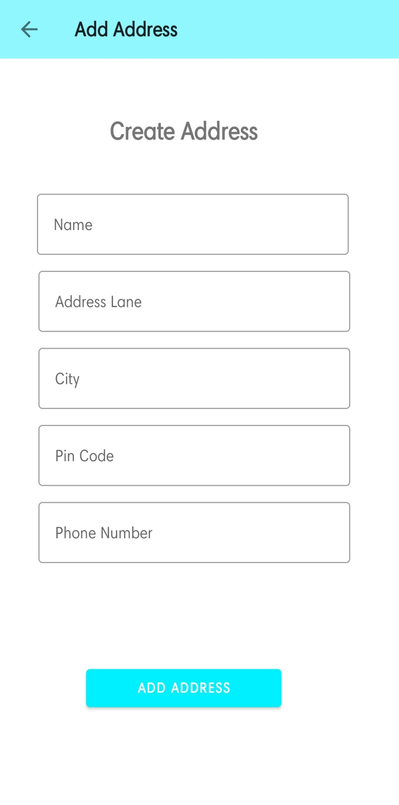

* Activity_address

*<?***xml version="1.0" encoding="utf-8"***?>*<**androidx.constraintlayout.widget.ConstraintLayout xmlns:android="http://schemas.android.com/apk/res/android"  
 xmlns:app="http://schemas.android.com/apk/res-auto"  
 xmlns:tools="http://schemas.android.com/tools"  
 android:layout_width="match_parent"  
 android:layout_height="match_parent"  
 tools:context=".activites.AddressActivity"**>  
  
 <**androidx.appcompat.widget.Toolbar  
 android:id="@+id/address_toolbar"  
 android:layout_width="match_parent"  
 android:layout_height="wrap_content"  
 android:background="#8FF7FD"  
 app:layout_constraintEnd_toEndOf="parent"  
 app:layout_constraintHorizontal_bias="0.0"  
 app:layout_constraintStart_toStartOf="parent"  
 app:layout_constraintTop_toTopOf="parent"  
 app:title="Your Address"** />  
  
  
 <**androidx.recyclerview.widget.RecyclerView  
 android:id="@+id/address_recycler"  
 android:layout_width="match_parent"  
 android:layout_height="wrap_content"  
 app:layout_constraintEnd_toEndOf="parent"  
 app:layout_constraintHorizontal_bias="1.0"  
 app:layout_constraintStart_toStartOf="parent"  
 app:layout_constraintTop_toBottomOf="@+id/address_toolbar"  
 tools:listitem="@layout/address_item"** />  
  
 <**Button  
 android:id="@+id/add_address_btn"  
 android:layout_width="match_parent"  
 android:layout_height="wrap_content"  
 android:layout_marginLeft="10dp"  
 android:layout_marginRight="10dp"  
 android:text="Add Address"  
 android:textColor="@color/white"  
 app:layout_constraintBottom_toTopOf="@+id/payment_btn"  
 app:layout_constraintEnd_toEndOf="parent"  
 app:layout_constraintStart_toStartOf="parent"** />  
  
 <**Button  
 android:id="@+id/payment_btn"  
 android:layout_width="match_parent"  
 android:layout_height="wrap_content"  
 android:layout_margin="10dp"  
 android:background="@color/blue"  
 android:text="Continue to payment"  
 android:textColor="@android:color/white"  
 app:layout_constraintBottom_toBottomOf="parent"  
 app:layout_constraintEnd_toEndOf="parent"  
 app:layout_constraintStart_toStartOf="parent"** />  
  
  
</**androidx.constraintlayout.widget.ConstraintLayout**>

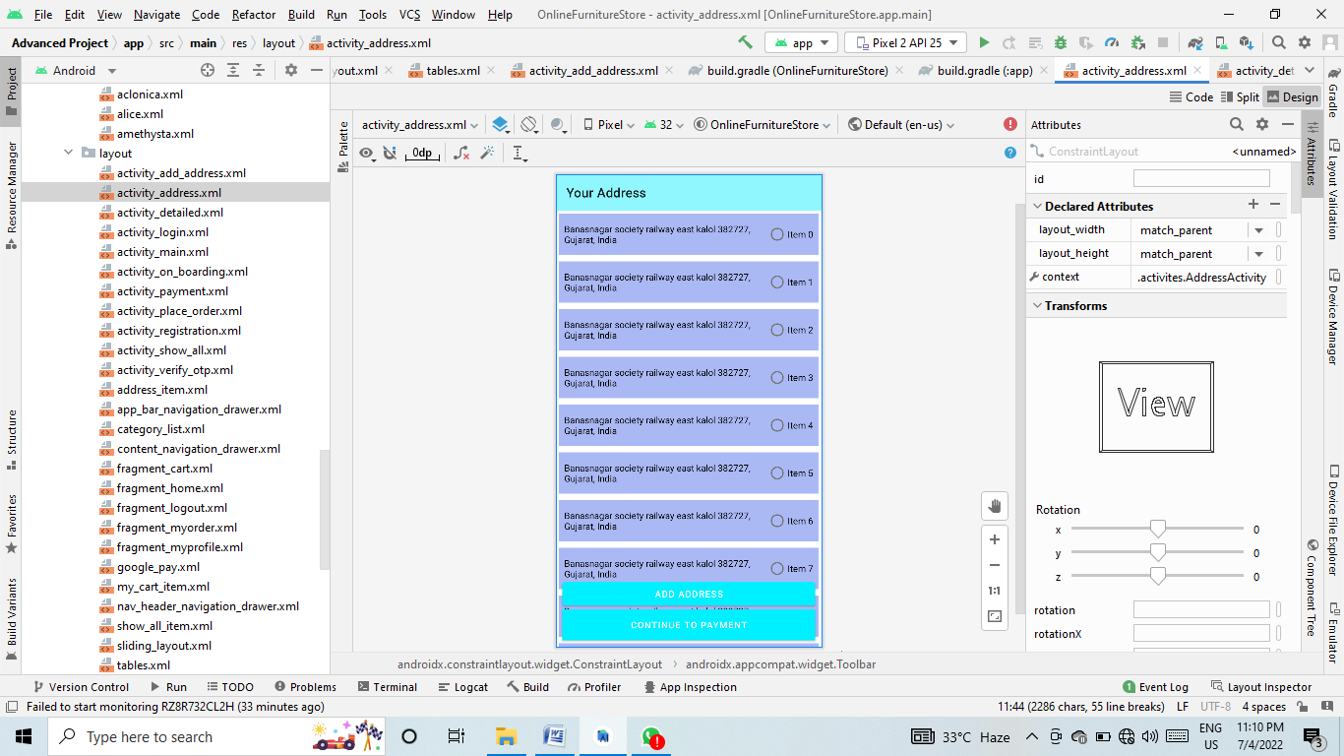

* Activity_detailed

*<?***xml version="1.0" encoding="utf-8"***?>*<**androidx.constraintlayout.widget.ConstraintLayout xmlns:android="http://schemas.android.com/apk/res/android"  
 xmlns:app="http://schemas.android.com/apk/res-auto"  
 xmlns:tools="http://schemas.android.com/tools"  
 android:layout_width="match_parent"  
 android:layout_height="match_parent"  
 tools:context=".activites.DetailedActivity"**>  
  
  
  
 <**ImageView  
 android:id="@+id/detailed_img"  
 android:layout_width="match_parent"  
 android:layout_height="250dp"  
 app:layout_constraintEnd_toEndOf="parent"  
 app:layout_constraintStart_toStartOf="parent"  
 app:layout_constraintTop_toTopOf="parent"  
 android:src="@drawable/ic_launcher_background"  
 android:scaleType="centerCrop"**/>  
  
 <**androidx.appcompat.widget.Toolbar  
 android:id="@+id/detailed_toolbar"  
 android:layout_width="match_parent"  
 android:layout_height="wrap_content"  
 app:layout_constraintEnd_toEndOf="parent"  
 app:layout_constraintStart_toStartOf="parent"  
 app:layout_constraintTop_toTopOf="parent"  
 app:title="Product Detailed"**/>  
  
 <**androidx.cardview.widget.CardView  
 android:transformPivotY="-50dp"  
 android:id="@+id/cardview"  
 android:layout_width="match_parent"  
 android:layout_height="wrap_content"  
 android:layout_marginLeft="20dp"  
 android:layout_marginRight="20dp"  
 app:cardCornerRadius="10dp"  
 android:elevation="10dp"  
 app:layout_constraintEnd_toEndOf="parent"  
 app:layout_constraintStart_toStartOf="parent"  
 app:layout_constraintTop_toBottomOf="@id/detailed_img"**>  
  
 <**LinearLayout  
 android:layout_width="match_parent"  
 android:layout_height="match_parent"  
 android:orientation="vertical"  
 android:layout_marginLeft="20dp"  
 android:layout_marginRight="20dp"**>  
  
 <**RelativeLayout  
 android:layout_width="match_parent"  
 android:layout_height="wrap_content"**>  
  
 <**TextView  
 android:id="@+id/detailed_name"  
 android:layout_width="wrap_content"  
 android:layout_height="wrap_content"  
 android:fontFamily="@font/amethysta"  
 android:text="Product Name"  
 android:textColor="@color/black"  
 android:textSize="25dp"  
 android:textStyle="bold"** />  
  
 <**TextView  
 android:id="@+id/detailed_rating"  
 android:layout_width="wrap_content"  
 android:layout_height="wrap_content"  
 android:layout_marginTop="8dp"  
 android:layout_toStartOf="@id/my_rating"  
 android:fontFamily="@font/amethysta"  
 android:text="4.0"  
 android:textColor="@color/black"  
 android:textSize="16sp"** />  
  
 <**RatingBar  
 android:id="@+id/my_rating"  
 android:layout_width="wrap_content"  
 android:layout_height="wrap_content"  
 android:isIndicator="true"  
 android:layout_marginTop="10dp"  
 android:numStars="5"  
 android:stepSize="0.1"  
 style="?android:ratingBarStyleSmall"  
 android:layout_alignParentRight="true"**/>  
  
  
 </**RelativeLayout**>  
  
 <**TextView  
 android:fontFamily="@font/amethysta"  
 android:id="@+id/detailed_desc"  
 android:layout_marginTop="10dp"  
 android:layout_width="wrap_content"  
 android:layout_height="wrap_content"  
 android:text="To Clean The Finish On Your Wood Furniture Just Use Warm Water, Cleaning Furniture With Water Won'T Hurt It Much Just Be Careful Not To Soak It. Wipe The Dirt Off The Surface With Soft Cloths Or Paper Towels Until They Come Up Fairly Clean. Avoid Direct Sunlight, Direct Water Splashing. Do Not Use Harsh Chemicals Or Abrasive Clothes While Cleaning. Do Not Scratch With Sharp Objects."**/>  
  
 <**TextView  
 android:layout_width="wrap_content"  
 android:layout_height="wrap_content"  
 android:text="Price"  
 android:textSize="21sp"  
 android:layout_gravity="center"  
 android:layout_marginTop="10dp"  
 android:textColor="@color/black"  
 android:textStyle="bold"  
 android:fontFamily="@font/amethysta"**/>  
  
 <**LinearLayout  
 android:layout_width="match_parent"  
 android:layout_height="wrap_content"  
 android:orientation="horizontal"  
 android:gravity="center"**>  
  
 <**TextView  
 android:layout_width="wrap_content"  
 android:layout_height="wrap_content"  
 android:text="₹"  
 android:textStyle="bold"  
 android:fontFamily="@font/amethysta"  
 android:textColor="@color/purple_700"**/>  
  
 <**TextView  
 android:id="@+id/detailed_price"  
 android:layout_width="wrap_content"  
 android:layout_height="wrap_content"  
 android:text="50"  
 android:textStyle="bold"  
 android:fontFamily="@font/amethysta"  
 android:textColor="@color/purple_700"**/>  
  
  
 </**LinearLayout**>  
  
 <**LinearLayout  
 android:layout_width="match_parent"  
 android:layout_height="wrap_content"  
 android:orientation="horizontal"  
 android:gravity="center_horizontal"  
 android:layout_margin="10dp"**>  
  
 <**ImageView  
 android:layout_marginRight="7dp"  
 android:layout_width="40dp"  
 android:layout_height="40dp"  
 android:src="@drawable/plusicon"  
 android:id="@+id/add_item"**/>  
  
 <**TextView  
 android:id="@+id/quantity"  
 android:layout_width="wrap_content"  
 android:layout_height="wrap_content"  
 android:text="1"  
 android:textSize="30sp"  
 android:textStyle="bold"**/>  
  
  
 <**ImageView  
 android:layout_marginRight="7dp"  
 android:layout_width="40dp"  
 android:layout_height="40dp"  
 android:src="@drawable/iconminus"  
 android:id="@+id/remove_item"**/>  
  
 </**LinearLayout**>  
  
 </**LinearLayout**>  
  
 </**androidx.cardview.widget.CardView**>  
  
 <**Button  
 android:backgroundTint="@color/pink"  
 android:id="@+id/add_to_cart"  
 android:layout_width="0dp"  
 android:layout_height="wrap_content"  
 android:text="Add To Cart"  
 android:textStyle="bold"  
 android:drawableLeft="@drawable/mycart"  
 android:drawableTint="@color/white"  
 android:textAllCaps="false"  
 app:layout_constraintBottom_toTopOf="@id/buy_now"  
 app:layout_constraintEnd_toEndOf="parent"  
 app:layout_constraintStart_toStartOf="parent"  
 app:layout_constraintTop_toBottomOf="@id/cardview"  
 app:layout_constraintWidth_percent=".8"  
 app:layout_constraintVertical_bias="1"  
 android:padding="14dp"**/>  
  
 <**Button  
 android:id="@+id/buy_now"  
 android:layout_width="0dp"  
 android:layout_height="wrap_content"  
 android:text="Buy Now"  
 android:textStyle="bold"  
 android:drawableLeft="@drawable/ic_baseline_shopping_cart_24"  
 android:drawableTint="@color/white"  
 android:padding="14dp"  
 android:textAllCaps="false"  
 app:layout_constraintBottom_toBottomOf="parent"  
 app:layout_constraintEnd_toEndOf="parent"  
 app:layout_constraintStart_toStartOf="parent"  
 app:layout_constraintWidth_percent=".8"** />  
  
</**androidx.constraintlayout.widget.ConstraintLayout**>

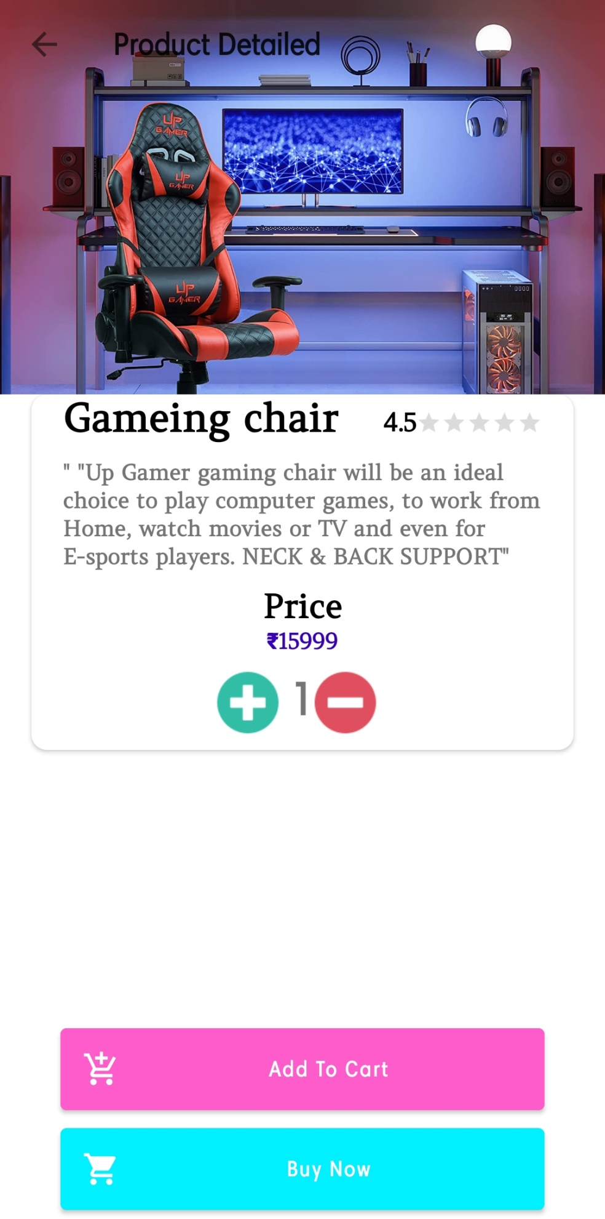

* Activity_login

*<?***xml version="1.0" encoding="utf-8"***?>*<**androidx.constraintlayout.widget.ConstraintLayout xmlns:android="http://schemas.android.com/apk/res/android"  
 xmlns:app="http://schemas.android.com/apk/res-auto"  
 xmlns:tools="http://schemas.android.com/tools"  
 android:layout_width="match_parent"  
 android:layout_height="match_parent"  
 android:background="@drawable/bggg"  
 tools:context=".activites.LoginActivity"**>  
  
  
  
  
 <**TextView  
 android:id="@+id/textView2"  
 android:layout_width="wrap_content"  
 android:layout_height="wrap_content"  
 android:fontFamily="@font/aclonica"  
 android:text="Sign In"  
 android:textSize="40sp"  
 android:textStyle="bold"  
 android:textColor="@color/textHeading"  
 app:layout_constraintBottom_toBottomOf="parent"  
 app:layout_constraintEnd_toEndOf="parent"  
 app:layout_constraintStart_toStartOf="parent"  
 app:layout_constraintTop_toTopOf="parent"  
 app:layout_constraintVertical_bias="0.2"**/>  
  
  
 <**EditText  
 android:id="@+id/email"  
 android:inputType="textPersonName"  
 android:layout_width="0dp"  
 android:layout_height="wrap_content"  
 android:layout_marginTop="8dp"  
 android:background="@drawable/edit_text_bg"  
 android:drawableLeft="@drawable/ic_baseline_account_circle"  
 android:drawablePadding="10dp"  
 android:elevation="3dp"  
 android:hint="Email"  
 android:padding="15dp"  
 app:layout_constraintEnd_toEndOf="parent"  
 app:layout_constraintStart_toStartOf="parent"  
 app:layout_constraintTop_toBottomOf="@id/textView2"  
 app:layout_constraintWidth_percent=".8"**/>  
  
 <**EditText  
 android:id="@+id/password"  
 android:inputType="textPassword"  
 android:layout_width="0dp"  
 android:layout_height="wrap_content"  
 android:layout_marginTop="8dp"  
 android:background="@drawable/edit_text_bg"  
 android:drawableLeft="@drawable/ic_baseline_vpn_key_24"  
 android:drawablePadding="10dp"  
 android:elevation="3dp"  
 android:hint="Password"  
 android:padding="15dp"  
 app:layout_constraintEnd_toEndOf="parent"  
 app:layout_constraintStart_toStartOf="parent"  
 app:layout_constraintTop_toBottomOf="@id/email"  
 app:layout_constraintWidth_percent=".8"**/>  
  
  
  
 <**Button  
 android:backgroundTint="@color/pink"  
 android:id="@+id/loginBtn"  
 android:layout_width="0dp"  
 android:layout_height="wrap_content"  
 android:padding="15dp"  
 android:text="Sign In"  
 android:textAllCaps="false"  
 android:textStyle="bold"  
 app:layout_constraintBottom_toBottomOf="parent"  
 app:layout_constraintEnd_toEndOf="parent"  
 app:layout_constraintStart_toStartOf="parent"  
 app:layout_constraintTop_toBottomOf="@+id/password"  
 app:layout_constraintVertical_bias=".2"  
 app:layout_constraintWidth_percent=".4"**/>  
  
 <**TextView  
 android:id="@+id/createText2"  
 android:layout_width="wrap_content"  
 android:layout_height="wrap_content"  
 android:text="Don't have An Account? Sign Up"  
 android:textColor="@color/blue"  
 android:textSize="17sp"  
 app:layout_constraintBottom_toBottomOf="parent"  
 app:layout_constraintEnd_toEndOf="@id/password"  
 app:layout_constraintHorizontal_bias=".3"  
 app:layout_constraintStart_toStartOf="@id/password"  
 app:layout_constraintTop_toBottomOf="@+id/loginBtn"  
 app:layout_constraintVertical_bias="0.2"** />  
  
  
 <**TextView  
 android:id="@+id/forgetPassword"  
 android:layout_width="wrap_content"  
 android:layout_height="wrap_content"  
 android:layout_marginTop="16dp"  
 android:textSize="17sp"  
 android:text="Forgot Password ?"  
 android:textColor="@color/pink"  
 app:layout_constraintEnd_toEndOf="parent"  
 app:layout_constraintStart_toStartOf="parent"  
 app:layout_constraintTop_toBottomOf="@+id/createText2"** />  
  
 <**ProgressBar  
 android:id="@+id/progressBar"  
 style="?android:attr/progressBarStyle"  
 android:layout_width="wrap_content"  
 android:layout_height="wrap_content"  
 android:layout_marginTop="68dp"  
 android:visibility="invisible"  
 app:layout_constraintEnd_toEndOf="parent"  
 app:layout_constraintHorizontal_bias="0.498"  
 app:layout_constraintStart_toStartOf="parent"  
 app:layout_constraintTop_toTopOf="@+id/createText2"** />  
  
</**androidx.constraintlayout.widget.ConstraintLayout**>

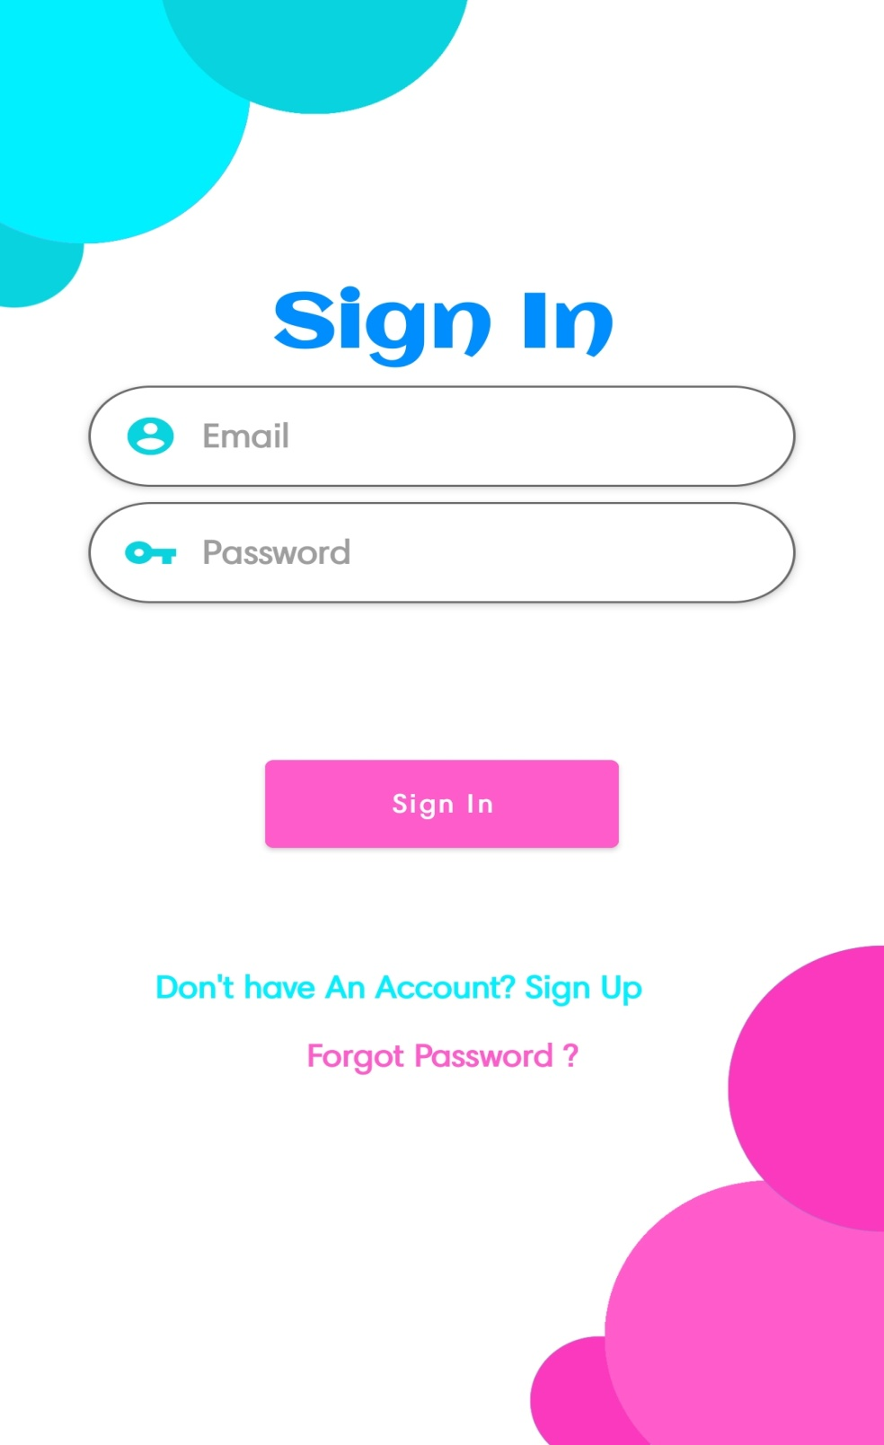

* Activity_main

*<?***xml version="1.0" encoding="utf-8"***?>*<**androidx.drawerlayout.widget.DrawerLayout xmlns:android="http://schemas.android.com/apk/res/android"  
 xmlns:app="http://schemas.android.com/apk/res-auto"  
 xmlns:tools="http://schemas.android.com/tools"  
 android:id="@+id/drawer_layout"  
 android:layout_width="match_parent"  
 android:layout_height="match_parent"  
 android:fitsSystemWindows="true"  
 tools:openDrawer="start"**>  
  
  
 <**include  
 android:id="@+id/app_bar_navigation_drawer"  
 layout="@layout/app_bar_navigation_drawer"  
 android:layout_width="match_parent"  
 android:layout_height="match_parent"** />  
  
 <**com.google.android.material.navigation.NavigationView  
 android:id="@+id/nav_view"  
 android:layout_width="wrap_content"  
 android:layout_height="match_parent"  
 android:layout_gravity="start"  
 android:fitsSystemWindows="true"  
 app:headerLayout="@layout/nav_header_navigation_drawer"  
 app:menu="@menu/activity_main_drawer"**/>  
</**androidx.drawerlayout.widget.DrawerLayout**>

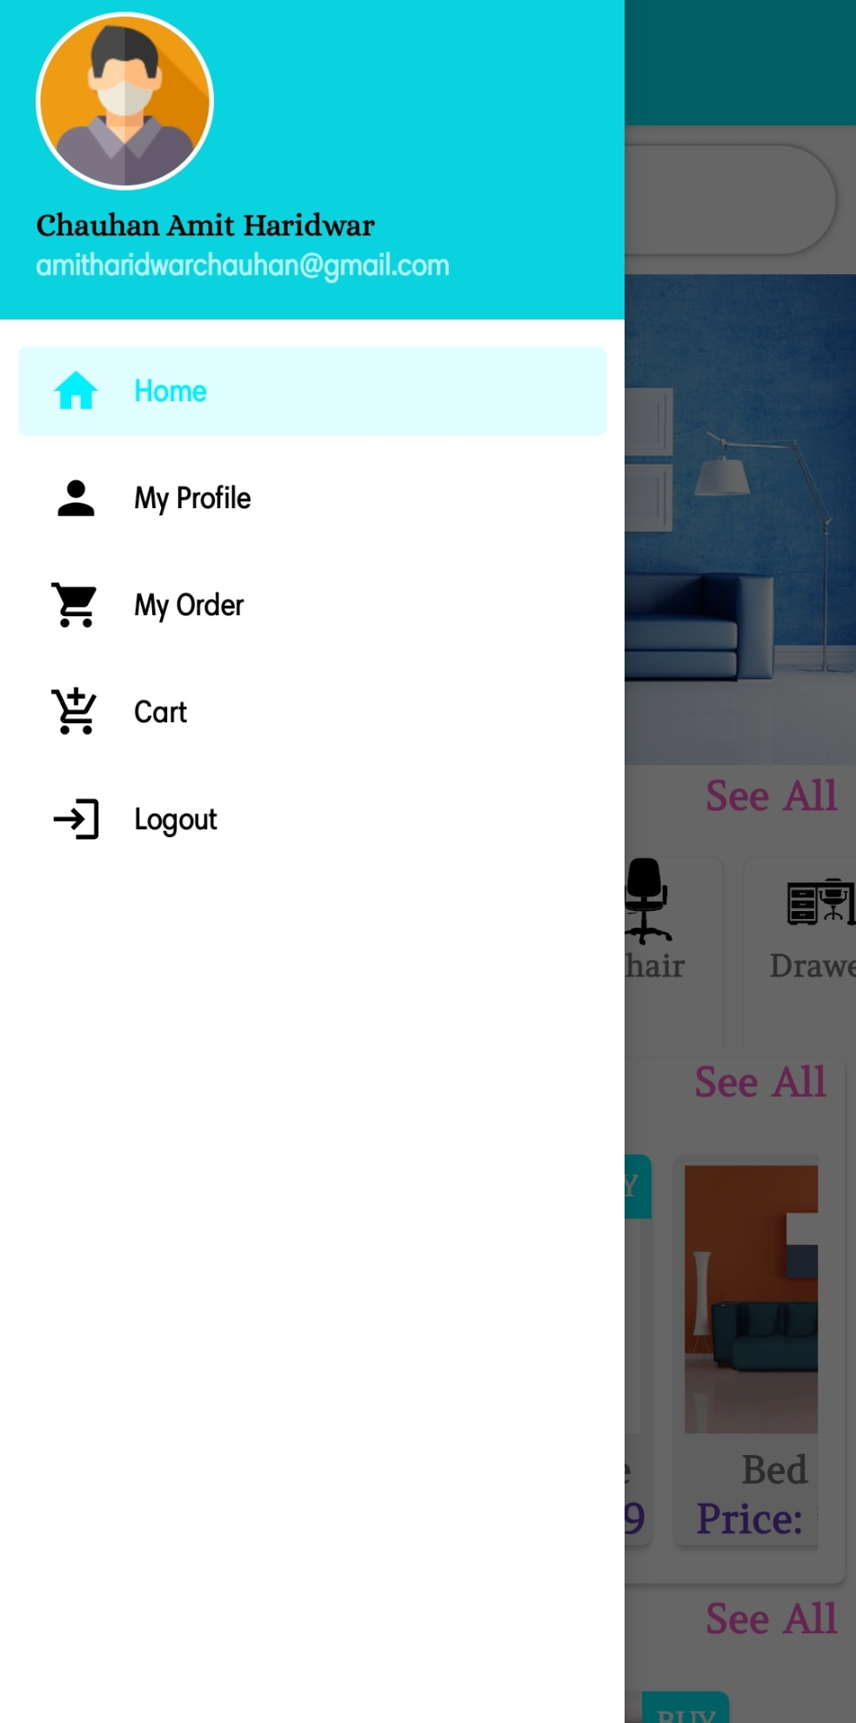

* Activity_on_boarding

*<?***xml version="1.0" encoding="utf-8"***?>*<**androidx.constraintlayout.widget.ConstraintLayout xmlns:android="http://schemas.android.com/apk/res/android"  
 xmlns:app="http://schemas.android.com/apk/res-auto"  
 xmlns:tools="http://schemas.android.com/tools"  
 android:layout_width="match_parent"  
 android:layout_height="match_parent"  
 android:padding="20dp"  
 tools:context=".activites.OnBoardingActivity"**>  
  
  
 <**androidx.viewpager.widget.ViewPager  
 android:id="@+id/slider"  
 android:layout_width="match_parent"  
 android:layout_height="0dp"  
 app:layout_constraintBottom_toTopOf="@+id/relativeLayout1"  
 app:layout_constraintEnd_toEndOf="parent"  
 app:layout_constraintStart_toStartOf="parent"  
 app:layout_constraintTop_toTopOf="parent"** />  
  
 <**RelativeLayout  
 android:id="@+id/relativeLayout1"  
 android:layout_width="match_parent"  
 android:layout_height="150dp"  
 app:layout_constraintBottom_toBottomOf="parent"  
 app:layout_constraintEnd_toEndOf="parent"  
 app:layout_constraintStart_toStartOf="parent"**>  
  
 <**Button  
 android:id="@+id/get_started_btn"  
 android:layout_width="match_parent"  
 android:layout_height="wrap_content"  
 android:padding="10dp"  
 android:text="Lets get started"  
 android:visibility="invisible"** />  
  
 <**LinearLayout  
 android:id="@+id/dots"  
 android:layout_width="wrap_content"  
 android:layout_height="wrap_content"  
 android:layout_alignParentBottom="true"  
 android:orientation="horizontal"  
 android:paddingBottom="20dp"** />  
  
 <**Button  
 android:id="@+id/next_btn"  
 android:layout_width="wrap_content"  
 android:layout_height="wrap_content"  
 android:layout_alignParentRight="true"  
 android:layout_alignParentBottom="true"  
 android:background="#00000000"  
 android:drawableEnd="@drawable/ic_baseline_arrow_forward_ios_24"  
 android:paddingBottom="30dp"** />  
  
  
 </**RelativeLayout**>  
  
</**androidx.constraintlayout.widget.ConstraintLayout**>

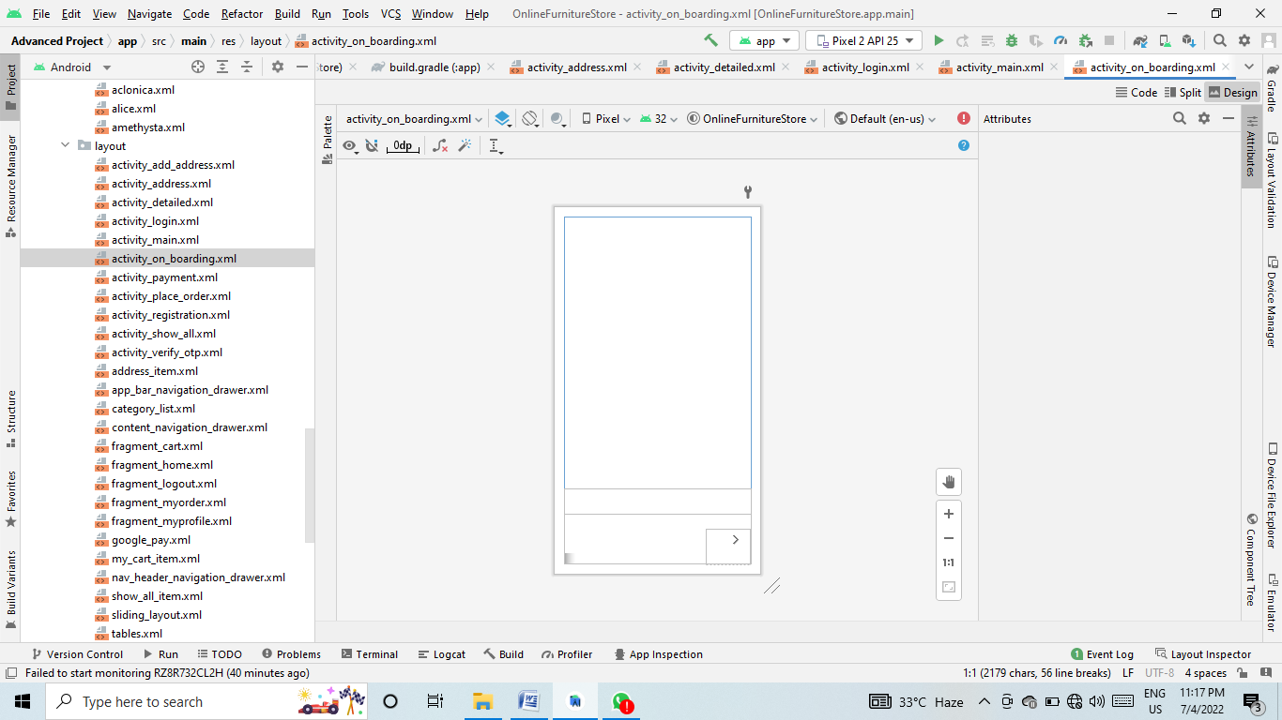

* Activity_payment

*<?***xml version="1.0" encoding="utf-8"***?>*<**androidx.constraintlayout.widget.ConstraintLayout xmlns:android="http://schemas.android.com/apk/res/android"  
 xmlns:app="http://schemas.android.com/apk/res-auto"  
 xmlns:tools="http://schemas.android.com/tools"  
 android:layout_width="match_parent"  
 android:layout_height="match_parent"  
 tools:context=".activites.PaymentActivity"**>  
  
 <**androidx.appcompat.widget.Toolbar  
 android:id="@+id/payment_toolbar"  
 android:background="#8FF7FD"  
 android:layout_width="match_parent"  
 android:layout_height="wrap_content"  
 app:layout_constraintEnd_toEndOf="parent"  
 app:layout_constraintHorizontal_bias="0.0"  
 app:layout_constraintStart_toStartOf="parent"  
 app:layout_constraintTop_toTopOf="parent"  
 app:title="Payment Detailed"**/>  
  
  
  
 <**ImageView  
 android:id="@+id/imageView3"  
 android:layout_width="340dp"  
 android:layout_height="244dp"  
 android:layout_marginTop="24dp"  
 app:layout_constraintEnd_toEndOf="parent"  
 app:layout_constraintHorizontal_bias="0.434"  
 app:layout_constraintStart_toStartOf="parent"  
 app:layout_constraintTop_toBottomOf="@+id/payment_toolbar"  
 app:srcCompat="@drawable/card_prev"** />  
  
 <**TextView  
 android:id="@+id/textView12"  
 android:layout_width="wrap_content"  
 android:layout_height="wrap_content"  
 android:layout_marginStart="84dp"  
 android:text="Subtotal"  
 android:textSize="18sp"  
 app:layout_constraintStart_toStartOf="parent"  
 app:layout_constraintTop_toBottomOf="@+id/imageView3"** />  
  
 <**TextView  
 android:id="@+id/textView14"  
 android:layout_width="wrap_content"  
 android:layout_height="wrap_content"  
 android:layout_marginTop="12dp"  
 android:text="Discount"  
 android:textSize="18sp"  
 app:layout_constraintEnd_toEndOf="@+id/textView12"  
 app:layout_constraintStart_toStartOf="@+id/textView12"  
 app:layout_constraintTop_toBottomOf="@+id/textView12"** />  
  
 <**TextView  
 android:id="@+id/textView15"  
 android:layout_width="wrap_content"  
 android:layout_height="wrap_content"  
 android:layout_marginTop="12dp"  
 android:text="Shipping"  
 android:textSize="18sp"  
 app:layout_constraintEnd_toEndOf="@+id/textView14"  
 app:layout_constraintStart_toStartOf="@+id/textView14"  
 app:layout_constraintTop_toBottomOf="@+id/textView14"** />  
 <**TextView  
 android:id="@+id/sub_total"  
 android:layout_width="wrap_content"  
 android:layout_height="wrap_content"  
 android:layout_marginEnd="84dp"  
 android:text="₹ 0"  
 android:textSize="18sp"  
 app:layout_constraintEnd_toEndOf="parent"  
 app:layout_constraintTop_toBottomOf="@+id/imageView3"** />  
  
 <**TextView  
 android:id="@+id/textView17"  
 android:layout_width="wrap_content"  
 android:layout_height="wrap_content"  
 android:layout_marginTop="12dp"  
 android:text="₹ 0"  
 android:textSize="18sp"  
 app:layout_constraintEnd_toEndOf="@+id/sub_total"  
 app:layout_constraintStart_toStartOf="@+id/sub_total"  
 app:layout_constraintTop_toBottomOf="@+id/sub_total"** />  
  
 <**TextView  
 android:id="@+id/textView18"  
 android:layout_width="wrap_content"  
 android:layout_height="wrap_content"  
 android:layout_marginTop="12dp"  
 android:text="₹ 0"  
 android:textSize="18sp"  
 app:layout_constraintEnd_toEndOf="@+id/textView17"  
 app:layout_constraintStart_toStartOf="@+id/textView17"  
 app:layout_constraintTop_toBottomOf="@+id/textView17"** />  
  
 <**View  
 android:id="@+id/divider5"  
 android:layout_width="430dp"  
 android:layout_height="1dp"  
 android:layout_marginTop="24dp"  
 android:background="?android:attr/listDivider"  
 app:layout_constraintEnd_toEndOf="parent"  
 app:layout_constraintStart_toStartOf="parent"  
 app:layout_constraintTop_toBottomOf="@+id/textView15"** />  
  
 <**TextView  
 android:id="@+id/textView19"  
 android:layout_width="wrap_content"  
 android:layout_height="wrap_content"  
 android:layout_marginStart="76dp"  
 android:layout_marginTop="18dp"  
 android:text="Total"  
 app:layout_constraintStart_toStartOf="parent"  
 app:layout_constraintTop_toBottomOf="@+id/divider5"** />  
  
 <**TextView  
 android:id="@+id/total_amt"  
 android:layout_width="wrap_content"  
 android:layout_height="wrap_content"  
 android:layout_marginTop="18dp"  
 android:layout_marginEnd="76dp"  
 android:text="₹ 00"  
 app:layout_constraintEnd_toEndOf="parent"  
 app:layout_constraintTop_toBottomOf="@+id/divider5"** />  
  
 <**Button  
 android:id="@+id/pay_btn"  
 android:layout_width="wrap_content"  
 android:layout_height="wrap_content"  
 android:layout_marginTop="44dp"  
 android:text="Check Out"  
 android:textStyle="bold"  
 android:textColor="@android:color/white"  
 app:layout_constraintEnd_toEndOf="parent"  
 app:layout_constraintHorizontal_bias="0.504"  
 app:layout_constraintStart_toStartOf="parent"  
 app:layout_constraintTop_toBottomOf="@+id/textView19"** />  
  
</**androidx.constraintlayout.widget.ConstraintLayout**>

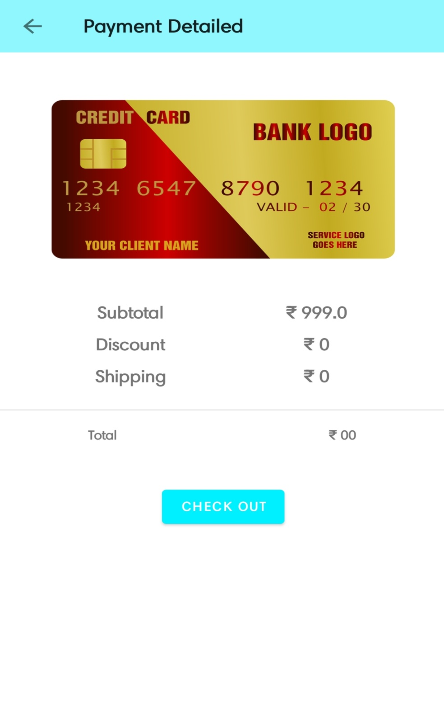

* activity_place_order
* *<?***xml version="1.0" encoding="utf-8"***?>*<**androidx.constraintlayout.widget.ConstraintLayout xmlns:android="http://schemas.android.com/apk/res/android"  
   xmlns:app="http://schemas.android.com/apk/res-auto"  
   xmlns:tools="http://schemas.android.com/tools"  
   android:layout_width="match_parent"  
   android:layout_height="match_parent"  
   tools:context=".activites.PlaceOrderActivity"  
   android:background="#4500E5FF"**>  
    
   <**TextView  
   android:id="@+id/textView3"  
   android:layout_width="match_parent"  
   android:layout_height="wrap_content"  
   android:fontFamily="@font/aclonica"  
   android:gravity="center"  
   android:text="Your Order Has Been Placed"  
   android:textSize="20sp"  
   android:textColor="@color/pink"  
   android:textStyle="bold"  
   app:layout_constraintBottom_toBottomOf="parent"  
   app:layout_constraintEnd_toEndOf="parent"  
   app:layout_constraintHorizontal_bias="0.0"  
   app:layout_constraintStart_toStartOf="parent"  
   app:layout_constraintTop_toTopOf="parent"  
   app:layout_constraintVertical_bias="0.103"** />  
    
   <**ImageView  
   android:id="@+id/place_img"  
   android:layout_width="416dp"  
   android:layout_height="314dp"  
   android:src="@drawable/onboardscreen1"  
   app:layout_constraintBottom_toBottomOf="parent"  
   app:layout_constraintEnd_toEndOf="parent"  
   app:layout_constraintHorizontal_bias="0.0"  
   app:layout_constraintStart_toStartOf="parent"  
   app:layout_constraintTop_toBottomOf="@+id/textView3"  
   app:layout_constraintVertical_bias="0.054"** />  
    
   <**TextView  
   android:layout_width="match_parent"  
   android:layout_height="wrap_content"  
   android:fontFamily="@font/alice"  
   android:gravity="center"  
   android:text="Thank you for purchasing our product \n Please Come again"  
   android:textSize="20sp"  
   android:textColor="@color/pink"  
   android:textStyle="bold"  
   app:layout_constraintBottom_toBottomOf="parent"  
   app:layout_constraintEnd_toEndOf="parent"  
   app:layout_constraintHorizontal_bias="0.0"  
   app:layout_constraintStart_toStartOf="parent"  
   app:layout_constraintTop_toBottomOf="@+id/place_img"  
   app:layout_constraintVertical_bias="0.322"** />  
    
    
  </**androidx.constraintlayout.widget.ConstraintLayout**>

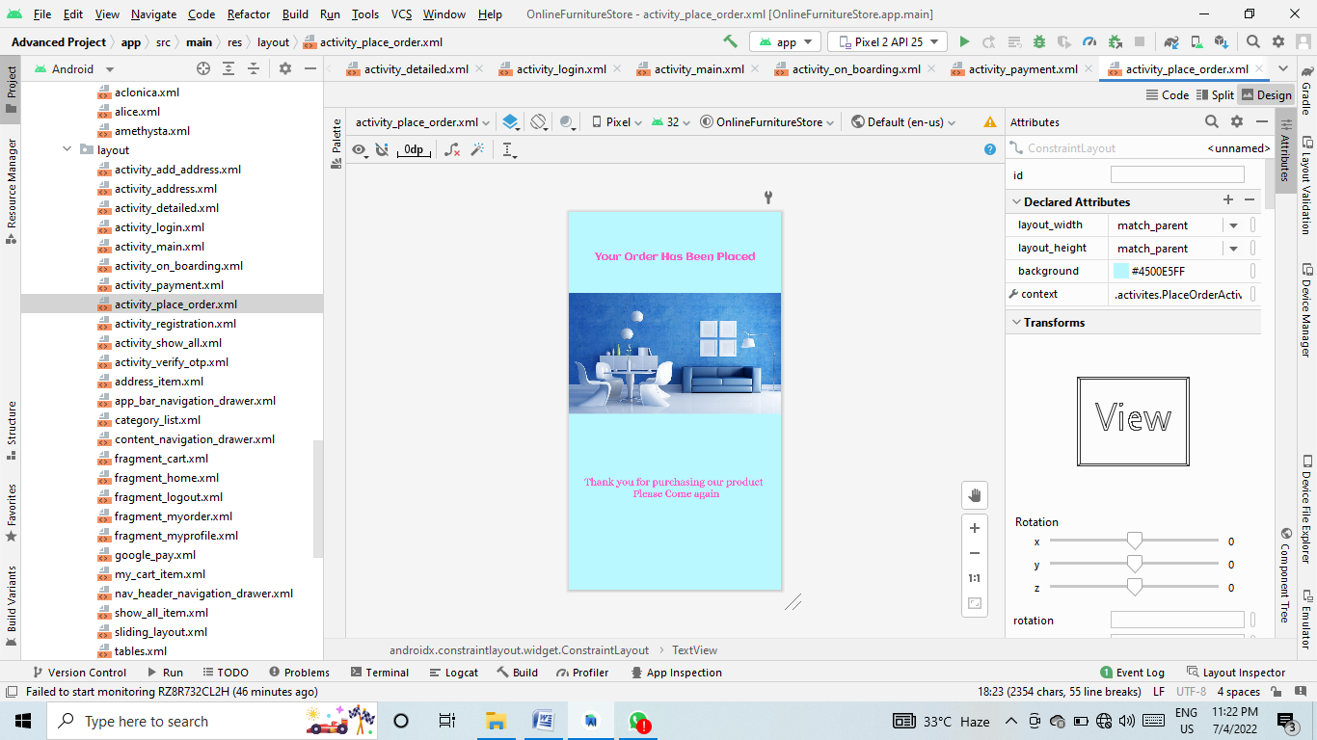

* activity_registration

*<?***xml version="1.0" encoding="utf-8"***?>*<**androidx.constraintlayout.widget.ConstraintLayout xmlns:android="http://schemas.android.com/apk/res/android"  
 xmlns:app="http://schemas.android.com/apk/res-auto"  
 xmlns:tools="http://schemas.android.com/tools"  
 android:layout_width="match_parent"  
 android:layout_height="match_parent"  
 android:background="@drawable/designlogin"  
 android:visibility="visible"  
 tools:context=".activites.RegistrationActivity"**>  
  
  
  
 <**TextView  
 android:id="@+id/textView2"  
 android:layout_width="wrap_content"  
 android:layout_height="wrap_content"  
 android:fontFamily="@font/aclonica"  
 android:text="Sign Up"  
 android:textSize="40sp"  
 android:textStyle="bold"  
 android:textColor="@color/textHeading"  
 app:layout_constraintBottom_toBottomOf="parent"  
 app:layout_constraintEnd_toEndOf="parent"  
 app:layout_constraintStart_toStartOf="parent"  
 app:layout_constraintTop_toTopOf="parent"  
 app:layout_constraintVertical_bias="0.2"**/>  
  
 <**EditText  
 android:id="@+id/fullName"  
 android:inputType="textPersonName"  
 android:layout_width="0dp"  
 android:layout_height="wrap_content"  
 android:layout_marginTop="8dp"  
 android:background="@drawable/edit_text_bg"  
 android:drawableLeft="@drawable/ic_baseline_person_24"  
 android:drawablePadding="10dp"  
 android:elevation="3dp"  
 android:hint="Full Name"  
 android:padding="15dp"  
 app:layout_constraintEnd_toEndOf="parent"  
 app:layout_constraintStart_toStartOf="parent"  
 app:layout_constraintTop_toBottomOf="@id/textView2"  
 app:layout_constraintWidth_percent=".8"**/>  
  
 <**EditText  
 android:id="@+id/phone"  
 android:layout_width="0dp"  
 android:layout_height="wrap_content"  
 android:layout_marginTop="8dp"  
 android:background="@drawable/edit_text_bg"  
 android:drawableLeft="@drawable/ic_baseline_phone_24"  
 android:drawablePadding="10dp"  
 android:elevation="3dp"  
 android:hint="Phone"  
 android:inputType="number"  
 android:padding="15dp"  
 app:layout_constraintEnd_toEndOf="parent"  
 app:layout_constraintStart_toStartOf="parent"  
 app:layout_constraintTop_toBottomOf="@id/fullName"  
 app:layout_constraintWidth_percent=".8"** />  
  
 <**EditText  
 android:id="@+id/email"  
 android:inputType="textPersonName"  
 android:layout_width="0dp"  
 android:layout_height="wrap_content"  
 android:layout_marginTop="8dp"  
 android:background="@drawable/edit_text_bg"  
 android:drawableLeft="@drawable/ic_baseline_account_circle"  
 android:drawablePadding="10dp"  
 android:elevation="3dp"  
 android:hint="Email"  
 android:padding="15dp"  
 app:layout_constraintEnd_toEndOf="parent"  
 app:layout_constraintStart_toStartOf="parent"  
 app:layout_constraintTop_toBottomOf="@id/phone"  
 app:layout_constraintWidth_percent=".8"**/>  
  
 <**EditText  
 android:id="@+id/password"  
 android:inputType="textPassword"  
 android:layout_width="0dp"  
 android:layout_height="wrap_content"  
 android:layout_marginTop="8dp"  
 android:background="@drawable/edit_text_bg"  
 android:drawableLeft="@drawable/ic_baseline_vpn_key_24"  
 android:drawablePadding="10dp"  
 android:elevation="3dp"  
 android:hint="Password"  
 android:padding="15dp"  
 app:layout_constraintEnd_toEndOf="parent"  
 app:layout_constraintStart_toStartOf="parent"  
 app:layout_constraintTop_toBottomOf="@id/email"  
 app:layout_constraintWidth_percent=".8"**/>  
  
 <**EditText  
 android:id="@+id/conf_password"  
 android:inputType="textPassword"  
 android:layout_width="0dp"  
 android:layout_height="wrap_content"  
 android:layout_marginTop="8dp"  
 android:background="@drawable/edit_text_bg"  
 android:drawableLeft="@drawable/ic_baseline_vpn_key_24"  
 android:drawablePadding="10dp"  
 android:elevation="3dp"  
 android:hint="Conform password"  
 android:padding="15dp"  
 app:layout_constraintEnd_toEndOf="parent"  
 app:layout_constraintStart_toStartOf="parent"  
 app:layout_constraintTop_toBottomOf="@id/password"  
 app:layout_constraintWidth_percent=".8"**/>  
  
 <**Button  
 android:id="@+id/registerBtn"  
 android:layout_width="0dp"  
 android:layout_height="wrap_content"  
 android:text="Sign Up"  
 android:padding="15dp"  
 android:textAllCaps="false"  
 android:textStyle="bold"  
 app:layout_constraintBottom_toBottomOf="parent"  
 app:layout_constraintEnd_toEndOf="parent"  
 app:layout_constraintStart_toStartOf="parent"  
 app:layout_constraintTop_toBottomOf="@+id/conf_password"  
 app:layout_constraintVertical_bias=".2"  
 app:layout_constraintWidth_percent=".4"**/>  
  
 <**TextView  
 android:id="@+id/createText"  
 android:layout_width="wrap_content"  
 android:layout_height="wrap_content"  
 android:text="Already Have An Account? Sign In"  
 android:textColor="@color/pink"  
 android:textSize="17sp"  
 app:layout_constraintBottom_toBottomOf="parent"  
 app:layout_constraintEnd_toEndOf="@id/conf_password"  
 app:layout_constraintHorizontal_bias="0.63"  
 app:layout_constraintStart_toStartOf="@id/conf_password"  
 app:layout_constraintTop_toBottomOf="@+id/registerBtn"  
 app:layout_constraintVertical_bias="0.192"** />  
  
 <**ProgressBar  
 android:id="@+id/progressBar"  
 style="?android:attr/progressBarStyle"  
 android:layout_width="wrap_content"  
 android:layout_height="wrap_content"  
 android:layout_marginTop="40dp"  
 android:visibility="invisible"  
 app:layout_constraintEnd_toEndOf="parent"  
 app:layout_constraintHorizontal_bias="0.498"  
 app:layout_constraintStart_toStartOf="parent"  
 app:layout_constraintTop_toTopOf="@+id/createText"** />  
  
  
</**androidx.constraintlayout.widget.ConstraintLayout**>

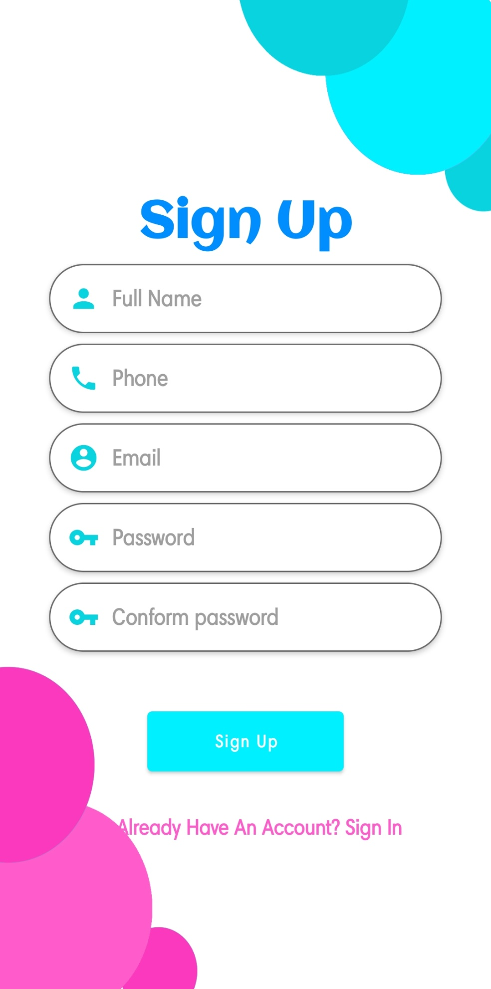

* Activity_show_all
* *<?***xml version="1.0" encoding="utf-8"***?>*<**androidx.constraintlayout.widget.ConstraintLayout xmlns:android="http://schemas.android.com/apk/res/android"  
   xmlns:app="http://schemas.android.com/apk/res-auto"  
   xmlns:tools="http://schemas.android.com/tools"  
   android:layout_width="match_parent"  
   android:layout_height="match_parent"  
   android:padding="5dp"  
   tools:context=".activites.ShowAllActivity"**>  
    
   <**androidx.appcompat.widget.Toolbar  
   android:id="@+id/show_all_toolbar"  
   android:layout_width="match_parent"  
   android:layout_height="wrap_content"  
   app:layout_constraintEnd_toEndOf="parent"  
   app:layout_constraintStart_toStartOf="parent"  
   app:layout_constraintTop_toTopOf="parent"  
   android:background="#8ff7fd"  
   android:minHeight="?attr/actionBarSize"  
   android:theme="?attr/actionBarTheme"  
   app:title="All Products"**/>  
    
    
   <**androidx.recyclerview.widget.RecyclerView  
   android:layout_width="match_parent"  
   android:layout_height="wrap_content"  
   android:id="@+id/show_all_rec"  
   app:layout_constraintHorizontal_bias="0.0"  
   app:layout_constraintEnd_toEndOf="parent"  
   app:layout_constraintStart_toStartOf="parent"  
   app:layout_constraintTop_toBottomOf="@id/show_all_toolbar"**/>  
    
  </**androidx.constraintlayout.widget.ConstraintLayout**>

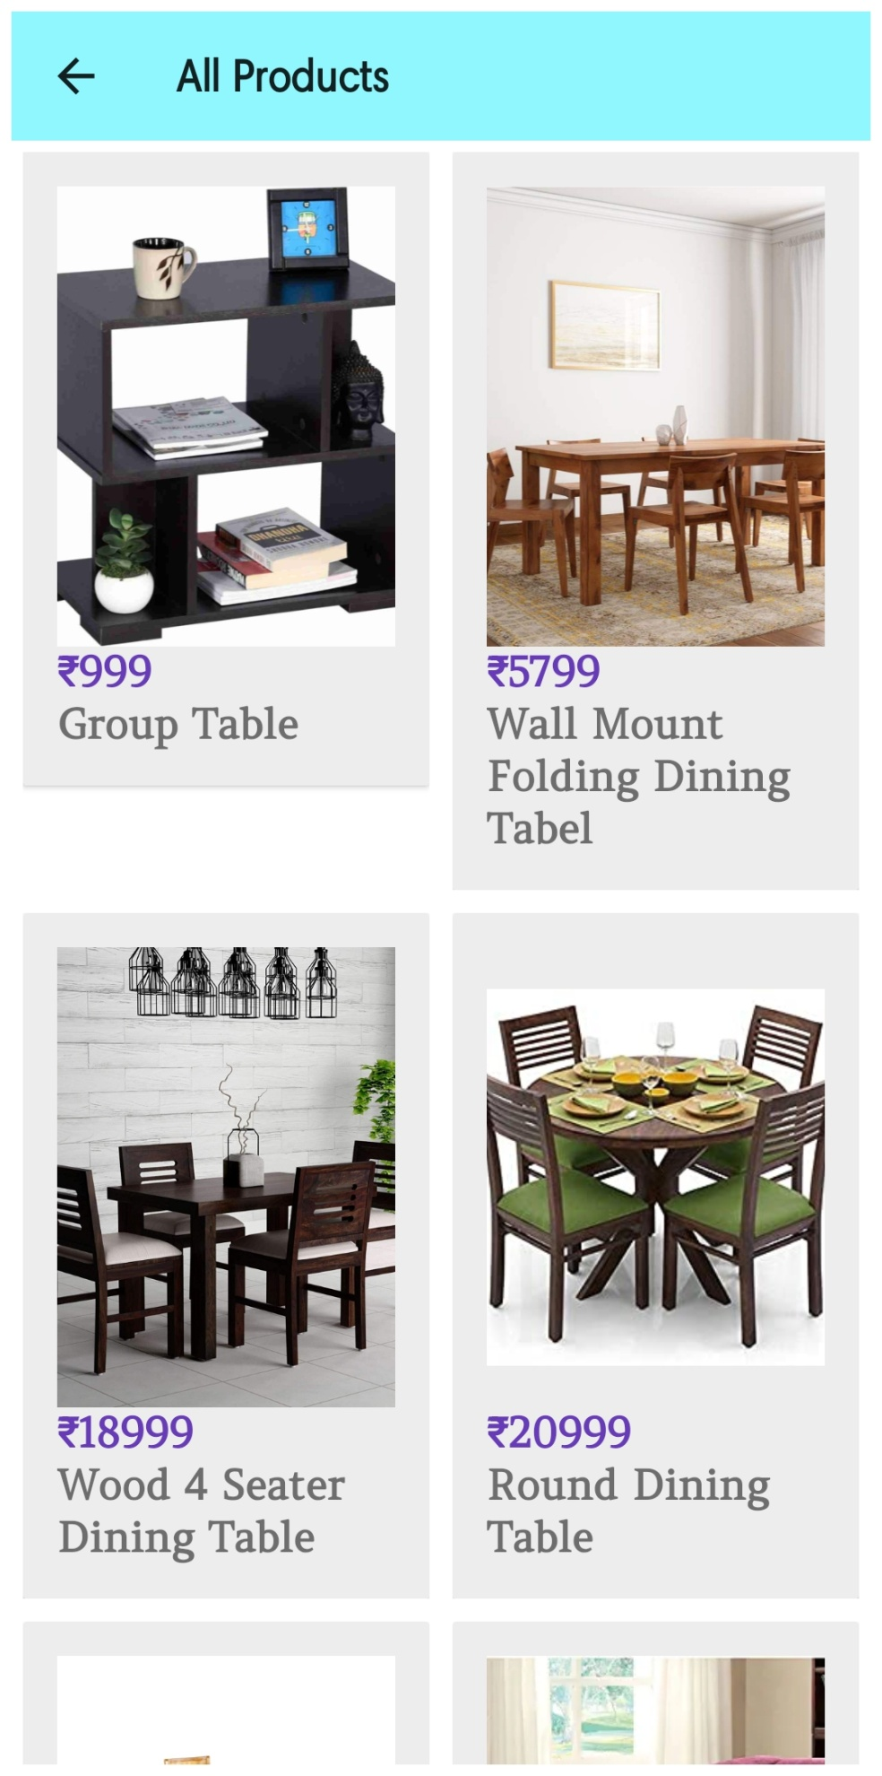

* Activity_verify_otp

*<?***xml version="1.0" encoding="utf-8"***?>*<**ScrollView xmlns:android="http://schemas.android.com/apk/res/android"  
 xmlns:app="http://schemas.android.com/apk/res-auto"  
 xmlns:tools="http://schemas.android.com/tools"  
 android:layout_width="match_parent"  
 android:layout_height="match_parent"  
 android:overScrollMode="never"  
 android:scrollbars="none"  
 tools:context=".activites.VerifyOTP"**>  
  
 <**LinearLayout  
 android:layout_width="match_parent"  
 android:layout_height="match_parent"  
 android:gravity="center_horizontal"  
 android:orientation="vertical"**>  
  
  
 <**ImageView  
 android:id="@+id/imageView"  
 android:layout_width="500dp"  
 android:layout_height="345dp"  
 app:srcCompat="@drawable/received_otp_icon"** />  
  
 <**TextView  
 android:layout_width="match_parent"  
 android:layout_height="wrap_content"  
 android:layout_marginLeft="60dp"  
 android:fontFamily="@font/aclonica"  
 android:text="OTP Verification"  
 android:textColor="@color/black"  
 android:textSize="28sp"  
 android:textStyle="bold"** />  
  
 <**TextView  
 android:layout_width="wrap_content"  
 android:layout_height="48dp"  
 android:layout_gravity="center"  
 android:layout_marginStart="50dp"  
 android:layout_marginLeft="80dp"  
 android:layout_marginTop="8dp"  
 android:layout_marginEnd="50dp"  
 android:fontFamily="@font/aclonica"  
 android:text="Please Enter the OTP sent to you"  
 android:textColor="@color/black"  
 android:textSize="14sp"  
 android:textStyle="bold"** />  
  
 <**TextView  
 android:id="@+id/textmobileshownumber"  
 android:layout_width="170dp"  
 android:layout_height="35dp"  
 android:layout_gravity="center"  
 android:layout_marginStart="50dp"  
 android:layout_marginEnd="50dp"  
 android:fontFamily="@font/aclonica"  
 android:textColor="@color/black"  
 android:textSize="16sp"  
 android:textStyle="bold"** />  
  
 <**LinearLayout  
 android:layout_width="match_parent"  
 android:layout_height="wrap_content"  
 android:layout_marginTop="30dp"  
 android:gravity="center"  
 android:orientation="horizontal"**>  
  
 <**EditText  
 android:background="@drawable/backgroundbox"  
 android:id="@+id/inputotp1"  
 android:layout_width="40dp"  
 android:layout_height="46dp"  
 android:gravity="center"  
 android:imeOptions="actionNext"  
 android:importantForAutofill="no"  
 android:inputType="number"  
 android:maxLength="1"  
 android:textColor="@color/black"  
 android:textSize="24sp"  
 android:textStyle="bold"  
 tools:ignore="LabelFor"**/>  
  
 <**EditText  
 android:background="@drawable/backgroundbox"  
 android:id="@+id/inputotp2"  
 android:layout_width="40dp"  
 android:layout_height="46dp"  
 android:layout_marginStart="4dp"  
 android:layout_marginLeft="4dp"  
 android:gravity="center"  
 android:imeOptions="actionNext"  
 android:importantForAutofill="no"  
 android:inputType="number"  
 android:maxLength="1"  
 android:textColor="@color/black"  
 android:textSize="24sp"  
 android:textStyle="bold"  
 tools:ignore="LabelFor"**/>  
  
 <**EditText  
 android:background="@drawable/backgroundbox"  
 android:id="@+id/inputotp3"  
 android:layout_width="40dp"  
 android:layout_height="46dp"  
 android:layout_marginStart="4dp"  
 android:layout_marginLeft="4dp"  
 android:gravity="center"  
 android:imeOptions="actionNext"  
 android:importantForAutofill="no"  
 android:inputType="number"  
 android:maxLength="1"  
 android:textColor="@color/black"  
 android:textSize="24sp"  
 android:textStyle="bold"  
 tools:ignore="LabelFor"**/>  
  
 <**EditText  
 android:background="@drawable/backgroundbox"  
 android:id="@+id/inputotp4"  
 android:layout_width="40dp"  
 android:layout_height="46dp"  
 android:layout_marginStart="4dp"  
 android:layout_marginLeft="4dp"  
 android:gravity="center"  
 android:imeOptions="actionNext"  
 android:importantForAutofill="no"  
 android:inputType="number"  
 android:maxLength="1"  
 android:textColor="@color/black"  
 android:textSize="24sp"  
 android:textStyle="bold"  
 tools:ignore="LabelFor"**/>  
  
 <**EditText  
 android:background="@drawable/backgroundbox"  
 android:id="@+id/inputotp5"  
 android:layout_width="40dp"  
 android:layout_height="46dp"  
 android:layout_marginStart="4dp"  
 android:layout_marginLeft="4dp"  
 android:gravity="center"  
 android:imeOptions="actionNext"  
 android:importantForAutofill="no"  
 android:inputType="number"  
 android:maxLength="1"  
 android:textColor="@color/black"  
 android:textSize="24sp"  
 android:textStyle="bold"  
 tools:ignore="LabelFor"**/>  
  
 <**EditText  
 android:background="@drawable/backgroundbox"  
 android:id="@+id/inputotp6"  
 android:layout_width="40dp"  
 android:layout_height="46dp"  
 android:layout_marginStart="4dp"  
 android:layout_marginLeft="4dp"  
 android:gravity="center"  
 android:imeOptions="actionNext"  
 android:importantForAutofill="no"  
 android:inputType="number"  
 android:maxLength="1"  
 android:textColor="@color/black"  
 android:textSize="24sp"  
 android:textStyle="bold"  
 tools:ignore="LabelFor"**/>  
 </**LinearLayout**>  
  
 <**LinearLayout  
 android:layout_width="match_parent"  
 android:layout_height="wrap_content"  
 android:layout_marginTop="20dp"  
 android:layout_gravity="center"  
 android:orientation="horizontal"**/>  
  
 <**TextView  
 android:layout_width="wrap_content"  
 android:layout_height="wrap_content"  
 android:text="Didn\'t receive the otp"  
 android:textColor="@color/black"  
 android:fontFamily="@font/aclonica"  
 android:textSize="14sp"**/>  
  
 <**TextView  
 android:layout_width="wrap_content"  
 android:layout_height="wrap_content"  
 android:id="@+id/textresendotp"  
 android:layout_marginStart="8dp"  
 android:text="RESEND OTP AGAIN"  
 android:layout_marginLeft="8dp"  
 android:textColor="@color/black"  
 android:textSize="15sp"  
 android:textStyle="bold"  
 android:fontFamily="@font/aclonica"  
 android:layout_marginTop="5dp"**/>  
  
 <**FrameLayout  
 android:layout_width="match_parent"  
 android:layout_height="wrap_content"**>  
  
 <**Button  
 android:id="@+id/buttongetotp"  
 android:layout_width="330dp"  
 android:layout_height="60dp"  
 android:layout_marginLeft="25dp"  
 android:layout_marginTop="20dp"  
 android:backgroundTint="@color/black"  
 android:text="Submit"  
 android:textColor="#F6F4F4"  
 android:textSize="16dp"  
 android:fontFamily="@font/aclonica"  
 android:textStyle="bold"** />  
  
 <**ProgressBar  
 android:id="@+id/progress_verify_otp"  
 android:layout_width="35dp"  
 android:layout_height="35dp"  
 android:layout_gravity="center"  
 android:visibility="gone"**/>  
  
 </**FrameLayout**>  
  
 </**LinearLayout**>  
</**ScrollView**>

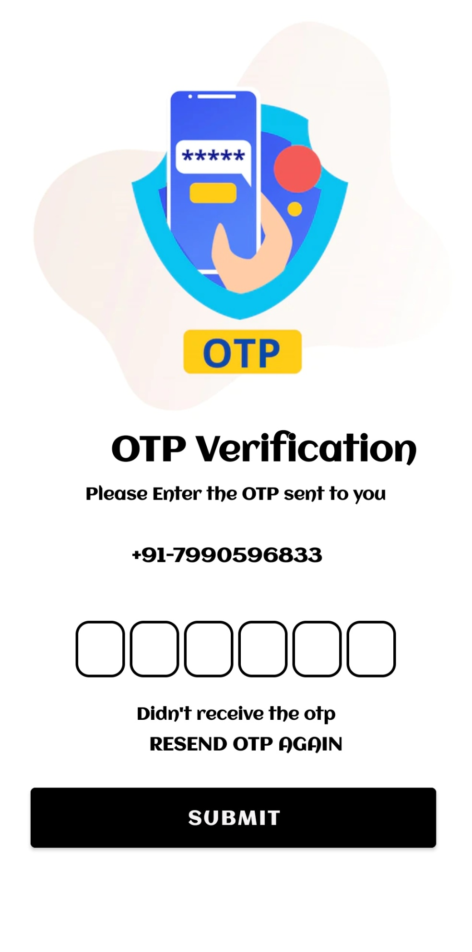

* Address_item

*<?***xml version="1.0" encoding="utf-8"***?>*<**androidx.constraintlayout.widget.ConstraintLayout xmlns:android="http://schemas.android.com/apk/res/android"  
 xmlns:app="http://schemas.android.com/apk/res-auto"  
 android:layout_width="match_parent"  
 android:layout_height="wrap_content"  
 android:layout_margin="5dp"  
 android:background="#AAB8F4"  
 android:padding="8dp"**>  
  
  
 <**TextView  
 android:id="@+id/address_add"  
 android:layout_width="300dp"  
 android:layout_height="wrap_content"  
 android:text="Banasnagar society railway east kalol 382727, Gujarat, India"  
 android:textColor="@color/black"  
 app:layout_constraintBottom_toBottomOf="parent"  
 app:layout_constraintStart_toStartOf="parent"  
 app:layout_constraintTop_toTopOf="parent"** />  
  
 <**RadioButton  
 android:id="@+id/select_address"  
 android:layout_width="wrap_content"  
 android:layout_height="wrap_content"  
 android:gravity="center"  
 app:layout_constraintBottom_toBottomOf="parent"  
 app:layout_constraintEnd_toEndOf="parent"  
 app:layout_constraintHorizontal_bias="1"  
 app:layout_constraintStart_toEndOf="@+id/address_add"  
 app:layout_constraintTop_toTopOf="parent"** />  
  
  
</**androidx.constraintlayout.widget.ConstraintLayout**>

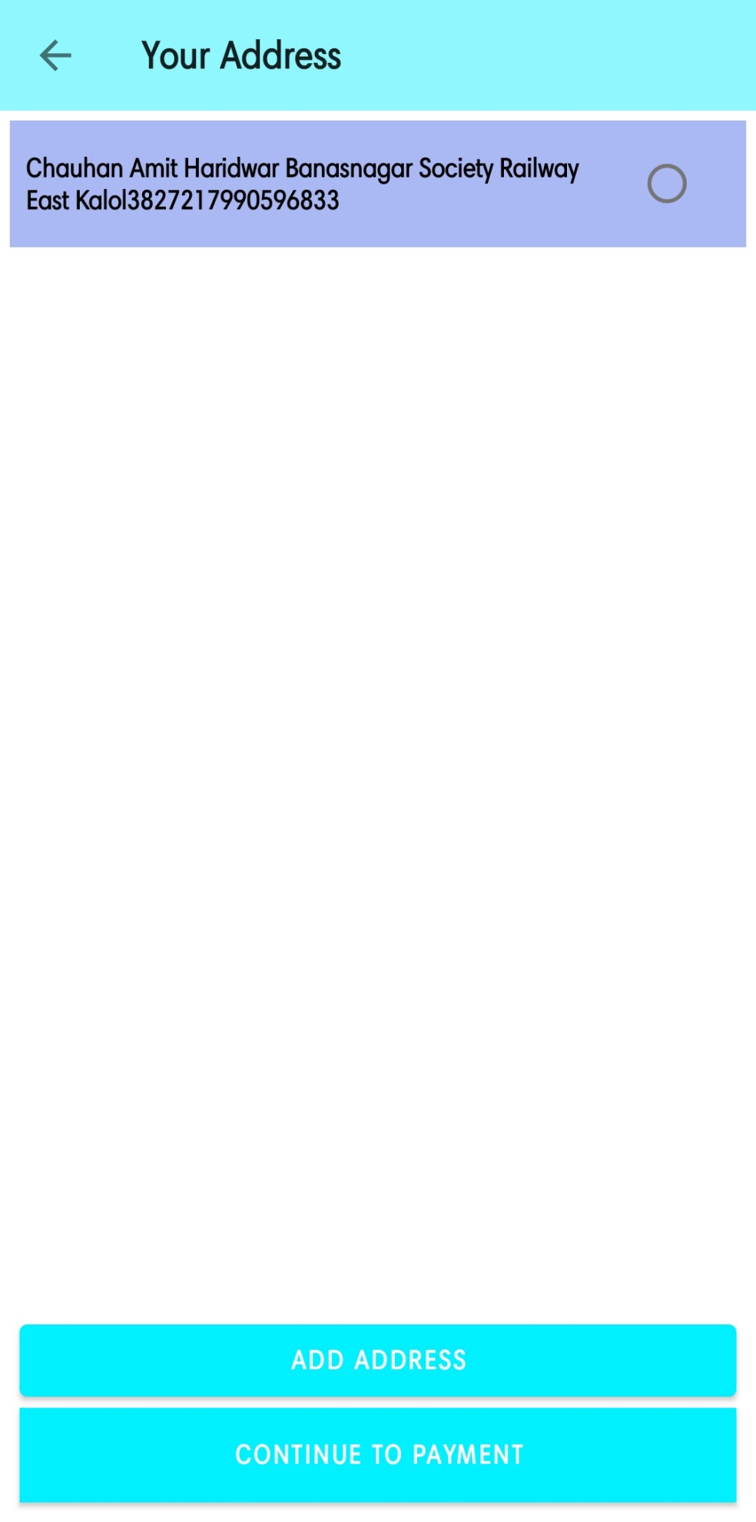

* app_bar_navigation_drawer

*<?***xml version="1.0" encoding="utf-8"***?>*<**androidx.coordinatorlayout.widget.CoordinatorLayout xmlns:android="http://schemas.android.com/apk/res/android"  
 xmlns:app="http://schemas.android.com/apk/res-auto"  
 xmlns:tools="http://schemas.android.com/tools"  
 android:layout_width="match_parent"  
 android:layout_height="match_parent"  
 tools:context=".activites.MainActivity"**>  
  
 <**com.google.android.material.appbar.AppBarLayout  
 android:layout_width="match_parent"  
 android:layout_height="wrap_content"  
 android:theme="@style/Theme.OnlineFurnitureStore.AppBarOverlay"**>  
  
 <**androidx.appcompat.widget.Toolbar  
 android:id="@+id/toolbar"  
 android:layout_width="match_parent"  
 android:layout_height="?attr/actionBarSize"  
 android:background="?attr/colorPrimary"  
 app:title="Home"  
 app:popupTheme="@style/Theme.OnlineFurnitureStore.PopupOverlay"  
 app:menu="@menu/navigation_drawer"**/>  
  
 </**com.google.android.material.appbar.AppBarLayout**>  
  
 <**include layout="@layout/content_navigation_drawer"** />  
  
</**androidx.coordinatorlayout.widget.CoordinatorLayout**>

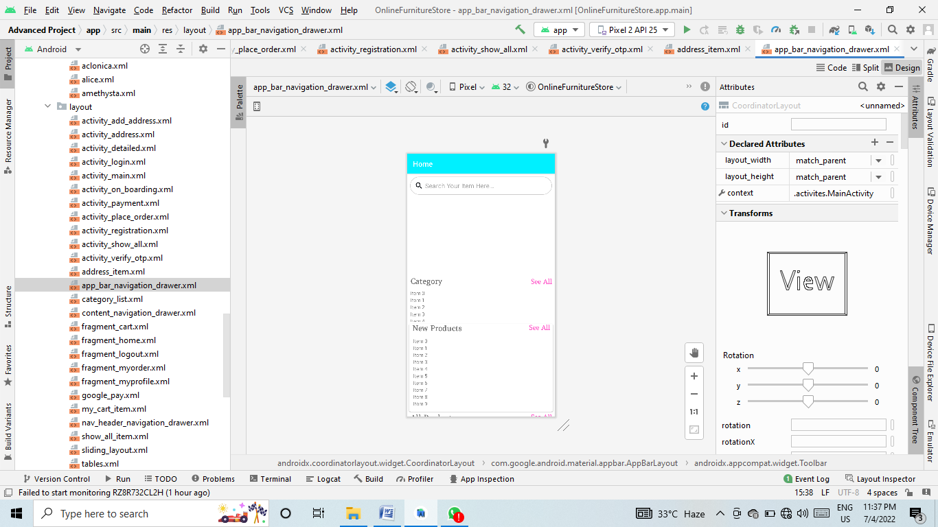

* category_list

*<?***xml version="1.0" encoding="utf-8"***?>*<**androidx.cardview.widget.CardView xmlns:android="http://schemas.android.com/apk/res/android"  
 xmlns:app="http://schemas.android.com/apk/res-auto"  
 android:layout_width="70dp"  
 android:layout_height="90dp"  
 android:layout_margin="5dp"  
 app:cardCornerRadius="5dp"**>  
  
 <**androidx.constraintlayout.widget.ConstraintLayout  
 android:layout_width="match_parent"  
 android:layout_height="match_parent"**>  
  
  
 <**ImageView  
 android:id="@+id/cat_img"  
 android:layout_width="40dp"  
 android:layout_height="40dp"  
 app:layout_constraintEnd_toEndOf="parent"  
 app:layout_constraintStart_toStartOf="parent"  
 app:layout_constraintTop_toTopOf="parent"** />  
  
 <**TextView  
 android:id="@+id/cat_name"  
 android:layout_width="wrap_content"  
 android:layout_height="60dp"  
 android:fontFamily="@font/amethysta"  
 android:text="Category Name"  
 android:textAlignment="center"  
 android:textStyle="bold"  
 app:layout_constraintEnd_toEndOf="parent"  
 app:layout_constraintStart_toStartOf="parent"  
 app:layout_constraintTop_toBottomOf="@+id/cat_img"** />  
 </**androidx.constraintlayout.widget.ConstraintLayout**>  
</**androidx.cardview.widget.CardView**>

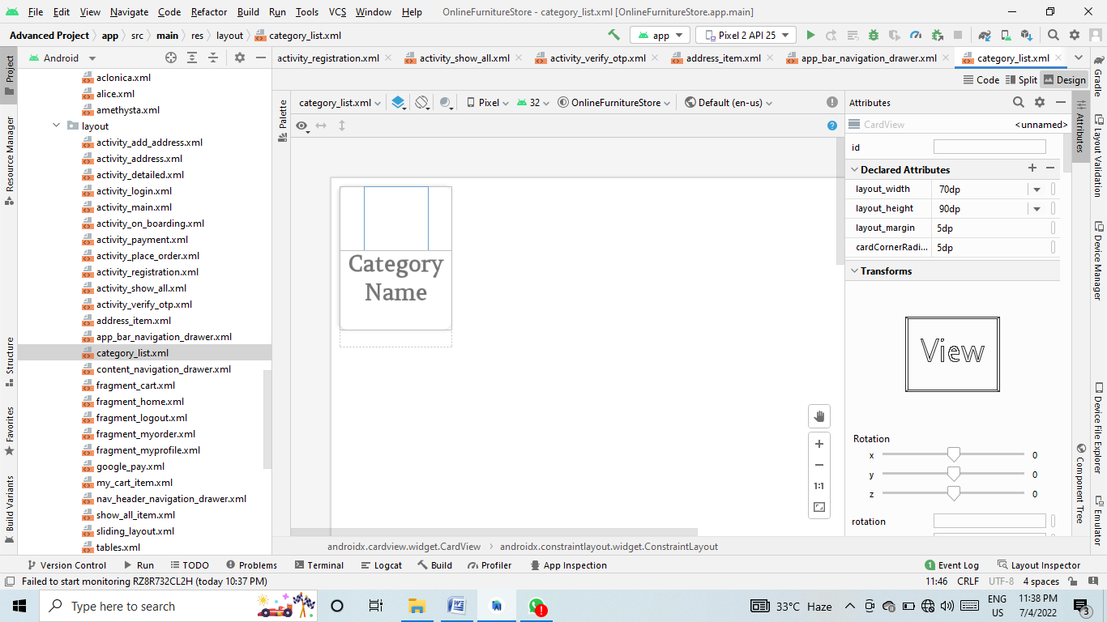

* content_navigation_drawer

*<?***xml version="1.0" encoding="utf-8"***?>*<**androidx.constraintlayout.widget.ConstraintLayout xmlns:android="http://schemas.android.com/apk/res/android"  
 xmlns:app="http://schemas.android.com/apk/res-auto"  
 xmlns:tools="http://schemas.android.com/tools"  
 android:layout_width="match_parent"  
 android:layout_height="match_parent"  
 app:layout_behavior="@string/appbar_scrolling_view_behavior"  
 tools:showIn="@layout/app_bar_navigation_drawer"**>  
  
 <**fragment  
 android:id="@+id/nav_host_fragment"  
 android:name="androidx.navigation.fragment.NavHostFragment"  
 android:layout_width="match_parent"  
 android:layout_height="match_parent"  
 app:defaultNavHost="true"  
 app:layout_constraintHorizontal_bias="0.0"  
 app:layout_constraintLeft_toLeftOf="parent"  
 app:layout_constraintRight_toRightOf="parent"  
 app:layout_constraintTop_toTopOf="parent"  
 app:navGraph="@navigation/mobile_navigation"** />  
</**androidx.constraintlayout.widget.ConstraintLayout**>

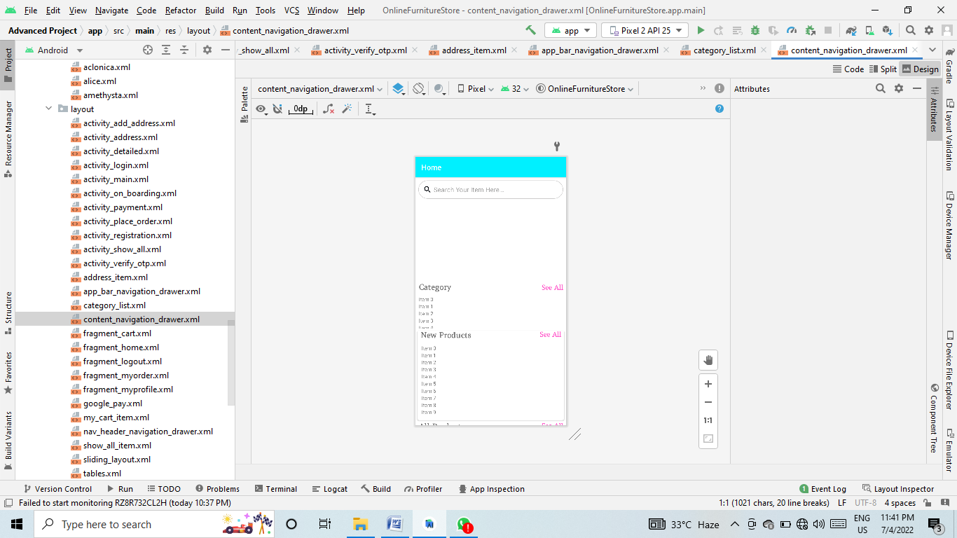

* fragment_cart

*<?***xml version="1.0" encoding="utf-8"***?>*<**androidx.constraintlayout.widget.ConstraintLayout xmlns:android="http://schemas.android.com/apk/res/android"  
 xmlns:app="http://schemas.android.com/apk/res-auto"  
 xmlns:tools="http://schemas.android.com/tools"  
 android:layout_width="match_parent"  
 android:layout_height="match_parent"  
 tools:context=".ui.MyCartFragment"**>  
  
  
  
  
 <**TextView  
 android:id="@+id/textView"  
 android:layout_width="0dp"  
 android:layout_height="wrap_content"  
 android:layout_marginTop="10dp"  
 android:background="#8ff7fd"  
 android:fontFamily="@font/amethysta"  
 android:gravity="center"  
 android:padding="18dp"  
 android:text="Total Price : ₹ "  
 android:textSize="20sp"  
 android:textStyle="bold"  
 app:layout_constraintEnd_toEndOf="parent"  
 app:layout_constraintStart_toStartOf="parent"  
 app:layout_constraintWidth_percent=".9"  
 tools:ignore="MissingConstraints"** />  
  
 <**androidx.recyclerview.widget.RecyclerView  
 android:id="@+id/cart_rec"  
 android:layout_width="0dp"  
 app:layout_constraintWidth_percent=".9"  
 android:layout_height="wrap_content"  
 app:layout_constraintEnd_toEndOf="parent"  
 app:layout_constraintStart_toStartOf="parent"  
 app:layout_constraintTop_toBottomOf="@+id/textView"  
 tools:listitem="@layout/my_cart_item"**/>  
  
 <**Button  
 android:id="@+id/buy_now"  
 android:layout_width="0dp"  
 android:layout_height="wrap_content"  
 android:layout_margin="10dp"  
 android:background="@color/blue"  
 android:backgroundTint="@color/purple_700"  
 android:drawableLeft="@drawable/ic_baseline_shopping_cart_24"  
 android:drawableTint="@color/white"  
 android:padding="14dp"  
 android:text="Buy Now"  
 android:textAllCaps="false"  
 android:textStyle="bold"  
 app:layout_constraintBottom_toBottomOf="parent"  
 app:layout_constraintEnd_toEndOf="parent"  
 app:layout_constraintStart_toStartOf="parent"  
 app:layout_constraintWidth_percent=".9"**/>  
  
  
</**androidx.constraintlayout.widget.ConstraintLayout**>

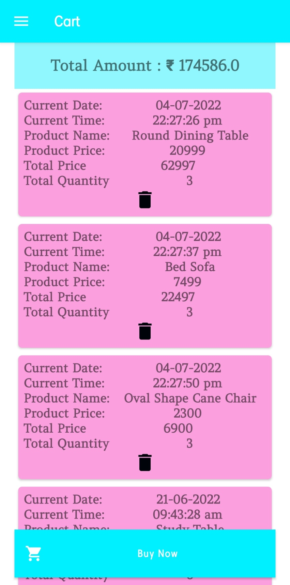

* fragment_home
* *<?***xml version="1.0" encoding="utf-8"***?>*<**androidx.core.widget.NestedScrollView xmlns:android="http://schemas.android.com/apk/res/android"  
   xmlns:tools="http://schemas.android.com/tools"  
   android:layout_width="match_parent"  
   android:layout_height="match_parent"  
   xmlns:app="http://schemas.android.com/apk/res-auto"  
   tools:context=".ui.HomeFragment"**>  
    
    
   <**LinearLayout  
   android:layout_width="match_parent"  
   android:layout_height="wrap_content"  
   android:orientation="vertical"**>  
    
   <**EditText  
   android:elevation="3dp"  
   android:id="@+id/search_box"  
   android:layout_width="match_parent"  
   android:layout_height="wrap_content"  
   android:layout_margin="8dp"  
   android:drawableLeft="@drawable/ic_baseline_search_24"  
   android:background="@drawable/search_gb"  
   android:padding="13dp"  
   android:hint="Search Your Item Here..."  
   android:drawablePadding="5dp"**/>  
    
   <**LinearLayout  
   android:id="@+id/home_layout"  
   android:layout_width="match_parent"  
   android:layout_height="match_parent"  
   android:orientation="vertical"**>  
    
   <**com.denzcoskun.imageslider.ImageSlider  
   android:id="@+id/image_slider"  
   android:layout_width="match_parent"  
   android:layout_height="220dp"  
   app:iss_auto_cycle="true"  
   app:iss_delay="0"  
   app:iss_period="1000"** />  
    
   <**LinearLayout  
   android:layout_width="match_parent"  
   android:layout_height="wrap_content"  
   android:layout_marginLeft="9dp"  
   android:orientation="horizontal"  
   android:weightSum="2"**>  
    
   <**TextView  
   android:layout_width="wrap_content"  
   android:layout_height="wrap_content"  
   android:layout_weight="1"  
   android:fontFamily="@font/amethysta"  
   android:text="Category"  
   android:textSize="21sp"  
   android:textStyle="bold"** />  
    
   <**TextView  
   android:id="@+id/category_see_all"  
   android:layout_width="wrap_content"  
   android:layout_height="wrap_content"  
   android:layout_marginRight="8dp"  
   android:layout_weight="1"  
   android:fontFamily="@font/amethysta"  
   android:gravity="end"  
   android:text="See All"  
   android:textColor="@color/pink"  
   android:textSize="18sp"  
   android:textStyle="bold"** />  
    
   </**LinearLayout**>  
    
   <**androidx.recyclerview.widget.RecyclerView  
   android:id="@+id/category_rec"  
   android:layout_width="wrap_content"  
   android:layout_height="90dp"  
   android:layout_marginLeft="9dp"  
   android:layout_marginTop="10dp"** />  
    
   <**androidx.cardview.widget.CardView  
   android:layout_width="match_parent"  
   android:layout_height="wrap_content"  
   android:layout_margin="5dp"  
   android:layout_marginTop="10dp"  
   android:elevation="6dp"  
   app:cardCornerRadius="5dp"**>  
    
    
   <**LinearLayout  
   android:layout_width="match_parent"  
   android:layout_height="match_parent"  
   android:orientation="vertical"**>  
    
   <**RelativeLayout  
   android:layout_width="wrap_content"  
   android:layout_height="wrap_content"**>  
    
   <**TextView  
   android:id="@+id/new_product"  
   android:layout_width="wrap_content"  
   android:layout_height="wrap_content"  
   android:layout_marginLeft="9dp"  
   android:fontFamily="@font/amethysta"  
   android:text="New Products"  
   android:textSize="21sp"  
   android:textStyle="bold"** />  
    
   <**TextView  
   android:id="@+id/newProduct_see_all"  
   android:layout_width="wrap_content"  
   android:layout_height="wrap_content"  
   android:layout_alignParentEnd="true"  
   android:layout_marginRight="8dp"  
   android:fontFamily="@font/amethysta"  
   android:text="See All"  
   android:textColor="@color/pink"  
   android:textSize="18sp"  
   android:textStyle="bold"** />  
   </**RelativeLayout**>  
    
    
    
   <**androidx.recyclerview.widget.RecyclerView  
   android:id="@+id/new_product_rec"  
   android:layout_width="wrap_content"  
   android:layout_height="wrap_content"  
   android:layout_margin="7dp"  
   android:layout_marginTop="6dp"  
   android:padding="5dp"** />  
   </**LinearLayout**>  
    
   </**androidx.cardview.widget.CardView**>  
    
   <**LinearLayout  
   android:layout_width="match_parent"  
   android:layout_height="match_parent"  
   android:orientation="vertical"**>  
    
   <**RelativeLayout  
   android:layout_width="wrap_content"  
   android:layout_height="wrap_content"**>  
    
   <**TextView  
   android:id="@+id/allProduct"  
   android:layout_width="wrap_content"  
   android:layout_height="wrap_content"  
   android:layout_marginLeft="9dp"  
   android:fontFamily="@font/amethysta"  
   android:text="All Products"  
   android:textSize="21sp"  
   android:textStyle="bold"** />  
    
    
   <**TextView  
   android:id="@+id/allProducts_see_all"  
   android:layout_width="wrap_content"  
   android:layout_height="wrap_content"  
   android:layout_alignParentEnd="true"  
   android:layout_marginRight="8dp"  
   android:fontFamily="@font/amethysta"  
   android:text="See All"  
   android:textColor="@color/pink"  
   android:textSize="18sp"  
   android:textStyle="bold"** />  
   </**RelativeLayout**>  
    
   <**androidx.recyclerview.widget.RecyclerView  
   android:id="@+id/allProducts_rec"  
   android:layout_width="wrap_content"  
   android:layout_height="wrap_content"  
   android:layout_gravity="center"  
   android:layout_margin="7dp"  
   android:layout_marginTop="6dp"  
   android:padding="5dp"** />  
    
   </**LinearLayout**>  
   </**LinearLayout**>  
   </**LinearLayout**>  
  </**androidx.core.widget.NestedScrollView**>

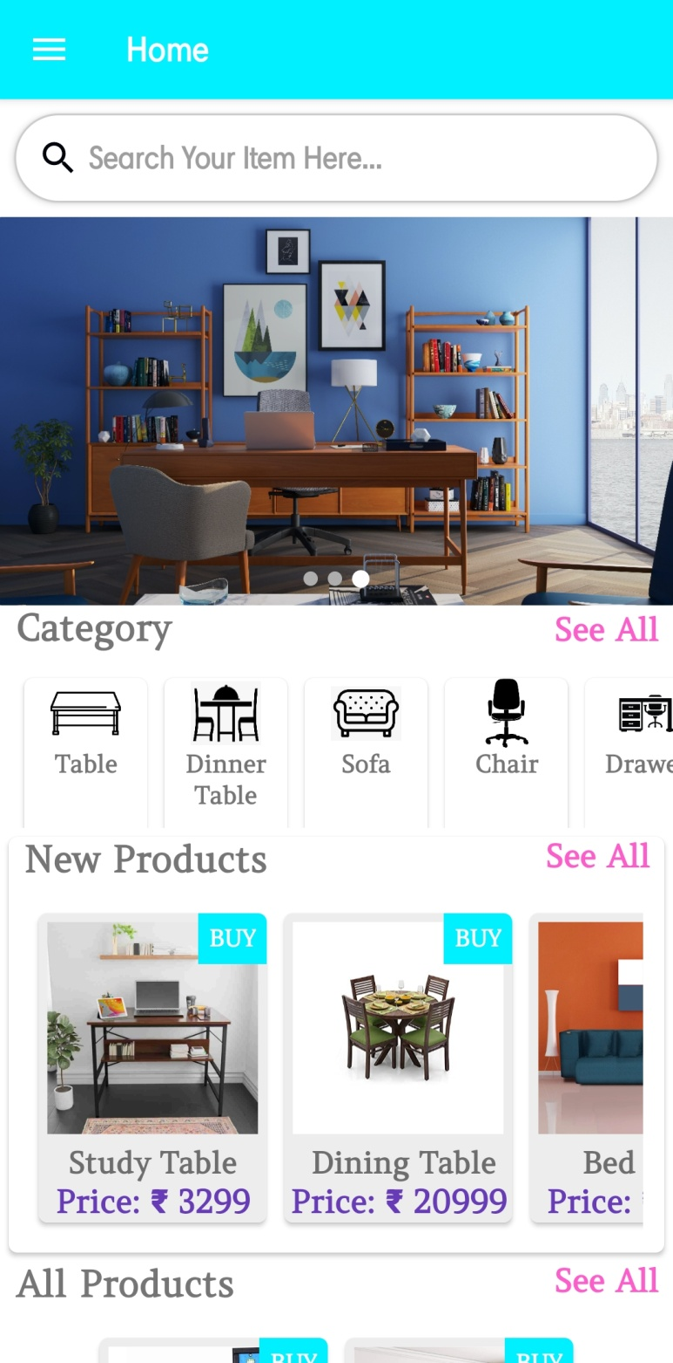

* fragment_logout

*<?***xml version="1.0" encoding="utf-8"***?>*<**androidx.constraintlayout.widget.ConstraintLayout xmlns:android="http://schemas.android.com/apk/res/android"  
 xmlns:tools="http://schemas.android.com/tools"  
 android:layout_width="match_parent"  
 android:layout_height="match_parent"  
 tools:context=".ui.LogoutFragment"**>  
  
 *<!--* ***TODO: Update blank fragment layout*** *-->* <**TextView  
 android:layout_width="match_parent"  
 android:layout_height="match_parent"  
 android:text="@string/hello_blank_fragment"** />  
  
</**androidx.constraintlayout.widget.ConstraintLayout**>

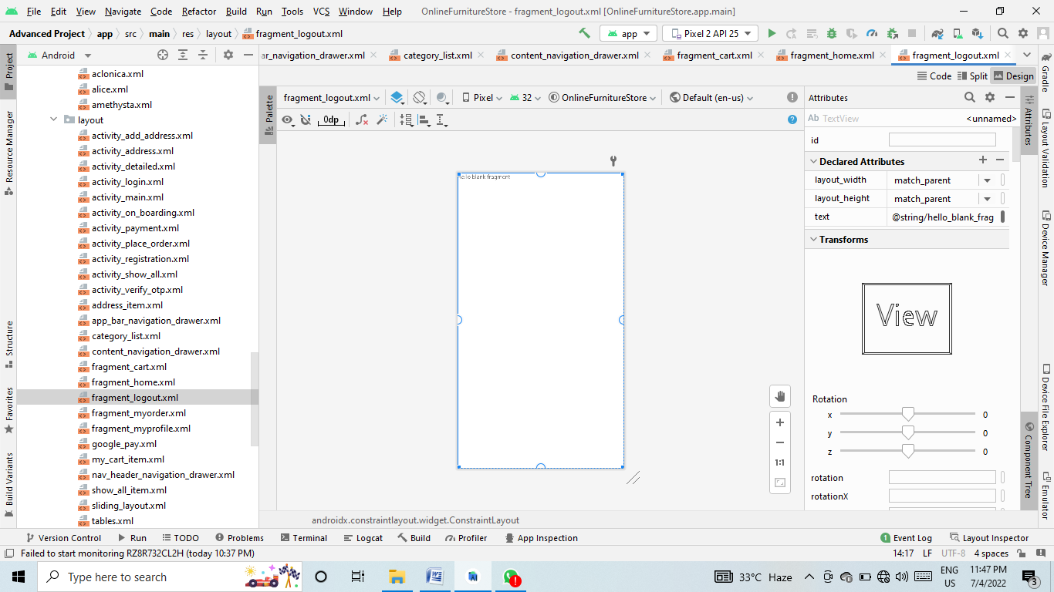

* fragment_myorder

*<?***xml version="1.0" encoding="utf-8"***?>*<**FrameLayout xmlns:android="http://schemas.android.com/apk/res/android"  
 xmlns:tools="http://schemas.android.com/tools"  
 android:layout_width="match_parent"  
 android:layout_height="match_parent"  
 tools:context=".ui.MyOrderFragment"**>  
  
 <**TextView  
 android:layout_width="match_parent"  
 android:layout_height="match_parent"  
 android:text="Hello"** />  
  
</**FrameLayout**>

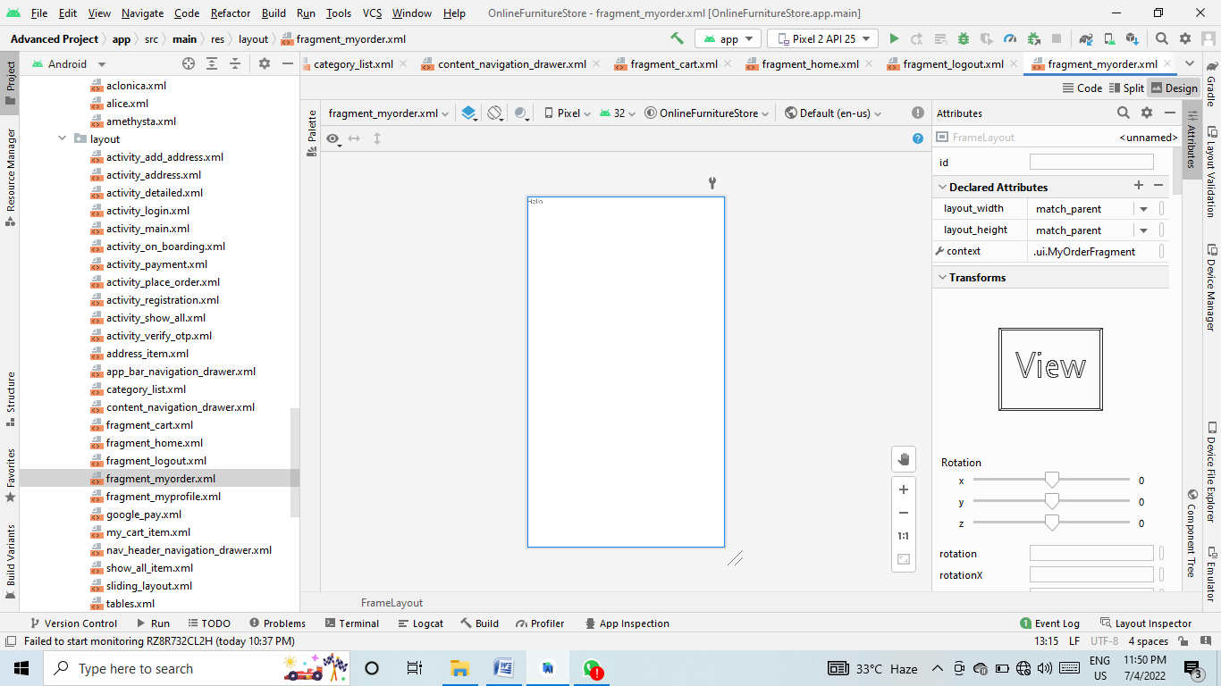

* fragment_myprofile

*<?***xml version="1.0" encoding="utf-8"***?>*<**androidx.constraintlayout.widget.ConstraintLayout xmlns:android="http://schemas.android.com/apk/res/android"  
 xmlns:tools="http://schemas.android.com/tools"  
 android:layout_width="match_parent"  
 android:layout_height="match_parent"  
 xmlns:app="http://schemas.android.com/apk/res-auto"  
 tools:context=".ui.MyProfileFragment"**>  
  
 <**de.hdodenhof.circleimageview.CircleImageView  
 xmlns:app="http://schemas.android.com/apk/res-auto"  
 android:id="@+id/profile_img"  
 android:layout_width="200dp"  
 android:layout_height="200dp"  
 android:src="@drawable/profile"  
 app:civ_border_width="2dp"  
 android:layout_marginTop="15dp"  
 app:civ_border_color="#FF000000"  
 app:layout_constraintEnd_toEndOf="parent"  
 app:layout_constraintStart_toStartOf="parent"  
 app:layout_constraintTop_toTopOf="parent"**/>  
  
  
 <**EditText  
 android:id="@+id/profile_name"  
 android:inputType="textPersonName"  
 android:layout_width="275dp"  
 android:layout_height="47dp"  
 android:background="@drawable/edittext_bg"  
 android:hint="Your Name"  
 android:padding="13dp"  
 android:layout_marginTop="20dp"  
 android:drawableLeft="@drawable/ic_baseline_person_24"  
 android:drawablePadding="10dp"  
 android:elevation="3dp"  
 app:layout_constraintEnd_toEndOf="parent"  
 app:layout_constraintStart_toStartOf="parent"  
 app:layout_constraintTop_toBottomOf="@id/profile_img"  
 app:layout_constraintWidth_percent="0.8"** />  
  
 <**EditText  
 android:id="@+id/profile_email"  
 android:layout_width="275dp"  
 android:layout_height="47dp"  
 android:background="@drawable/edittext_bg"  
 android:inputType="textEmailAddress"  
 android:hint="Your Email"  
 android:padding="13dp"  
 android:layout_marginTop="10dp"  
 android:drawableLeft="@drawable/ic_baseline_account_circle"  
 android:drawablePadding="10dp"  
 android:elevation="3dp"  
 app:layout_constraintEnd_toEndOf="parent"  
 app:layout_constraintStart_toStartOf="parent"  
 app:layout_constraintTop_toBottomOf="@id/profile_name"  
 app:layout_constraintWidth_percent="0.8"** />  
  
 <**EditText  
 android:id="@+id/profile_number"  
 android:layout_width="275dp"  
 android:layout_height="47dp"  
 android:background="@drawable/edittext_bg"  
 android:hint="Phone Number"  
 android:inputType="numberPassword"  
 android:padding="13dp"  
 android:layout_marginTop="10dp"  
 android:drawableLeft="@drawable/ic_baseline_phone_24"  
 android:drawablePadding="10dp"  
 android:elevation="3dp"  
 app:layout_constraintEnd_toEndOf="parent"  
 app:layout_constraintStart_toStartOf="parent"  
 app:layout_constraintTop_toBottomOf="@id/profile_email"  
 app:layout_constraintWidth_percent="0.8"** />  
  
 <**EditText  
 android:id="@+id/profile_address"  
 android:layout_width="275dp"  
 android:layout_height="47dp"  
 android:background="@drawable/edittext_bg"  
 android:inputType="textPersonName"  
 android:hint="Your Address"  
 android:padding="13dp"  
 android:layout_marginTop="10dp"  
 android:drawableLeft="@drawable/ic_baseline_location_on_24"  
 android:drawablePadding="10dp"  
 android:elevation="3dp"  
 app:layout_constraintEnd_toEndOf="parent"  
 app:layout_constraintStart_toStartOf="parent"  
 app:layout_constraintTop_toBottomOf="@id/profile_number"  
 app:layout_constraintWidth_percent="0.8"** />  
  
 <**Button  
 android:id="@+id/profile_update"  
 android:layout_width="150dp"  
 android:layout_height="wrap_content"  
 android:padding="14dp"  
 android:text="Update"  
 android:textSize="20sp"  
 android:textAllCaps="false"  
 android:textStyle="bold"  
 app:layout_constraintBottom_toBottomOf="parent"  
 app:layout_constraintEnd_toEndOf="parent"  
 app:layout_constraintStart_toStartOf="parent"  
 app:layout_constraintTop_toBottomOf="@+id/profile_address"  
 app:layout_constraintVertical_bias="0.3"**/>  
  
  
</**androidx.constraintlayout.widget.ConstraintLayout**>

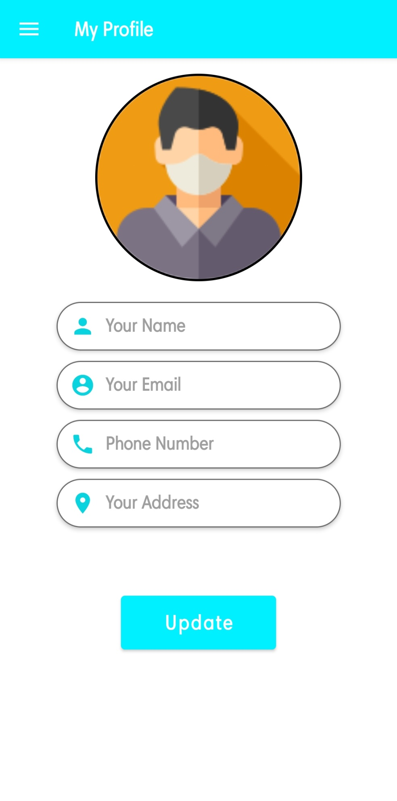

* google_pay

*<?***xml version="1.0" encoding="utf-8"***?>*<**LinearLayout  
 xmlns:android="http://schemas.android.com/apk/res/android"  
 xmlns:tools="http://schemas.android.com/tools"  
 android:layout_width="match_parent"  
 android:layout_height="match_parent"  
 tools:context=".activites.GooglePay"  
 android:orientation="vertical"**>  
 <**EditText  
 android:layout_width="match_parent"  
 android:layout_height="wrap_content"  
 android:hint="Name"  
 android:layout_marginLeft="20dp"  
 android:layout_marginRight="20dp"  
 android:layout_marginTop="20dp"  
 android:id="@+id/name"  
 android:text="Chauhan Amit Haridwar"**/>  
  
 <**EditText  
 android:layout_width="match_parent"  
 android:layout_height="wrap_content"  
 android:hint="UPI ID"  
 android:layout_marginLeft="20dp"  
 android:layout_marginRight="20dp"  
 android:layout_marginTop="20dp"  
 android:id="@+id/upi_id"  
 android:text="799059amit@paytm"**/>  
  
 <**EditText  
 android:layout_width="match_parent"  
 android:layout_height="wrap_content"  
 android:hint="Amount"  
 android:layout_marginLeft="20dp"  
 android:layout_marginRight="20dp"  
 android:layout_marginTop="20dp"  
 android:id="@+id/amount_et"  
 android:inputType="numberDecimal"  
 android:text="1"**/>  
  
  
 <**EditText  
 android:layout_width="match_parent"  
 android:layout_height="wrap_content"  
 android:hint="Note"  
 android:layout_marginLeft="20dp"  
 android:layout_marginRight="20dp"  
 android:layout_marginTop="20dp"  
 android:id="@+id/note"  
 android:text="Furniture Test UPI Payment"**/>  
  
 <**Button  
 android:layout_width="100dp"  
 android:layout_height="wrap_content"  
 android:background="@color/blue"  
 android:id="@+id/send"  
 android:layout_marginTop="20dp"  
 android:layout_centerHorizontal="true"  
 android:text="Pay Now"**/>  
  
  
</**LinearLayout**>

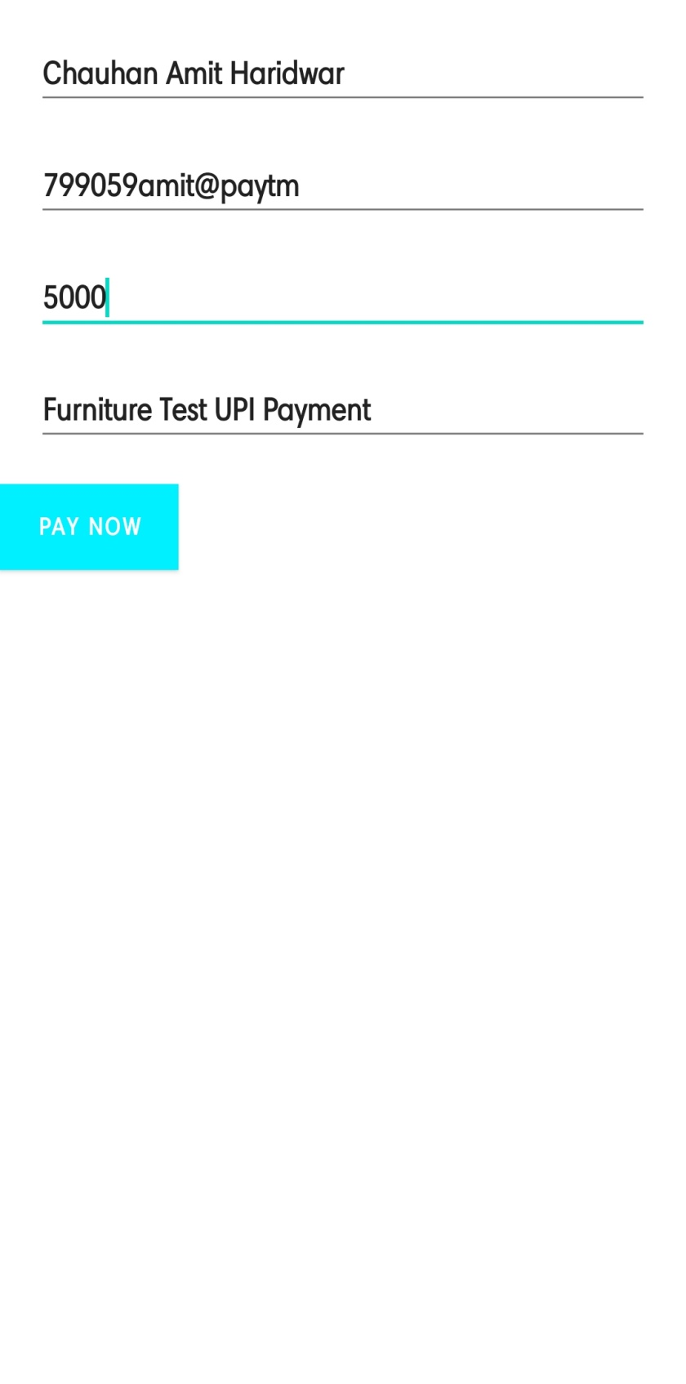

* my_cart_item

*<?***xml version="1.0" encoding="utf-8"***?>*<**androidx.cardview.widget.CardView xmlns:android="http://schemas.android.com/apk/res/android"  
 xmlns:app="http://schemas.android.com/apk/res-auto"  
 android:layout_width="match_parent"  
 android:layout_height="wrap_content"  
 app:cardCornerRadius="5dp"  
 android:elevation="4dp"  
 android:layout_margin="5dp"**>  
  
 <**LinearLayout  
 android:id="@+id/delete"  
 android:layout_width="match_parent"  
 android:layout_height="wrap_content"  
 android:background="#FB9FDE"  
 android:orientation="vertical"  
 android:padding="7dp"**>  
  
 <**LinearLayout  
 android:layout_width="match_parent"  
 android:layout_height="match_parent"  
 android:orientation="horizontal"  
 android:weightSum="2"**>  
  
 <**TextView  
 android:layout_width="wrap_content"  
 android:layout_height="wrap_content"  
 android:layout_weight="1"  
 android:fontFamily="@font/amethysta"  
 android:text="Current Date: "  
 android:textSize="16sp"  
 android:textStyle="bold"** />  
  
 <**TextView  
 android:id="@+id/current_date"  
 android:layout_width="wrap_content"  
 android:layout_height="wrap_content"  
 android:layout_weight="1"  
 android:fontFamily="@font/amethysta"  
 android:text="Current Date: "  
 android:textSize="16sp"  
 android:textStyle="bold"** />  
  
 </**LinearLayout**>  
  
 <**LinearLayout  
 android:layout_width="match_parent"  
 android:layout_height="match_parent"  
 android:orientation="horizontal"  
 android:weightSum="2"**>  
  
 <**TextView  
 android:layout_width="wrap_content"  
 android:layout_height="wrap_content"  
 android:layout_weight="1"  
 android:fontFamily="@font/amethysta"  
 android:text="Current Time: "  
 android:textSize="16sp"  
 android:textStyle="bold"** />  
  
 <**TextView  
 android:id="@+id/current_time"  
 android:layout_width="wrap_content"  
 android:layout_height="wrap_content"  
 android:layout_weight="1"  
 android:fontFamily="@font/amethysta"  
 android:text="Current Time: "  
 android:textSize="16sp"  
 android:textStyle="bold"** />  
  
 </**LinearLayout**>  
  
 <**LinearLayout  
 android:layout_width="match_parent"  
 android:layout_height="match_parent"  
 android:orientation="horizontal"  
 android:weightSum="2"**>  
  
 <**TextView  
 android:layout_width="wrap_content"  
 android:layout_height="wrap_content"  
 android:layout_weight="1"  
 android:fontFamily="@font/amethysta"  
 android:text="Product Name: "  
 android:textSize="16sp"  
 android:textStyle="bold"** />  
  
 <**TextView  
 android:id="@+id/product_name"  
 android:layout_width="wrap_content"  
 android:layout_height="wrap_content"  
 android:layout_weight="1"  
 android:fontFamily="@font/amethysta"  
 android:text="Current Date: "  
 android:textSize="16sp"  
 android:textStyle="bold"** />  
  
 </**LinearLayout**>  
  
 <**LinearLayout  
 android:layout_width="match_parent"  
 android:layout_height="match_parent"  
 android:orientation="horizontal"  
 android:weightSum="2"**>  
  
 <**TextView  
 android:layout_width="wrap_content"  
 android:layout_height="wrap_content"  
 android:layout_weight="1"  
 android:fontFamily="@font/amethysta"  
 android:text="Product Price: "  
 android:textSize="16sp"  
 android:textStyle="bold"** />  
  
 <**TextView  
 android:id="@+id/product_price"  
 android:layout_width="wrap_content"  
 android:layout_height="wrap_content"  
 android:layout_weight="1"  
 android:fontFamily="@font/amethysta"  
 android:text="Current Date: "  
 android:textSize="16sp"  
 android:textStyle="bold"** />  
  
 </**LinearLayout**>  
  
 <**LinearLayout  
 android:layout_width="match_parent"  
 android:layout_height="match_parent"  
 android:orientation="horizontal"  
 android:weightSum="2"**>  
  
 <**TextView  
 android:layout_width="wrap_content"  
 android:layout_height="wrap_content"  
 android:layout_weight="1"  
 android:fontFamily="@font/amethysta"  
 android:text="Total Price "  
 android:textSize="16sp"  
 android:textStyle="bold"** />  
  
 <**TextView  
 android:id="@+id/total_price"  
 android:layout_width="wrap_content"  
 android:layout_height="wrap_content"  
 android:layout_weight="1"  
 android:fontFamily="@font/amethysta"  
 android:text="Total price "  
 android:textSize="16sp"  
 android:textStyle="bold"** />  
  
 </**LinearLayout**>  
  
 <**LinearLayout  
 android:layout_width="match_parent"  
 android:layout_height="match_parent"  
 android:orientation="horizontal"  
 android:weightSum="2"**>  
  
 <**TextView  
 android:layout_width="wrap_content"  
 android:layout_height="wrap_content"  
 android:layout_weight="1"  
 android:fontFamily="@font/amethysta"  
 android:text="Total Quantity "  
 android:textSize="16sp"  
 android:textStyle="bold"** />  
  
 <**TextView  
 android:id="@+id/total_quantity"  
 android:layout_width="wrap_content"  
 android:layout_height="wrap_content"  
 android:layout_weight="1"  
 android:fontFamily="@font/amethysta"  
 android:text="Total Quantity"  
 android:textSize="16sp"  
 android:textStyle="bold"** />  
  
 </**LinearLayout**>  
  
 <**ImageView  
 android:id="@id/delete"  
 android:layout_width="match_parent"  
 android:layout_height="30dp"  
 android:src="@drawable/ic_baseline_delete_24"** />  
  
 </**LinearLayout**>  
</**androidx.cardview.widget.CardView**>

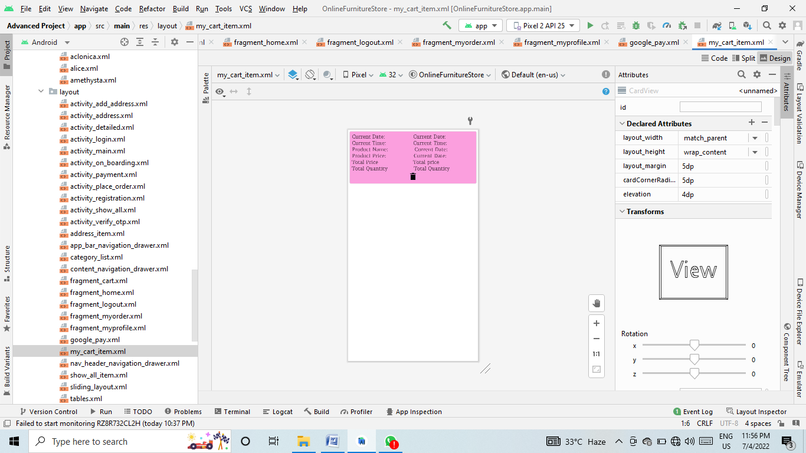

* nav_header_navigation_drawer

*<?***xml version="1.0" encoding="utf-8"***?>*<**LinearLayout xmlns:android="http://schemas.android.com/apk/res/android"  
 xmlns:app="http://schemas.android.com/apk/res-auto"  
 android:layout_width="match_parent"  
 android:layout_height="@dimen/nav_header_height"  
 android:background="@drawable/side_nav_bar"  
 android:gravity="bottom"  
 android:orientation="vertical"  
 android:paddingLeft="@dimen/activity_horizontal_margin"  
 android:paddingTop="@dimen/activity_vertical_margin"  
 android:paddingRight="@dimen/activity_horizontal_margin"  
 android:paddingBottom="@dimen/activity_vertical_margin"  
 android:theme="@style/ThemeOverlay.AppCompat.Dark"**>  
  
 <**de.hdodenhof.circleimageview.CircleImageView  
 xmlns:app="http://schemas.android.com/apk/res-auto"  
 android:id="@+id/nav_header_img"  
 android:layout_width="80dp"  
 android:layout_height="80dp"  
 android:src="@drawable/profile"  
 app:civ_border_width="2dp"  
 android:layout_marginTop="15dp"  
 app:civ_border_color="#FFFFFF"  
 app:layout_constraintEnd_toEndOf="parent"  
 app:layout_constraintStart_toStartOf="parent"  
 app:layout_constraintTop_toTopOf="parent"**/>  
  
 <**TextView  
 android:id="@+id/nav_header_name"  
 android:textColor="@color/black"  
 android:textStyle="bold"  
 android:fontFamily="@font/alice"  
 android:layout_width="match_parent"  
 android:layout_height="wrap_content"  
 android:paddingTop="@dimen/nav_header_vertical_spacing"  
 android:text="@string/nav_header_title"  
 android:textAppearance="@style/TextAppearance.AppCompat.Body1"** />  
  
 <**TextView  
 android:id="@+id/nav_header_email"  
 android:layout_width="wrap_content"  
 android:layout_height="wrap_content"  
 android:text="@string/nav_header_subtitle"** />  
</**LinearLayout**>

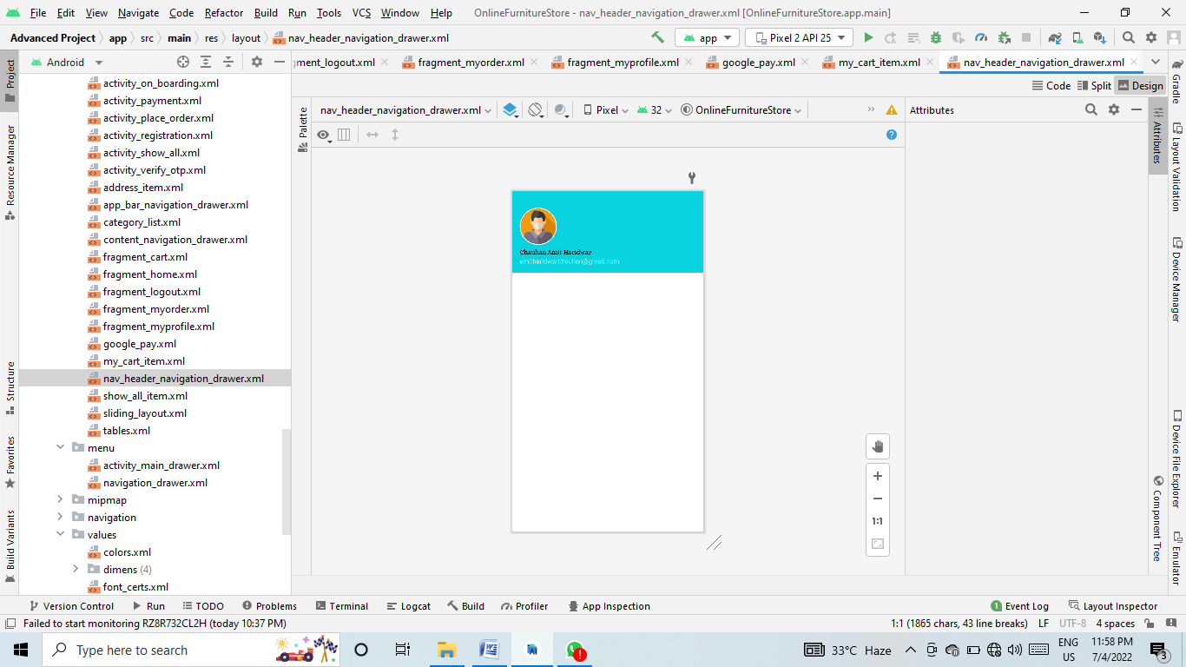

* show_all_item

*<?***xml version="1.0" encoding="utf-8"***?>*<**LinearLayout xmlns:android="http://schemas.android.com/apk/res/android"  
 xmlns:app="http://schemas.android.com/apk/res-auto"  
 android:layout_width="match_parent"  
 android:layout_height="wrap_content"  
 android:padding="5dp"**>  
 <**androidx.cardview.widget.CardView  
 android:layout_width="match_parent"  
 android:layout_height="wrap_content"  
 android:padding="5dp"**>  
 <**LinearLayout  
 android:layout_width="match_parent"  
 android:layout_height="wrap_content"  
 android:gravity="center"  
 android:padding="15dp"  
 android:orientation="vertical"  
 android:background="#EDEDED"**>  
  
 <**ImageView  
 android:id="@+id/item_image"  
 android:layout_width="300dp"  
 android:layout_height="200dp"  
 app:srcCompat="@drawable/ic_launcher_foreground"** />  
  
 <**TextView  
 android:textColor="#673AB7"  
 android:fontFamily="@font/amethysta"  
 android:id="@+id/item_cost"  
 android:layout_width="match_parent"  
 android:layout_height="wrap_content"  
 android:textSize="18sp"  
 android:text="₹ 50"** />  
  
 <**TextView  
 android:id="@+id/item_nam"  
 android:layout_width="match_parent"  
 android:layout_height="wrap_content"  
 android:textSize="18sp"  
 android:text="Woman T shirt"  
 android:fontFamily="@font/amethysta"**/>  
 </**LinearLayout**>  
 </**androidx.cardview.widget.CardView**>  
  
</**LinearLayout**>

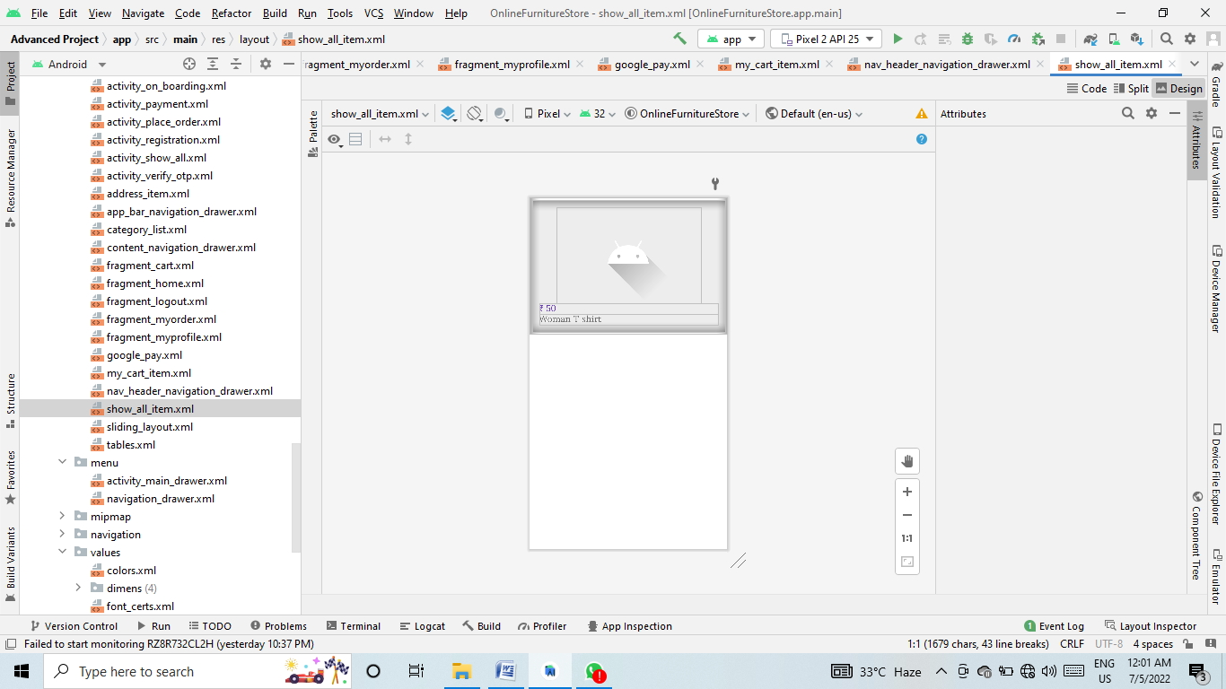

* sliding_layout

*<?***xml version="1.0" encoding="utf-8"***?>*<**androidx.constraintlayout.widget.ConstraintLayout xmlns:android="http://schemas.android.com/apk/res/android"  
 xmlns:app="http://schemas.android.com/apk/res-auto"  
 android:layout_width="match_parent"  
 android:layout_height="match_parent"**>  
  
  
 <**ImageView  
 android:id="@+id/slider_img"  
 android:layout_width="0dp"  
 android:layout_height="250dp"  
 app:layout_constraintEnd_toEndOf="parent"  
 app:layout_constraintStart_toStartOf="parent"  
 app:layout_constraintTop_toTopOf="parent"  
 app:srcCompat="@drawable/onboardscreen1"** />  
  
 <**TextView  
 android:id="@+id/heading"  
 android:layout_width="wrap_content"  
 android:layout_height="wrap_content"  
 android:fontFamily="@font/aclonica"  
 android:text="@string/first_slide"  
 android:textAlignment="center"  
 android:textSize="25sp"  
 android:textStyle="bold"  
 app:layout_constraintEnd_toEndOf="parent"  
 app:layout_constraintStart_toStartOf="parent"  
 app:layout_constraintTop_toBottomOf="@+id/slider_img"** />  
  
 <**TextView  
 android:id="@+id/description"  
 android:layout_width="wrap_content"  
 android:layout_height="wrap_content"  
 android:layout_marginTop="10dp"  
 android:text="@string/des1"  
 android:textAlignment="center"  
 android:textStyle="bold"  
 app:layout_constraintEnd_toEndOf="parent"  
 app:layout_constraintStart_toStartOf="parent"  
 app:layout_constraintTop_toBottomOf="@+id/heading"** />  
  
</**androidx.constraintlayout.widget.ConstraintLayout**>

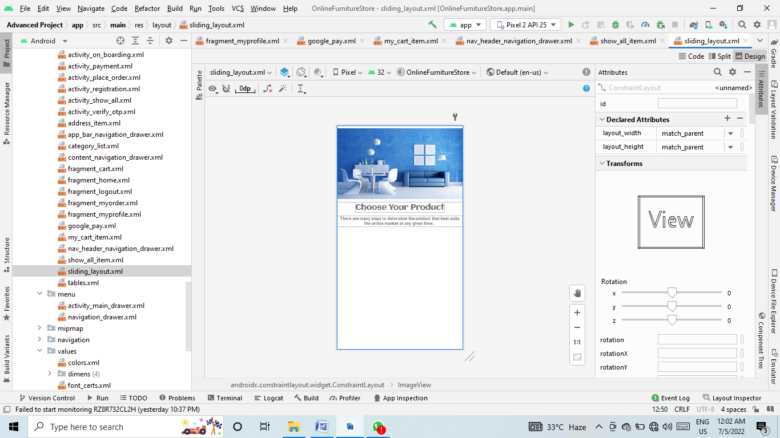

* tables

*<?***xml version="1.0" encoding="utf-8"***?>*<**androidx.cardview.widget.CardView xmlns:android="http://schemas.android.com/apk/res/android"  
 android:layout_width="130dp"  
 android:layout_height="wrap_content"  
 xmlns:app="http://schemas.android.com/apk/res-auto"  
 app:cardCornerRadius="5dp"  
 android:padding="5dp"  
 android:layout_margin="5dp"**>  
  
 <**androidx.constraintlayout.widget.ConstraintLayout  
 android:layout_width="match_parent"  
 android:layout_height="match_parent"  
 android:background="#EDEDED"**>  
  
*<!-- android:scaleType="centerCrop"-->* <**ImageView  
 android:background="@color/white"  
 android:id="@+id/new_img"  
 android:layout_width="120dp"  
 android:layout_height="120dp"  
 android:layout_marginTop="5dp"  
 android:src="@drawable/ic_baseline_person_24"  
 app:layout_constraintEnd_toEndOf="parent"  
 app:layout_constraintStart_toStartOf="parent"  
 app:layout_constraintTop_toTopOf="parent"**/>  
  
 <**TextView  
 android:fontFamily="@font/amethysta"  
 android:id="@+id/textView2"  
 android:layout_width="wrap_content"  
 android:layout_height="wrap_content"  
 android:background="@color/blue"  
 android:padding="6dp"  
 android:text="BUY"  
 android:textColor="@color/white"  
 android:textSize="13sp"  
 android:textStyle="bold"  
 app:layout_constraintTop_toBottomOf="@id/new_img"  
 app:layout_constraintEnd_toEndOf="parent"  
 app:layout_constraintTop_toTopOf="parent"  
 app:layout_constraintVertical_bias="1.0"**/>  
  
 <**TextView  
 android:fontFamily="@font/amethysta"  
 android:id="@+id/pro_name"  
 android:layout_width="wrap_content"  
 android:layout_height="wrap_content"  
 android:layout_marginTop="6dp"  
 android:text="Product Name"  
 android:textSize="17sp"  
 android:textStyle="bold"  
 app:layout_constraintEnd_toEndOf="parent"  
 app:layout_constraintStart_toStartOf="parent"  
 app:layout_constraintTop_toBottomOf="@id/new_img"**/>  
  
 <**androidx.constraintlayout.widget.ConstraintLayout  
 android:layout_width="wrap_content"  
 android:layout_height="wrap_content"  
 app:layout_constraintEnd_toEndOf="@id/pro_name"  
 app:layout_constraintStart_toStartOf="@id/pro_name"  
 app:layout_constraintTop_toBottomOf="@id/pro_name"**>  
  
 <**TextView  
 android:fontFamily="@font/amethysta"  
 app:layout_constraintHorizontal_bias="0"  
 android:textStyle="bold"  
 android:id="@+id/rupees"  
 android:layout_width="match_parent"  
 android:layout_height="wrap_content"  
 android:text="Price: ₹ "  
 android:textColor="#673AB7"  
 android:textSize="18sp"  
 app:layout_constraintBottom_toBottomOf="parent"  
 app:layout_constraintEnd_toEndOf="parent"  
 app:layout_constraintStart_toStartOf="parent"**/>  
  
 <**TextView  
 android:id="@+id/new_price"  
 android:layout_width="match_parent"  
 android:layout_height="wrap_content"  
 android:text="1500"  
 android:fontFamily="@font/amethysta"  
 android:textColor="#673AB7"  
 android:textSize="18sp"  
 android:textStyle="bold"  
 app:layout_constraintBottom_toBottomOf="@id/rupees"  
 app:layout_constraintStart_toEndOf="@id/rupees"  
 app:layout_constraintTop_toTopOf="@id/rupees"**/>  
  
  
 </**androidx.constraintlayout.widget.ConstraintLayout**>  
 </**androidx.constraintlayout.widget.ConstraintLayout**>  
  
</**androidx.cardview.widget.CardView**>

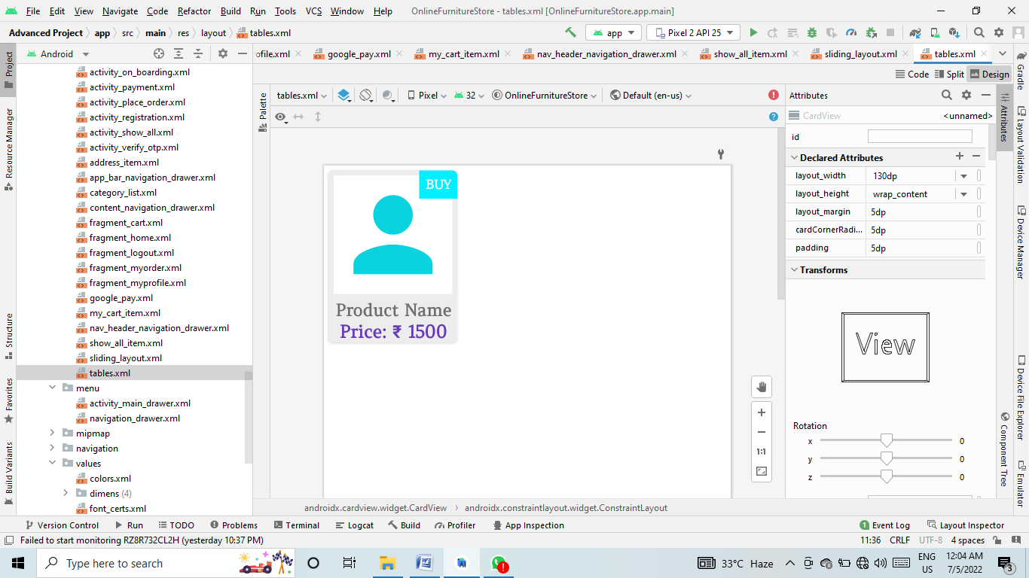

* menu

activity_main_drawer

*<?***xml version="1.0" encoding="utf-8"***?>*<**menu xmlns:android="http://schemas.android.com/apk/res/android"  
 xmlns:tools="http://schemas.android.com/tools"  
 tools:showIn="navigation_view"**>  
  
 <**group android:checkableBehavior="single"**>  
  
 <**item  
 android:id="@+id/nav_home"  
 android:icon="@drawable/ic_baseline_home_24"  
 android:title="Home"** />  
 <**item  
 android:id="@+id/nav_myprofile"  
 android:icon="@drawable/ic_baseline_person_24"  
 android:title="My Profile"** />  
  
  
  
 <**item  
 android:id="@+id/nav_myorder"  
 android:icon="@drawable/ic_baseline_shopping_cart_24"  
 android:title="My Order"** />  
  
  
 <**item  
 android:id="@+id/nav_cart"  
 android:icon="@drawable/ic_baseline_add_shopping_cart_24"  
 android:title="Cart"** />  
  
 <**item  
 android:id="@+id/nav_logout"  
 android:icon="@drawable/ic_baseline_login_24"  
 android:title="Logout"** />  
 </**group**>  
</**menu**>

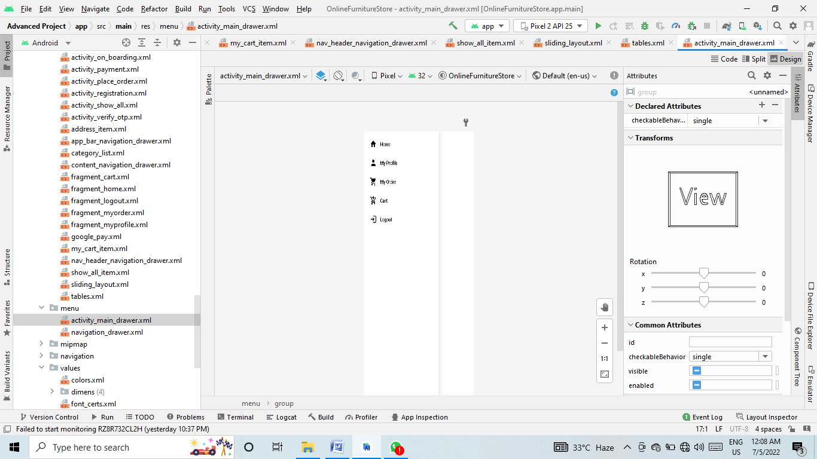

* Navigation

mobile_navigation

*<?***xml version="1.0" encoding="utf-8"***?>*<**navigation xmlns:android="http://schemas.android.com/apk/res/android"  
 xmlns:app="http://schemas.android.com/apk/res-auto"  
 xmlns:tools="http://schemas.android.com/tools"  
 android:id="@+id/mobile_navigation"  
 app:startDestination="@+id/nav_home"**>  
  
 <**fragment  
 android:id="@+id/nav_myprofile"  
 android:name="com.project.amit.onlinefurniturestore.ui.MyProfileFragment"  
 android:label="@string/menu_myprofile"  
 tools:layout="@layout/fragment_myprofile"** />  
  
 <**fragment  
 android:id="@+id/nav_myorder"  
 android:name="com.project.amit.onlinefurniturestore.ui.MyOrderFragment"  
 android:label="@string/menu_myorder"  
 tools:layout="@layout/fragment_myorder"** />  
  
 <**fragment  
 android:id="@+id/nav_home"  
 android:name="com.project.amit.onlinefurniturestore.ui.HomeFragment"  
 android:label="@string/menu_home"  
 tools:layout="@layout/fragment_home"** />  
  
 <**fragment  
 android:id="@+id/nav_cart"  
 android:name="com.project.amit.onlinefurniturestore.ui.MyCartFragment"  
 android:label="@string/menu_cart"  
 tools:layout="@layout/fragment_cart"** />  
  
 <**fragment  
 android:id="@+id/navlogout"  
 android:name="com.project.amit.onlinefurniturestore.ui.LogoutFragment"  
 android:label="Logout"  
 tools:layout="@layout/fragment_logout"** />  
  
  
</**navigation**>

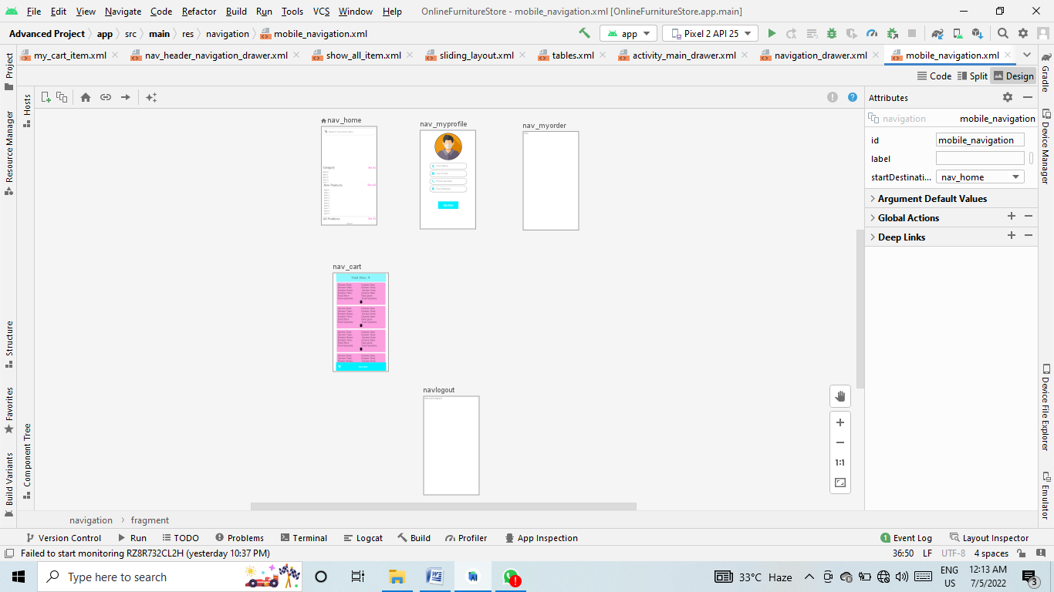

* Values

Colors

*<?***xml version="1.0" encoding="utf-8"***?>*<**resources**>  
 <**color name="purple_200"**>#FFBB86FC</**color**>  
 <**color name="purple_500"**>#FF6200EE</**color**>  
 <**color name="purple_700"**>#FF3700B3</**color**>  
 <**color name="teal_200"**>#FF03DAC5</**color**>  
 <**color name="teal_700"**>#FF018786</**color**>  
 <**color name="black"**>#FF000000</**color**>  
 <**color name="white"**>#FFFFFFFF</**color**>  
  
 <**color name="pink"**>#FF5CCB</**color**>  
 <**color name="blue"**>#00F0FF</**color**>  
 <**color name="backgroundColor"**>#FFFCFC</**color**>  
 <**color name="textHeading"**>#008EFF</**color**>  
</**resources**>

* build.gradle

plugins **{** id **'com.android.application'** id **'com.google.gms.google-services'  
}**android **{** compileSdk 32  
  
 defaultConfig **{** applicationId **"com.project.amit.onlinefurniturestore"** minSdk 25  
 targetSdk 32  
 versionCode 1  
 versionName **"1.0"** testInstrumentationRunner **"androidx.test.runner.AndroidJUnitRunner"  
 }** buildTypes **{** release **{** minifyEnabled **false** proguardFiles getDefaultProguardFile(**'proguard-android-optimize.txt'**), **'proguard-rules.pro'  
 }  
 }** compileOptions **{** sourceCompatibility JavaVersion.***VERSION_1_8*** targetCompatibility JavaVersion.***VERSION_1_8* }** buildFeatures **{** viewBinding **true  
 }  
}**dependencies **{** implementation **'androidx.appcompat:appcompat:1.4.1'** implementation **'com.google.android.material:material:1.6.0'** implementation **'androidx.constraintlayout:constraintlayout:2.1.4'** implementation **'com.google.firebase:firebase-auth:21.0.4'** implementation **'com.google.firebase:firebase-firestore:24.1.2'** implementation **'com.google.firebase:firebase-database:20.0.5'** implementation **'androidx.lifecycle:lifecycle-livedata-ktx:2.4.1'** implementation **'androidx.lifecycle:lifecycle-viewmodel-ktx:2.4.1'** implementation **'androidx.navigation:navigation-fragment:2.4.2'** implementation **'androidx.navigation:navigation-ui:2.4.2'** implementation **'androidx.legacy:legacy-support-v4:1.0.0'** implementation **'com.google.firebase:firebase-storage:20.0.1'** testImplementation **'junit:junit:4.13.2'** androidTestImplementation **'androidx.test.ext:junit:1.1.3'** androidTestImplementation **'androidx.test.espresso:espresso-core:3.4.0'** *// slider image* implementation **'com.github.denzcoskun:ImageSlideshow:0.1.0'** *//Glide* implementation **'com.github.bumptech.glide:glide:4.13.0'** annotationProcessor **'com.github.bumptech.glide:compiler:4.13.0'** *//Razorpay payment method* implementation **'com.razorpay:checkout:1.6.19'** *//Circle Image* implementation **'de.hdodenhof:circleimageview:3.1.0'  
  
}**